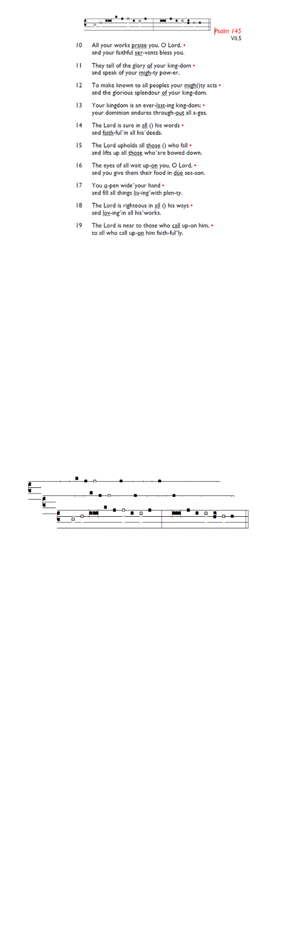
Weekly Events
Monday-Friday 8.30am -8.50am: Morning Prayers.
Wednesday Craft Group at HT November 19th, & 3rd December from 1.30-3.30pm.
Thursday 10am Eucharist, 11am Bible Study, 12.30pm Spanish Class.

Looking ahead November:
Sunday 23rd November, Prelude to Advent – Churches Together Concert, 3-4pm at All Saints Church, Tooting.

Events for December & Advent:
Please book the date, Christmas Fair at Holy Trinity Church, Friday December 5th, from 6.30pm. All welcome to join in the festive fun!

The Paddock School, Christmas visit, Thursday 11th December 1.30pm. Volunteers required to help assist with refreshments on the day. Please let Angela or Churchwardens know if you can help.

Saturday 13th December: Decorating the church for the Carol Service, please arrive at 10am, all welcome to help out.

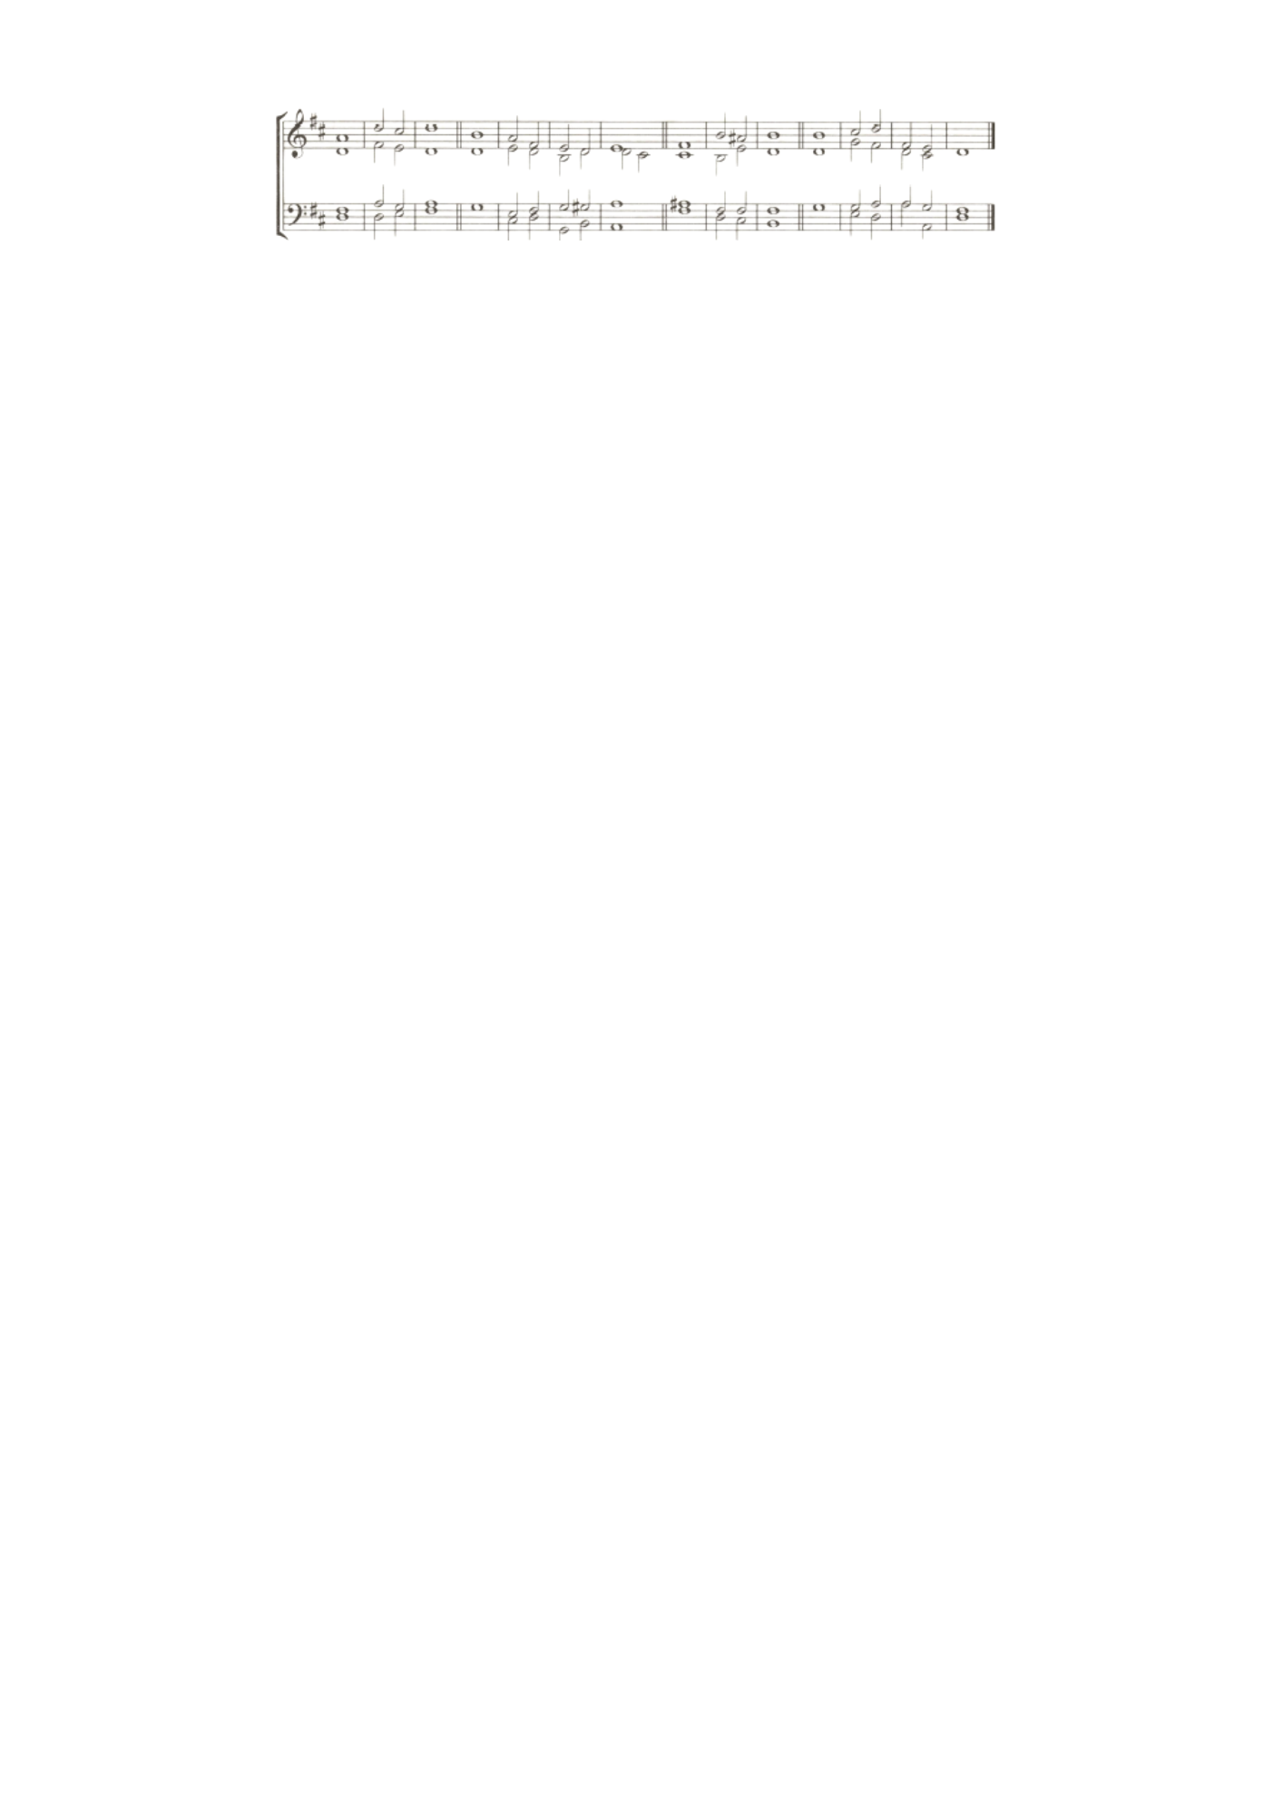
Sunday 14th December, Festive Family Carol Service,
6-7pm.

Wednesday 24th December, Midnight Mass 11pm.

Thursday 25th December, Christmas Day Service, 10am.

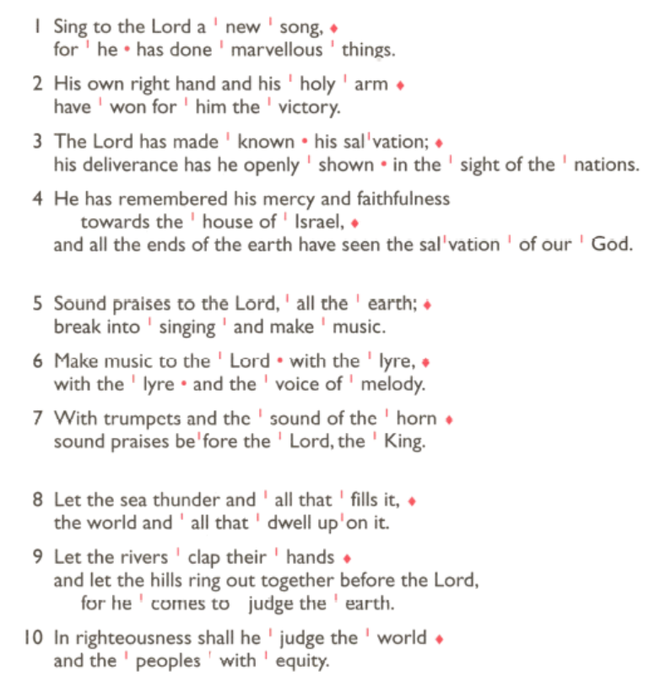
Wednesday 31st December, Watchnight Service, 11pm.

Those who have asked for prayers:
Thelma Benjamin, Gene Bovell, Aileen Brewley, Fitzgerald Brewley, Gloria Ellis Clarke, Yvonne Clarke, Oscar Sam Carrol, Kathleen Cummings, Jennifer Donahue, Kenny Farrell, Shirly Lynch, Horatio Obodai, Esther Persaud, Tina Roberts, Olivia Schulz, Orville Simpson, Thelma Simpson, Mark Sinclair, Delce Taylor, Louisa Upjohn, Eula Watson, Velda Welch.

Contacts & Church Office:
Administrator, Church Notices & Bookings:
Zorah Baig 020 8772 4454
churchoffice@uppertooting.net
The Revd Angela Rayner: (Vicar) 07385 181103
vicar@uppertooting.net
The Revd Sarah Whitehouse (Assistant Priest)
sarah@uppertooting.net
Jacqueline Obodai– Churchwarden. 07956 337643
jackieo12@live.com
Idene Waithe –Churchwarden. 07883 421147
murmaid47@outlook.com

Steve Payne – Buildings Manager 07885 706637
Claudette Dey – Pastoral Lay Minister 07979 598889

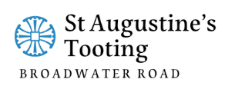

11am Parish Eucharist
16th November 2025 2nd before Advent

Celebrant: The Revd Angela Rayner

Preacher: The Revd Obi Chike
Readers: Claudette Dey, Ethel Addo
Intercessions: Sam Carrol
Greeters: Helen Duxbury, Steve Payne

Hymns
Processional 456: Stand up and bless the Lord
Psalm: 98
Offertory 216: How firm a foundation
Communion: 122: Father, Lord of all creation
Recessional 82: Christ whose glory fills the skies

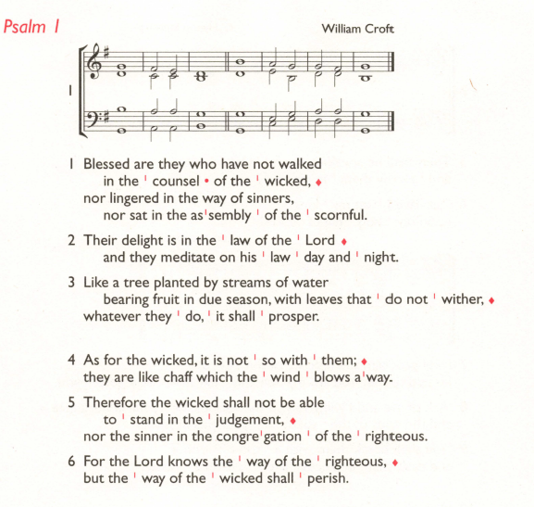
Psalm 98 George J. Elvey

