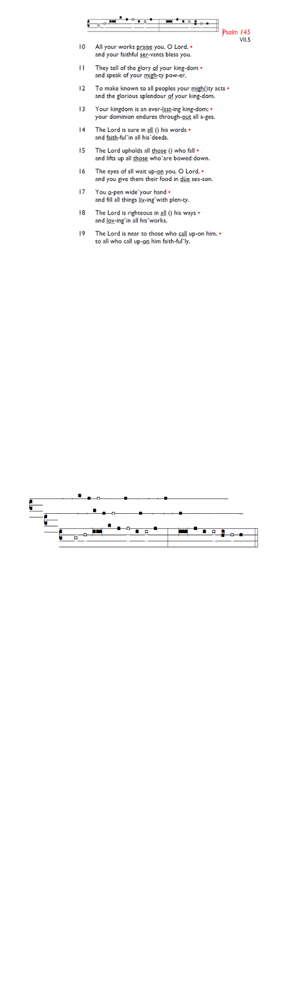
Weekly Events
Monday-Friday 8.30am -8.50am: Morning Prayers.
Wednesday Craft Group at HT November 19th, & 3rd December from 1.30-3.30pm.
Thursday 10am Eucharist, 11am Bible Study, 12.30pm Spanish Class.

Today, Prelude to Advent – Churches Together Concert,
3-4pm at All Saints Church, Tooting.

Events for December & Advent:
Tuesday 4th December 5.30pm: Springfield Village will be switching on their Christmas lights, Chapel Square.

The Paddock School, Christmas visit, Thursday 11th December 1.30pm. Volunteers required to help assist with refreshments on the day. Please let Angela or Churchwardens know if you can help.

Saturday 13th December: Decorating the church for the Carol Service, please arrive at 10am, all welcome to help out.
EMERGENCY APPEAL
In response to the recent emergencies in Jamaica (Hurricane Melissa) and the Philippines (earthquake and typhoons), St Augustine’s PCC has agreed to support the work of the Red Cross and to make a special donation of £500 to each.

In addition, we will take a number of special collections over the coming weeks. All donations will go into one fund and will then be divided equally—50% to the Jamaica appeal (Red Cross Appeal No. MDRJM005) and 50% to the Philippines appeal (Red Cross Appeal No. MDRPH057). If you would like to contribute, please use the marked envelopes available in church or donate online using the “Hurricane Relief” reference. Thank you for your generosity.

Those who have asked for prayers:
Thelma Benjamin, Gene Bovell, Aileen Brewley, Fitzgerald Brewley, Gloria Ellis Clarke, Yvonne Clarke, Oscar Sam Carrol, Kathleen Cummings, Jennifer Donahue, Kenny Farrell, Shirly Lynch, Horatio Obodai, Esther Persaud, Tina Roberts, Olivia Schulz, Orville Simpson, Thelma Simpson, Mark Sinclair, Delce Taylor, Louisa Upjohn, Eula Watson, Velda Welch.

Contacts & Church Office:
Administrator, Church Notices & Bookings:
Zorah Baig 020 8772 4454
churchoffice@uppertooting.net
The Revd Angela Rayner: (Vicar) 07385 181103
vicar@uppertooting.net
The Revd Sarah Whitehouse (Assistant Priest)
sarah@uppertooting.net
Jacqueline Obodai– Churchwarden. 07956 337643
jackieo12@live.com
Idene Waithe –Churchwarden. 07883 421147
murmaid47@outlook.com

Steve Payne – Buildings Manager 07885 706637
Claudette Dey – Pastoral Lay Minister 07979 598889


11am Parish Eucharist
23rd November 2025 Christ the King

Celebrant: The Revd Sarah Whitehouse

Preacher: The Revd Sarah Whitehouse
Readers: Neil Yates O’Brien, Tyrone Payne
Intercessions: Ethel Addo
Greeters: Ann Whelan Wilkes, Ethel Addo

Hymns
Processional 480: The head that once was crowned
Psalm: 46
Offertory 13: All hail the power of Jesus’ name
Communion 484: The King of love my shepherd is
Recessional 103: Crown him with many crowns

Psalm 46 Martin Luther
