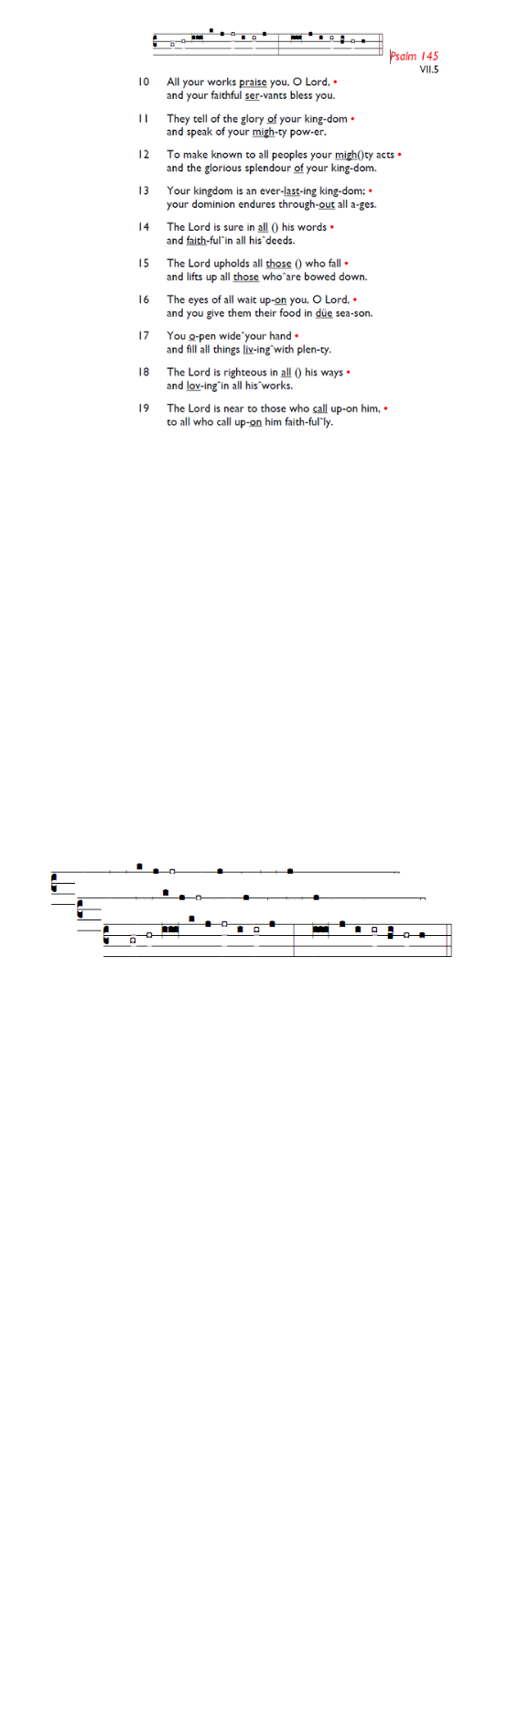
Weekly Events
Monday-Friday 8.30am -8.50am: Morning Prayers.
Wednesday Craft Group at HT November 19th, & 3rd December from 1.30-3.30pm.
Thursday 10am Eucharist, 11am Bible Study, 12.30pm Spanish Class.

Looking ahead November:
TODAY, PCC meeting from 12.30pm to 1.30pm.

Tuesday, 11th November, BACTA Peace Prayers outside Tooting Broadway Tube station 6-7pm.

Reminder: Safeguarding Foundation Level 1 Course will take place on Saturday 15th November at St James’ Church, MITCHAM ROAD 10am-12.30p. In the afternoon from 1pm-3-pm Domestic Violence course.
Contact Mella to book your place, see email below: administrator@stmarybalham.org.uk

Sunday 23rd November, Prelude to Advent – Churches Together Concert, 3-4pm at All Saints Church, Tooting.

Advance notice for December

Please book the date, Christmas Fair at Holy Trinity Church, Friday December 5th, from 6.30pm. All welcome to join in the festive fun!

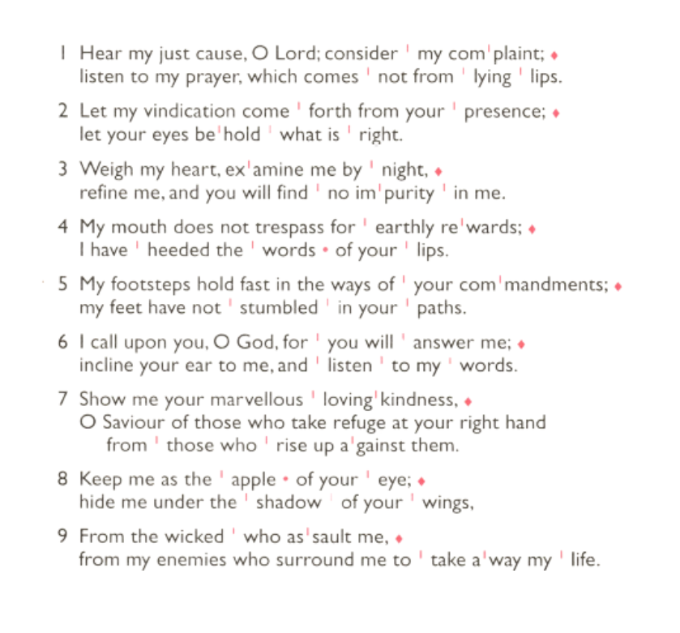
The Paddock School, Christmas visit, Thursday 11th December 1.30pm. Volunteers required to help assist with refreshments on the day. Please let Angela or Churchwardens know if you can help.

Those who have asked for prayers:
Thelma Benjamin, Gene Bovell, Aileen Brewley, Fitzgerald Brewley, Gloria Ellis Clarke, Yvonne Clarke, Oscar Sam Carrol, Kathleen Cummings, Jennifer Donahue, Kenny Farrell, Shirly Lynch, Horatio Obodai, Esther Persaud, Tina Roberts, Olivia Schulz, Orville Simpson, Thelma Simpson, Mark Sinclair, Delce Taylor, Louisa Upjohn, Eula Watson, Velda Welch.

Contacts & Church Office:
Administrator, Church Notices & Bookings:
Zorah Baig 020 8772 4454
churchoffice@uppertooting.net
The Revd Angela Rayner: (Vicar) 07385 181103
vicar@uppertooting.net
The Revd Sarah Whitehouse (Assistant Priest)
sarah@uppertooting.net
Jacqueline Obodai– Churchwarden. 07956 337643
jackieo12@live.com
Idene Waithe –Churchwarden. 07883 421147
murmaid47@outlook.com

Steve Payne – Buildings Manager 07885 706637
Claudette Dey – Pastoral Lay Minister 07979 598889

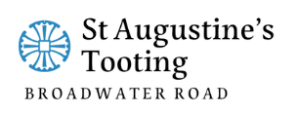

11am Parish Eucharist
9th November 2025 Third before Advent
Remembrance Service

Celebrant: The Revd Sarah Whitehouse

Preacher: The Revd Sarah Whitehouse
Readers: Bernicee Baird-Dundas, Steve Payne
Intercessions: Doris Pappoe
Greeters: Rachel Phillips, Sandra Jones

Hymns
Processional 177: God save our gracious King
205: He who would be valiant be
Psalm: 17:1-9
Offertory 259: Jerusalem the golden
Communion: 114: Eternal Father strong to save
Recessional 366: O God our help in ages past

Communion anthem: Pie Jesu (Maurice Durufle)
Organ voluntary: Nimrod from Enigma Variations (Edward Elgar)
