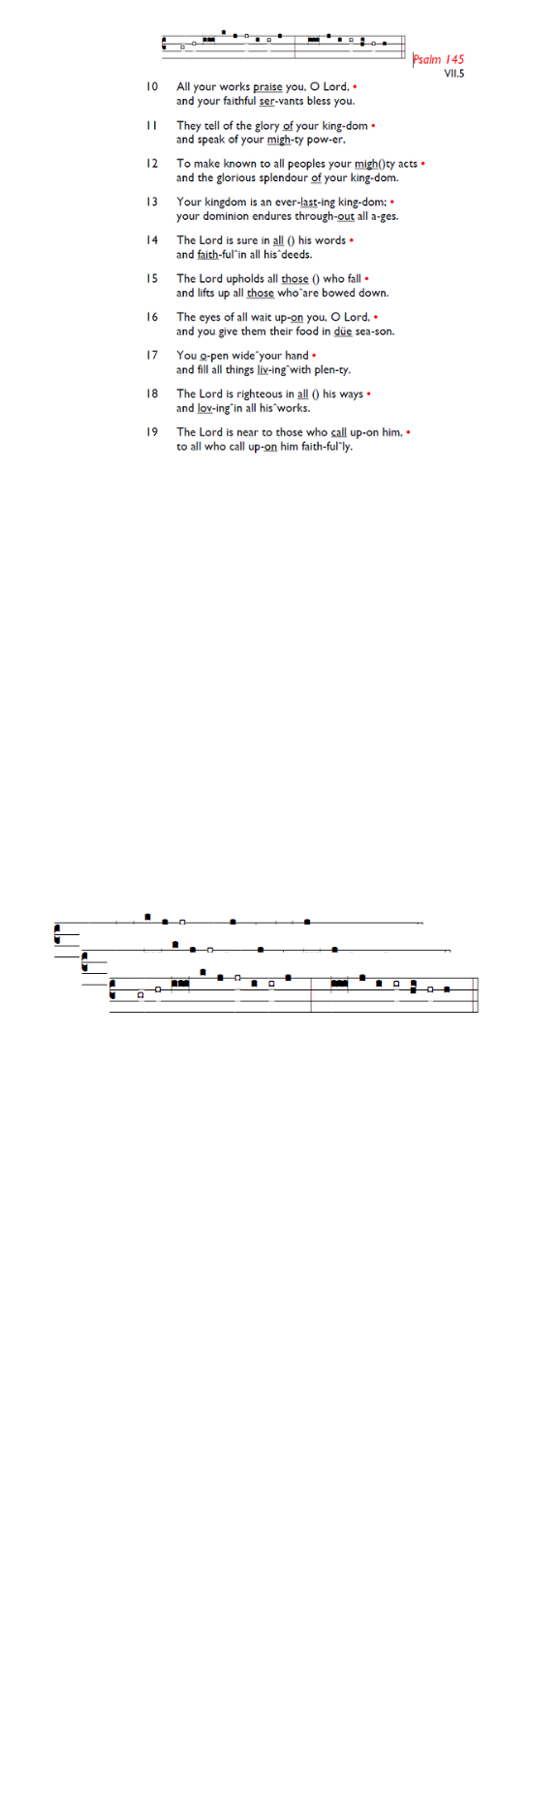
Weekly Events
Monday-Friday 8.30am -8.50am: Morning Prayers.
Wednesday Craft Group at HT 3rd December from 1.30-3.30pm.
Thursday 10am Eucharist, 11am Bible Study, 12.30pm Spanish Class.

Events for December & Advent:
Tuesday 4th December 5.30pm: Springfield Village will be switching on their Christmas lights, Chapel Square.

The Paddock School, Christmas visit, Thursday 11th December 1.30pm. Volunteers required to help assist with refreshments on the day. Please let Angela or Churchwardens know if you can help.

Saturday 13th December: Decorating the church for the Carol Service, please arrive at 10am, all welcome to help out.

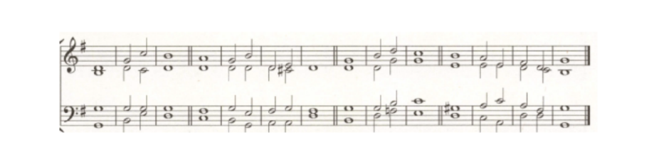
Emergency Appeal: Correction to previous weeks’ notice. There was an error with the information provided, the PCC have now decided that £1000 should be donated to Jamaica Hurricane Relief Fund. If you are donating online, please only donate to the Jamaica Hurricane Relief Fund.

Those who have asked for prayers:
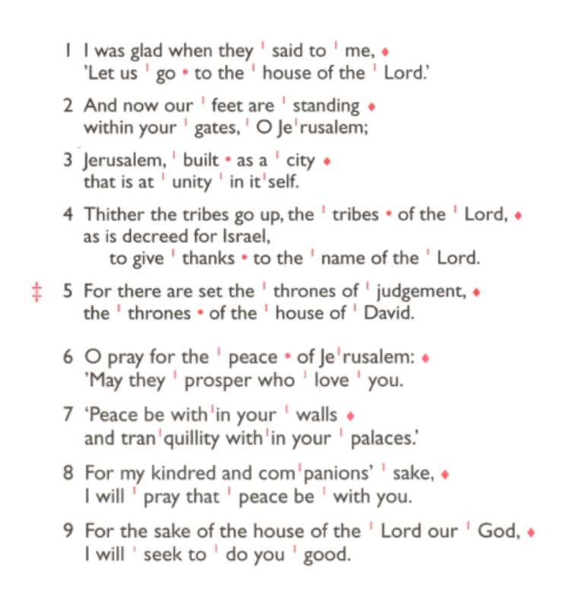
Thelma Benjamin, Gene Bovell, Aileen Brewley, Fitzgerald Brewley, Gloria Ellis Clarke, Yvonne Clarke, Oscar Sam Carrol, Kathleen Cummings, Jennifer Donahue, Kenny Farrell, Shirly Lynch, Horatio Obodai, Esther Persaud, Tina Roberts, Olivia Schulz, Orville Simpson, Thelma Simpson, Mark Sinclair, Delce Taylor, Louisa Upjohn, Eula Watson, Velda Welch.

Contacts & Church Office:
Administrator, Church Notices & Bookings:
Zorah Baig 020 8772 4454
churchoffice@uppertooting.net
The Revd Angela Rayner: (Vicar) 07385 181103
vicar@uppertooting.net
The Revd Sarah Whitehouse (Assistant Priest)
sarah@uppertooting.net
Jacqueline Obodai– Churchwarden. 07956 337643
jackieo12@live.com
Idene Waithe –Churchwarden. 07883 421147
murmaid47@outlook.com

Steve Payne – Buildings Manager 07885 706637
Claudette Dey – Pastoral Lay Minister 07979 598889



11am Parish Eucharist
30th November 2025 Advent 1

Celebrant: The Revd Dorothy Penniecooke

Preacher: The Revd Angela Rayner
Readers: Richard Decker, Idene Waithe
Intercessions: Tyrone Payne
Greeters: Helen Duxbury, Jeremy Clarke

Hymns
Processional 307: Lo, he comes with clouds descending
Psalm 122:
Offertory 358: O come, O come Emmanuel
Communion 282: Jesus where’er they people meet
Recessional 529: Wake, O wake! with tidings thrilling

Psalm 122 Joseph Barnby

