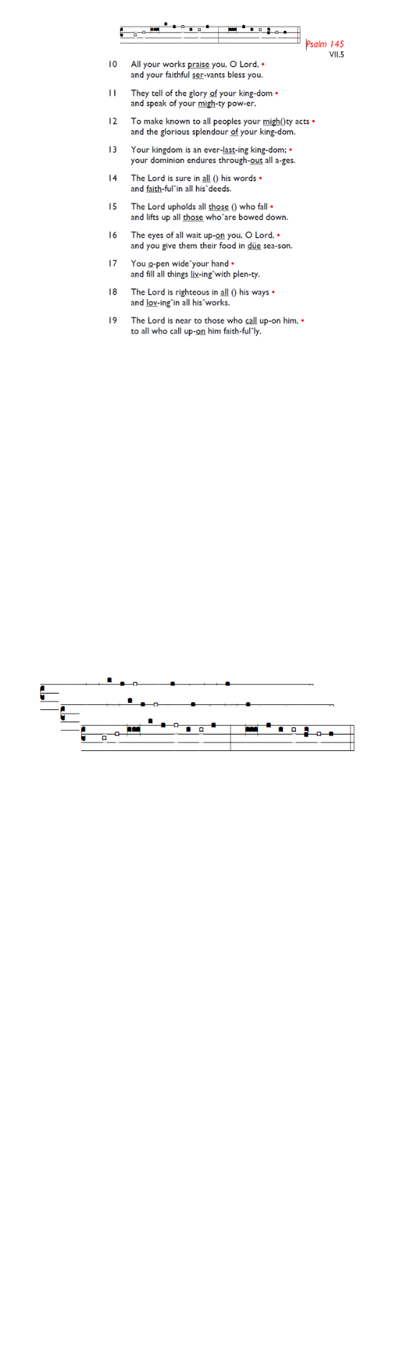
Weekly Events
Monday-Friday 8.30am -8.50am: Morning Prayers.
Thursday, Eucharist 10-11am, Bible Studies 11am – 12noon 12.30pm – 1.30pm Spanish Class restarts this week.

This week

Today Epiphany Lunch at 2.15pm at the Trafalgar King’s Rd SW3. After the service, we will travel there and back by Uber. £30 for three courses, £25 for two courses.

Sunday 18th January, Epiphanytide Service of Hope & Reflection 6-7pm followed by refreshments.

Tue 20th, 12.30pm: Churches Together Sanctuary Lunch at St Anselm's as part of Week of Prayer for Christian Unity. Bring & share food and stories. Please sign up on list at the back. More info from Kate Allan or visit: is.gd/CTJanLunch25

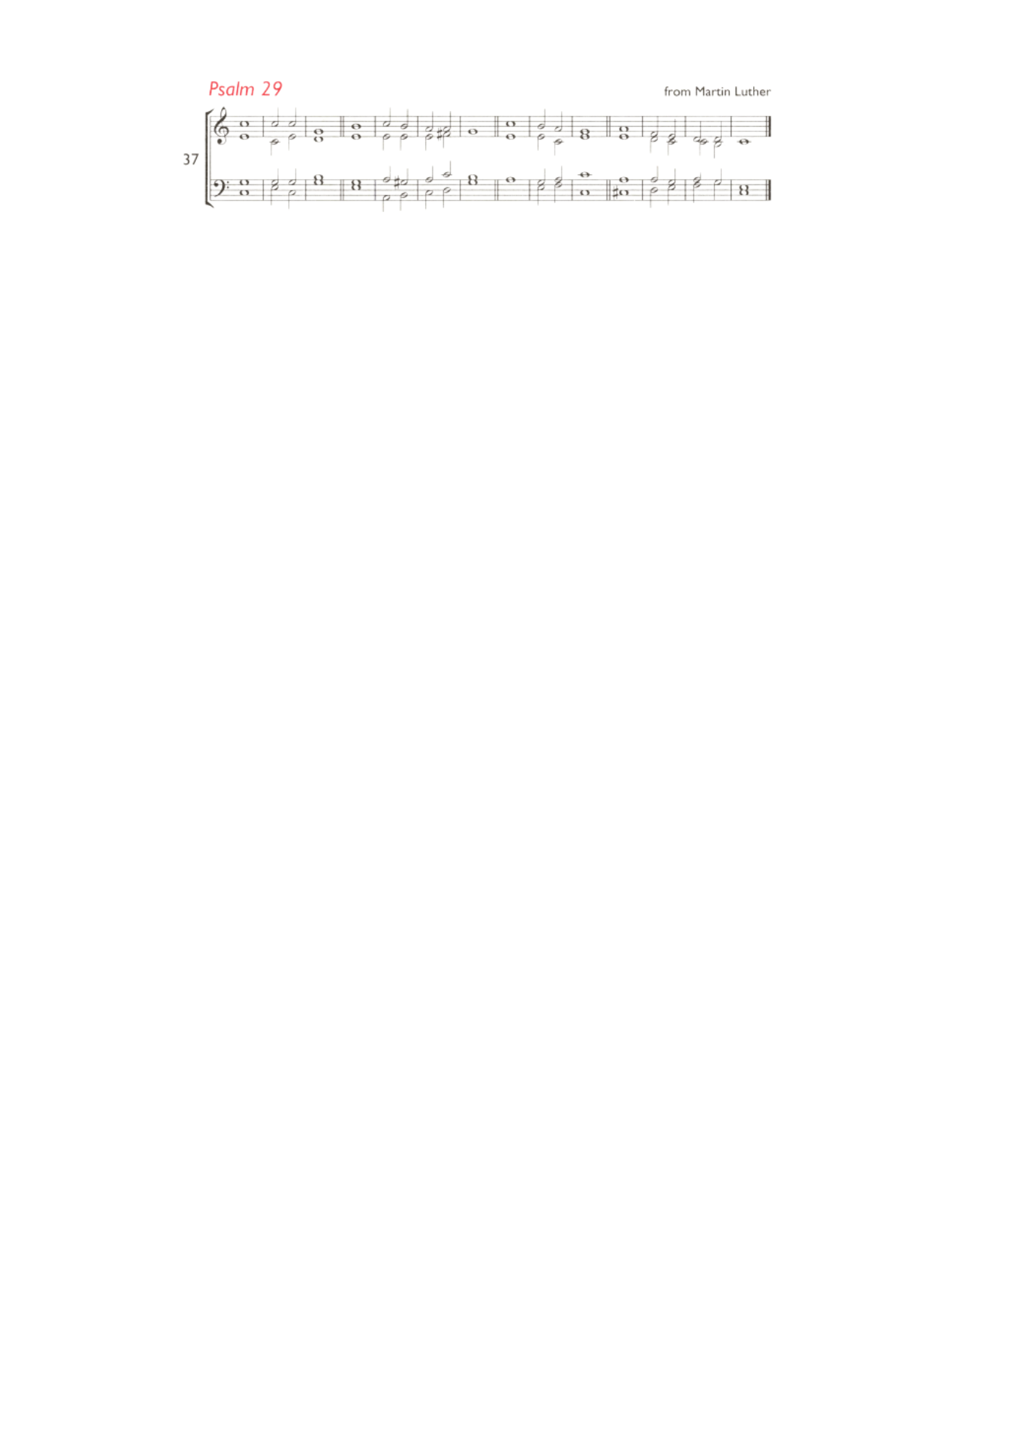
Wed 21st, 7.30pm-8.30pm: Online study and reflections led by Rev Inderjit Bhogal, theologian and founder of the City of Sanctuary movement as part of the Week of Prayer for Christian Unity. On Zoom at: is.gd/InderjitTalk

Sat 25th, 7.30pm-8.30pm: Online study and reflections led by Rev Nadim Nassar of St Mary Magdalene Church. On Zoom at: is.gd/NadimTalk

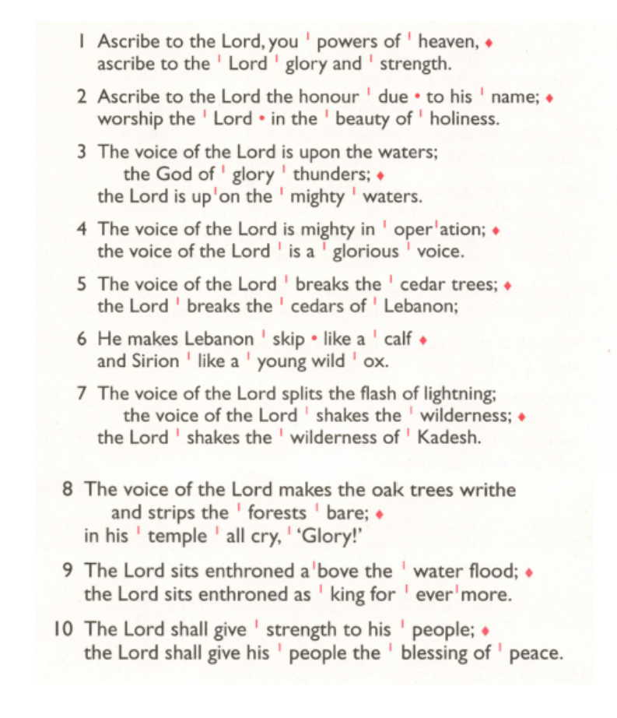
Sat 31st, 10am-2pm: Lay Ministry Taster Day, Trinity House London Bridge. Come and discover more about different types of ministry Reader, Pioneer, Church Army and Children. Guest speaker Adjoa Andoh MBE. For more information and to book your place, email learning@southwark.anglican.org

Those who have asked for prayers:
Thelma Benjamin, Gene Bovell, Aileen Brewley, Fitzgerald Brewley, Gloria Ellis Clarke, Yvonne Clarke, Oscar Sam Carrol, Kathleen Cummings, Jennifer Donahue, Kenny Farrell, Shirly Lynch, Horatio Obodai, Esther Persaud, Tina Roberts, Olivia Schulz, Orville Simpson, Thelma Simpson, Mark Sinclair, Delce Taylor, Louisa Upjohn, Eula Watson, Velda Welch.

Contacts & Church Office:
Administrator, Church Notices & Bookings:
Zorah Baig 020 8772 4454
churchoffice@uppertooting.net
The Revd Angela Rayner: (Vicar) 07385 181103
vicar@uppertooting.net
The Revd Sarah Whitehouse (Assistant Priest)
sarah@uppertooting.net
Claudette Dey – Pastoral Lay Minister 07979 598889
Jacqueline Obodai– Churchwarden. 07956 337643
jackieo12@live.com
Idene Waithe –Churchwarden. 07883 421147
murmaid47@outlook.com
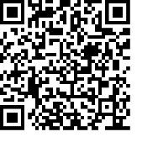
Steve Payne – Buildings Manager 07885 706637



11am Parish Eucharist
11th January 2026 Baptism of Christ

Celebrant: The Revd Angela Rayner
Preacher: The Revd Obi Chike

Readers: Sue Bruno, Neil Yates O’Brien
Intercessions: Tyrone Payne
Greeters: Ann Whelan Wilkes, Rachel Phillips

Hymns
Processional 394: O worship the Lord
Psalm 29:
Offertory 193: Hail to the Lord’s anointed
Communion 111: Do not be afraid
Recessional 537: We three kings of Orient are

