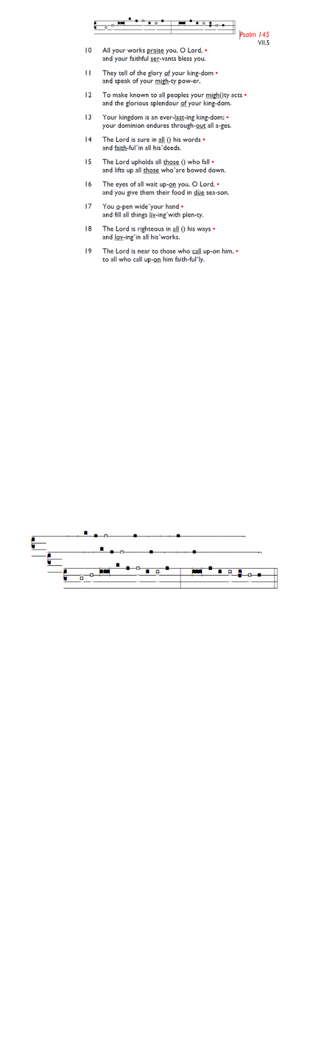
Weekly Events
Monday-Friday 8.30am -8.50am: Morning Prayers.
Wednesdays @ Holy Trinity, Craft Group 1-3pm on Jan 28th,
11th & 25th Feb.
Thursday, Eucharist 10-11am, Bible Studies 11am – 12noon 12.30pm – 1.30pm Spanish Class restarts this week.

This week
TODAY, Epiphanytide Service of Hope & Reflection 6-7pm followed by refreshments.

Tue 20th, 12.30pm: Churches Together Sanctuary Lunch at St Anselm's as part of Week of Prayer for Christian Unity. Bring & share food and stories. Please sign up on list at the back. More info from Kate Allan or visit: is.gd/CTJanLunch25

Wed 21st, 7.30pm-8.30pm: Online study and reflections led by Rev Inderjit Bhogal, theologian, and founder of the City of Sanctuary movement as part of the Week of Prayer for Christian Unity. On Zoom at: is.gd/InderjitTalk

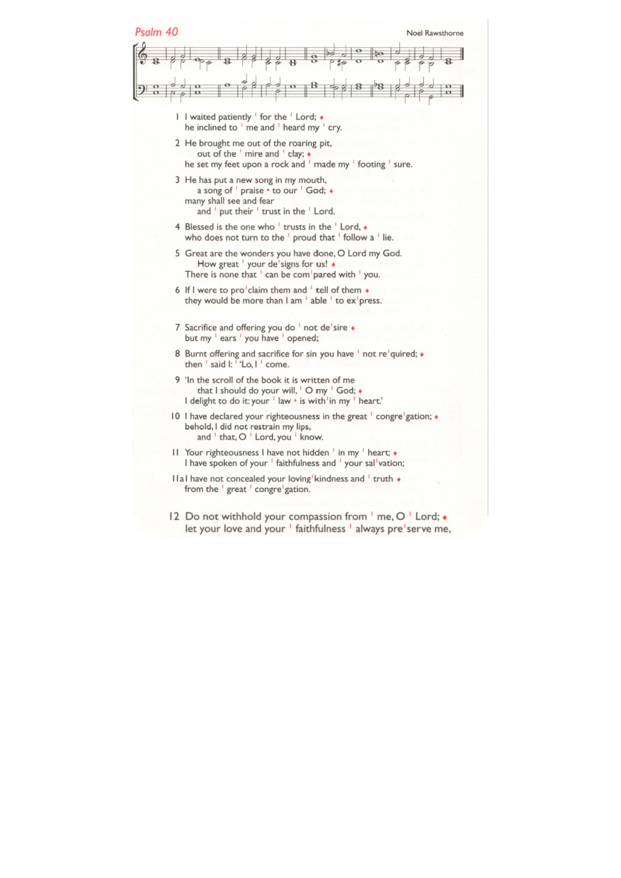
Sun 25th, 7.30pm-8.30pm: Online study and reflections led by Rev Nadim Nassar of St Mary Magdalene Church. On Zoom at: is.gd/NadimTalk

Sat 31st, 10am-2pm: Lay Ministry Taster Day, Trinity House London Bridge. Come and discover more about different types of ministry Reader, Pioneer, Church Army and Children. Guest speaker Adjoa Andoh MBE. For more information and to book your place, email learning@southwark.anglican.org

Sun 1st Feb, 6pm: Candlemas Procession, Choral Evensong & Curry. At Holy Trinity Church. Further details to be added soon. To sign up for curry: is.gd/Curry2026

Those who have asked for prayers:
Thelma Benjamin, Gene Bovell, Aileen Brewley, Fitzgerald Brewley, Gloria Ellis Clarke, Yvonne Clarke, Oscar Sam Carrol, Kathleen Cummings, Jennifer Donahue, Kenny Farrell, Shirly Lynch, Shanthi Nesaraj, Horatio Obodai, Esther Persaud, Tina Roberts, Olivia Schulz, Orville Simpson, Thelma Simpson, Mark Sinclair, Delce Taylor, Louisa Upjohn, Eula Watson, Velda Welch.

Contacts & Church Office:
Administrator, Church Notices & Bookings:
Zorah Baig 020 8772 4454
churchoffice@uppertooting.net
The Revd Angela Rayner: (Vicar) 07385 181103
vicar@uppertooting.net
The Revd Sarah Whitehouse (Assistant Priest)
sarah@uppertooting.net
Claudette Dey – Pastoral Lay Minister 07979 598889
Jacqueline Obodai– Churchwarden. 07956 337643
jackieo12@live.com
Idene Waithe –Churchwarden. 07883 421147
murmaid47@outlook.com

Steve Payne – Buildings Manager 07885 706637



11am Parish Eucharist
18th January 2026 Epiphany 2

Celebrant: The Revd Revd Sarah Whitehouse
Preacher: The Revd Sarah Whitehouse

Readers: Claudette Dey, Steve Payne
Intercessions: Ethel Addo
Greeters: Ethel Addo, Sandra Jones

Hymns
Processional 50: Awake, my soul, and with the sun
Psalm 40 1-12:
Offertory 451: Songs of thankfulness and praise
Communion 428: Purify my heart
Recessional 13: All hail the power of Jesus’s name

