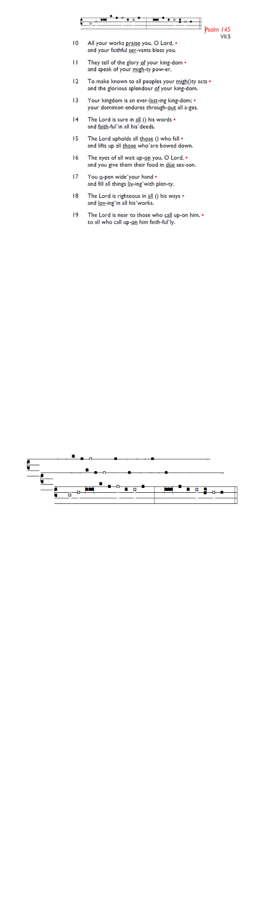
Weekly Events
Monday-Friday 8.30am -8.50am: Morning Prayers.
Wednesdays @ Holy Trinity, Craft Group 1-3pm on,
11th & 25th Feb. Thursday, Eucharist 10-11am, Bible Studies 11am – 12noon 12.30pm – 1.30pm Spanish.

This week

TODAY, 6pm: Candlemas Procession, Choral Evensong & 7pm curry in large hall, veggie option available. At Holy Trinity Church. To sign up for curry: gd/Curry2026

17th February, Shrove Tuesday @ Holy Trinity Church, All Age Pancake party, 4-6pm. Please sign-up so we have enough pancakes.

LENT begins soon; St Augustine’s will be reading The Things Jesus Carried by Stephen Cottrell on Thursday mornings at 11am. If you would like to join the group, please add your name to the sign-up sheet, or use gd/LentGroup26

Booking enquiries: For any hall booking enquiries at St. Augustine’s, can you please call or email the office who will then pass on the request for approval to the Vicar and Churchwardens.

Those who have asked for prayers:
Thelma Benjamin, Gene Bovell, Aileen Brewley, Fitzgerald Brewley, Gloria Ellis Clarke, Yvonne Clarke, Oscar Sam Carrol, Kathleen Cummings, Jennifer Donahue, Kenny Farrell, Shirly Lynch, Shanthi Nesaraj, Horatio Obodai, Esther Persaud, Tina Roberts, Olivia Schulz, Orville Simpson, Thelma Simpson, Mark Sinclair, Delce Taylor, Louisa Upjohn, Eula Watson, Velda Welch.

Contacts & Church Office:
Administrator, Church Notices & Bookings:
Zorah Baig 020 8772 4454
churchoffice@uppertooting.net
The Revd Angela Rayner: (Vicar) 07385 181103
vicar@uppertooting.net
The Revd Sarah Whitehouse (Assistant Priest)
sarah@uppertooting.net
Claudette Dey – Pastoral Lay Minister 07979 598889
Jacqueline Obodai– Churchwarden. 07956 337643
jackieo12@live.com
Idene Waithe –Churchwarden. 07883 421147
murmaid47@outlook.com

Steve Payne – Buildings Manager 07885 706637



11am Parish Eucharist
1st February 2026 Candlemas

Celebrant: The Revd Dorothy Penniecooke
Preacher: The Revd Dorothy Pennicooke

Readers: Soma, Rachel Phillips
Intercessions: Jacqueline Obodai
Greeters: Ann Whelan Wilkes, Steve Payne

Hymns
Processional 70: Bright the vision that delighted
Psalm 24:
Offertory 26: Alleluia, sing to Jesus
Communion 244: In Christ there is not east and west
Recessional 277: Jesus shall reign where’re the sun
