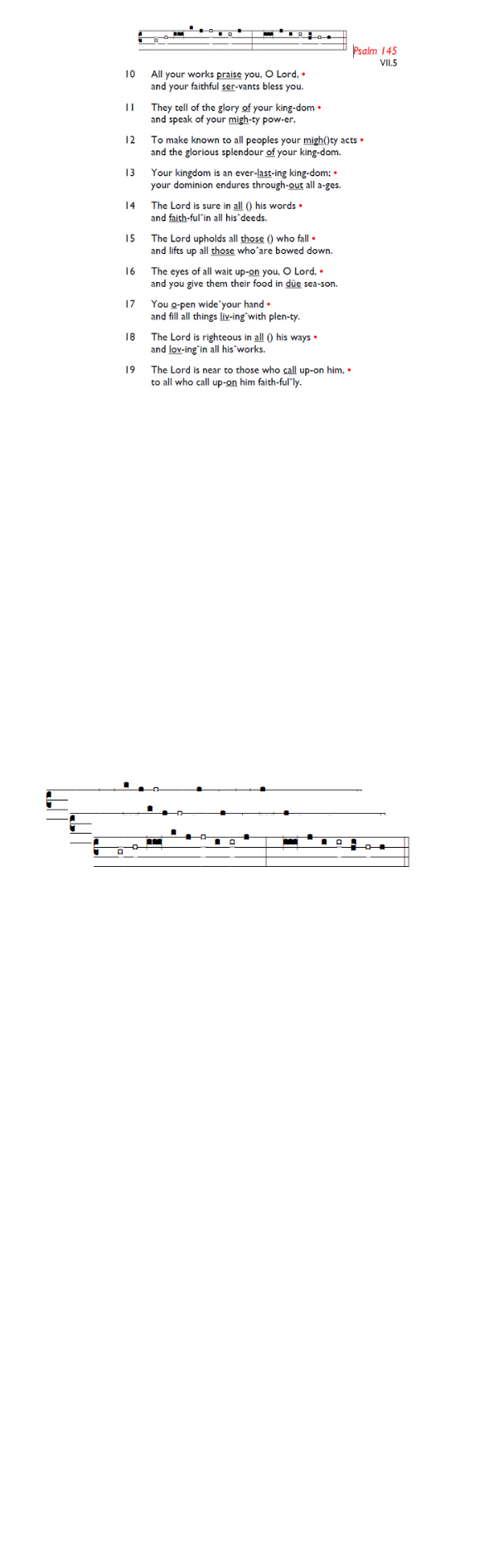
Weekly Events
Monday-Friday 8.30am -8.50am: Morning Prayers.
Wednesdays @ Holy Trinity, Craft Group 1-3pm, Jan 28th,
Then 11th & 25th Feb. Wednesday 28th January 12 noon, Spanish class for this week only.
Thursday, Eucharist 10-11am, Bible Studies

This week
TODAY, 7.30pm-8.30pm: Online study and reflections led by Rev Nadim Nassar of St Mary Magdalene Church. On Zoom at: is.gd/NadimTalk

Friday 30th January, 11am: There will be the taking down of Christmas Decorations and volunteers are required. Thank you for your support if you can help.

Sat 31st, 10am-2pm: Lay Ministry Taster Day, Trinity House London Bridge. Come and discover more about different types of ministry Reader, Pioneer, Church Army and Children. Guest speaker Adjoa Andoh MBE. For more information and to book your place, email learning@southwark.anglican.org

Sun 1st Feb, 6pm: Candlemas Procession, Choral Evensong & Curry. At Holy Trinity Church. Further details to be added soon. To sign up for curry: is.gd/Curry2026

17th February, Shrove Tuesday @ Holy Trinity Church, All Age Pancake party, 4-6pm.

Booking enquiries: For any hall booking enquiries at St. Augustine’s, can you please call or email the office who will then pass on the request for approval to the Vicar and Churchwardens.

Those who have asked for prayers:
Thelma Benjamin, Gene Bovell, Aileen Brewley, Fitzgerald Brewley, Gloria Ellis Clarke, Yvonne Clarke, Oscar Sam Carrol, Kathleen Cummings, Jennifer Donahue, Kenny Farrell, Shirly Lynch, Shanthi Nesaraj, Horatio Obodai, Esther Persaud, Tina Roberts, Olivia Schulz, Orville Simpson, Thelma Simpson, Mark Sinclair, Delce Taylor, Louisa Upjohn, Eula Watson, Velda Welch.

Contacts & Church Office:
Administrator, Church Notices & Bookings:
Zorah Baig 020 8772 4454
churchoffice@uppertooting.net
The Revd Angela Rayner: (Vicar) 07385 181103
vicar@uppertooting.net
The Revd Sarah Whitehouse (Assistant Priest)
sarah@uppertooting.net
Claudette Dey – Pastoral Lay Minister 07979 598889
Jacqueline Obodai– Churchwarden. 07956 337643
jackieo12@live.com
Idene Waithe –Churchwarden. 07883 421147
murmaid47@outlook.com
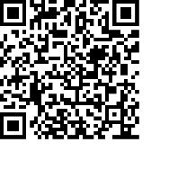
Steve Payne – Buildings Manager 07885 706637

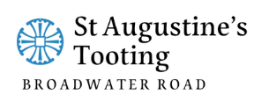

11am Parish Eucharist
25th January 2026 Conversion of Paul

Celebrant: The Revd Sarah Whitehouse
Preacher: Ethan Glackin-McColgan

Readers: Russell Yates, Bernicee Baird-Dundas
Intercessions: Doris Pappoe
Greeters: Paula Stevenson, Jeremy Clarke

Hymns
Processional 30: And can it be that I should gain
Psalm 67:
Offertory 305: Light’s abode, celestial Salem
Communion 231: I heard the voice of Jesus say
Recessional 532: We have a gospel to proclaim
