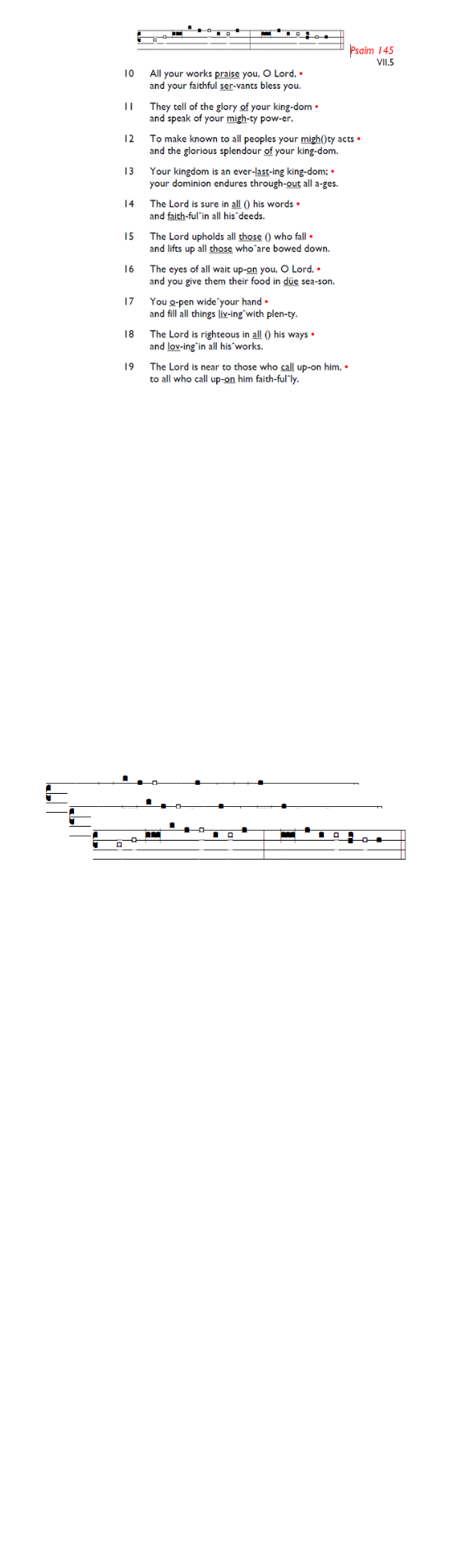
Weekly Events
Monday-Friday 8.30am -8.50am: Morning Prayers.
Wednesdays @ Holy Trinity, Craft Group 1-3pm on,
25th Feb. Thursday, Eucharist 10-11am, Bible Studies 11am – 12noon 12.30pm – 1.30pm Spanish.

This week
All are invited to Holy Trinity’s Pancake Party on Tue 17th Feb at 4pm. If you’d like to attend, please sign up here is.gd/ShroveTuesday26 or on the sign-up sheet at the back of church so that we know how many pancakes to prepare.

18th February, Ash Wednesday Eucharist with ashing,
12-1pm. There will be a Eucharist with Ashing at Holy Trinity at 8pm also.

Sunday 22nd February, PCC meeting 12.30-1-30pm.

Sun 8th March, 11.30am (ish): Holy Week Pre-Meeting. If you’d be interested in taking part or assisting in Holy Week with serving, reading, cooking, welcoming, or any other way, please be ready to meet after the Sunday service.

LENT begins soon; St Augustine’s will be reading The Things Jesus Carried by Stephen Cottrell on Thursday mornings at 11am. You are also welcome to attend Holy Trinity, Lent Group at 8-9.30pm, on Wednesday 25th February in small hall. If you would like to join either group, please add your name to the sign-up sheet, or use gd/LentGroup26

Booking enquiries: For any hall booking enquiries at St. Augustine’s, can you please call or email the office who will then pass on the request for approval to the Vicar and Churchwardens

Those who have asked for prayers:
Thelma Benjamin, Gene Bovell, Aileen Brewley, Fitzgerald Brewley, Gloria Ellis Clarke, Yvonne Clarke, Oscar Sam Carrol, Kathleen Cummings, Jennifer Donahue, Kenny Farrell, Shirly Lynch, Shanthi Nesaraj, Horatio Obodai, Esther Persaud, Tina Roberts, Olivia Schulz, Orville Simpson, Thelma Simpson, Mark Sinclair, Delce Taylor, Louisa Upjohn, Eula Watson, Velda Welch.

Contacts & Church Office:
Administrator, Church Notices & Bookings:
Zorah Baig 020 8772 4454
churchoffice@uppertooting.net
The Revd Angela Rayner: (Vicar) 07385 181103
vicar@uppertooting.net
The Revd Sarah Whitehouse (Assistant Priest)
sarah@uppertooting.net
Claudette Dey – Pastoral Lay Minister 07979 598889
Jacqueline Obodai– Churchwarden. 07956 337643
jackieo12@live.com
Idene Waithe –Churchwarden. 07883 421147
murmaid47@outlook.com

Steve Payne – Buildings Manager 07885 706637


11am Parish Eucharist
15th February 2026 Sunday before Lent

Celebrant: The Revd Angela Rayner
Preacher: The Revd Angela Rayner

Readers: Phillipa Baker, Sam Carrol
Intercessions: Jacqueline Obodaio
Greeters: Paula Stevenson, Ethel Addo

Hymns
Processional 82: Christ, whose glory fills the skies
Psalm 99
Offertory 46: At the name of Jesus
Communion 278: Jesus shall take the highest honour
Recessional 63: Blest are the pure in heart

