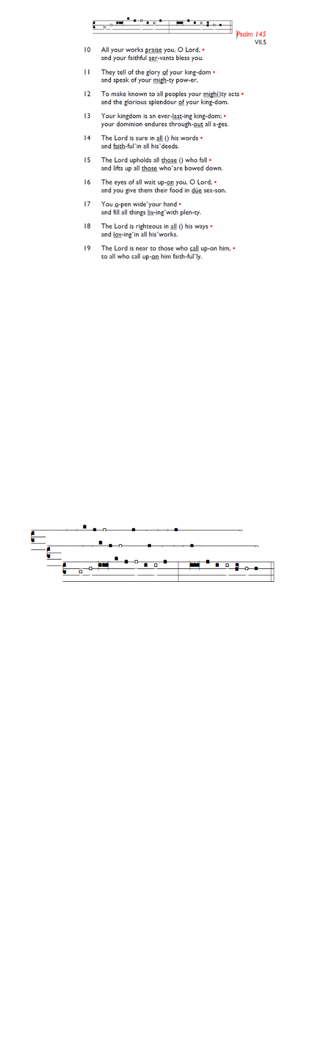
Weekly Events
Monday-Friday 8.30am -8.50am: Morning Prayers.
Craft Group @ Holy Trinity, Wednesday 11th & 25th March from 1-3pm. Thursday, Eucharist 10-11am, Bible Studies
11am – 12noon. There will be no Spanish classes on 5th
& 26th March. Next Spanish class, Wednesday 11th March
2-3pm.

This week
Fridays in Lent – 6pm: Stations of the Cross, a simple, prayerful devotion walking with Christ in his Passion.

Confessions: The Vicar is available at our sister church,
Holy Trinity Church, 74 Trinity Road, to hear formal confessions in the Chapel. Sat 7th, 14th, 21st, 28th March All between 6.30pm-7pm
Fri 6th Mar, 2pm: World Day of Prayer service held at Salvation Army, Balham High Rd (SW12 9AH). The materials have been prepared this year by the women of Nigeria. Those of Nigerian and West African heritage are especially encouraged to attend, and refreshments will be served afterwards. is.gd/WorldDayPrayer

Sun 8th March 11.30am (ish): Holy Week Pre-Meeting. If you’d be interested in taking part or assisting in Holy Week with serving, reading, cooking, welcoming, or any other way, please be ready to meet after the Sunday service.

INEQE Safeguarding Group is conducting independent safeguarding audits across all Church of England dioceses. Southwark’s review takes place in June 2026. Parishioners are invited to complete an anonymous and confidential survey to share their views. Watch a video message from Bp Christopher about it: is.gd/SouthwarkAudit26
All survey responses go directly to INEQE’s audit team, not to the Diocese. The survey closes at 11.30pm on Wed 8 April 2026. Take part in the survey: is.gd/INEQE2026

Those who have asked for prayers:
Thelma Benjamin, Gene Bovell, Aileen Brewley, Fitzgerald Brewley, Gloria Ellis Clarke, Yvonne Clarke, Oscar Sam Carrol, Kathleen Cummings, Jennifer Donahue, Kenny Farrell, Shirly Lynch, Shanthi Nesaraj, Horatio Obodai, Esther Persaud, Tina Roberts, Olivia Schulz, Orville Simpson, Thelma Simpson, Mark Sinclair, Delce Taylor, Louisa Upjohn, Idene Waithe, Eula Watson, Velda Welch.

Contacts & Church Office:
Administrator, Church Notices & Bookings:
Zorah Baig 020 8772 4454
churchoffice@uppertooting.net
The Revd Angela Rayner: (Vicar) 07385 181103
vicar@uppertooting.net
The Revd Sarah Whitehouse (Assistant Priest)
sarah@uppertooting.net
Claudette Dey – Pastoral Lay Minister 07979 598889
Jacqueline Obodai– Churchwarden. 07956 337643
jackieo12@live.com
Idene Waithe –Churchwarden. 07883 421147
murmaid47@outlook.com
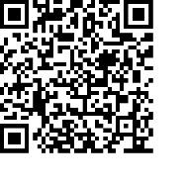
Steve Payne – Buildings Manager 07885 706637

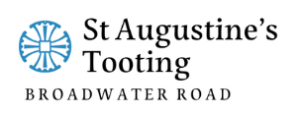

11am Parish Eucharist
1st March 2026 Lent 2

Celebrant: The Revd Sarah Whitehouse
Preacher: The Revd Sarah Whitehouse

Readers: Jay, Neil Yates O’Brien
Intercessions: Ethel Addo
Greeters: Ann Whelan Wilkes, Ethel Addo

Hymns
Processional 426: Praise to the holiest in height
Psalm 121
Offertory 478: The God of Abraham praise
Communion 260: Jesu, grants me this I pray
Recessional 372: O Jesus, I have promised

