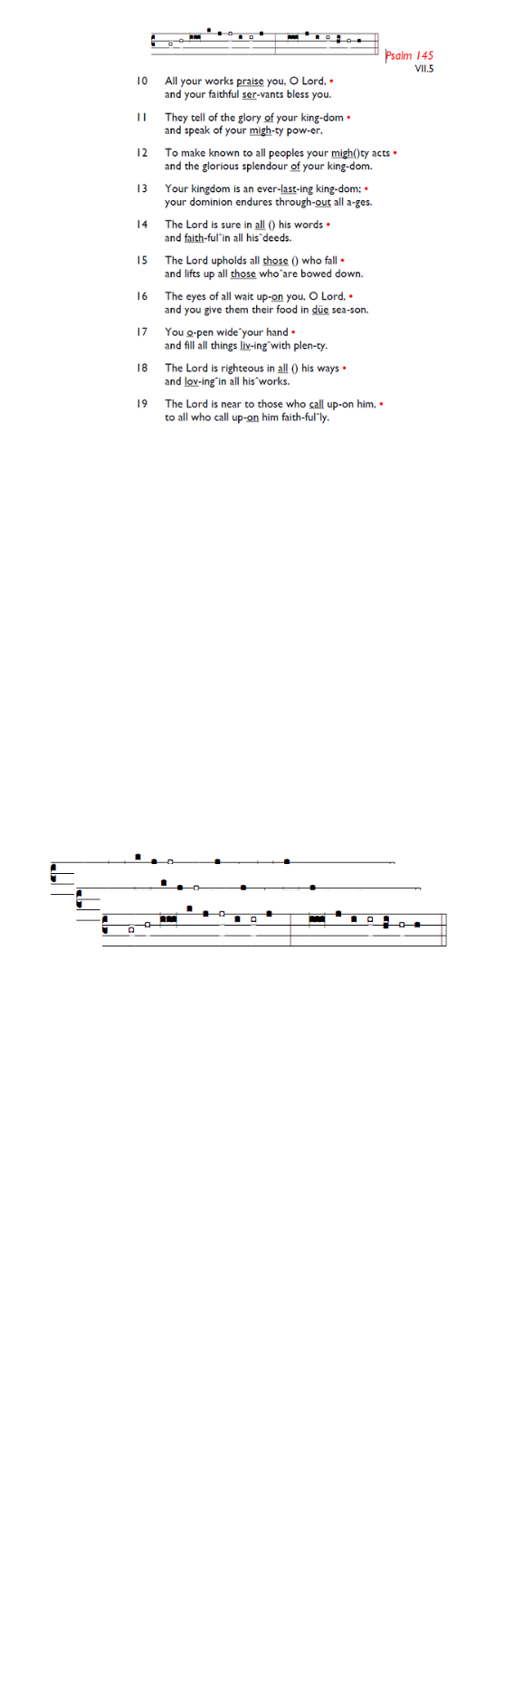
Weekly Events
Monday-Friday 8.30am -8.50am: Morning Prayers.
Thursday, Eucharist 10-11am, Bible Studies
11am – 12noon, Spanish class Wednesday 25th Feb starting 11am. There will be no Spanish Classes on 5th & 26th March.

This week
TODAY, PCC meeting 12.30-1-30pm.

LENT continues; St Augustine’s will be reading The Things Jesus Carried by Stephen Cottrell on Thursday mornings at 11am. You are also welcome to attend Holy Trinity, Lent Group at 8-9.30pm, on Wednesday 25th February in the small hall. The group is reading ‘Lentwise’ by Paula Gooder. If you would like to join either group, please add your name to the sign-up sheet, or use gd/LentGroup26

Fridays in Lent – 6pm: Stations of the Cross, a simple, prayerful devotion walking with Christ in his Passion.

Confessions: The Vicar is available at our sister church,
Holy Trinity Church, 74 Trinity Road, to hear formal confessions in the Chapel. Sat 7th, 14th, 21st, 28th March All between 6.30pm-7pm
Fri 6th Mar, 2pm: World Day of Prayer service held at Salvation Army, Balham High Rd (SW12 9AH). The materials have been prepared this year by the women of Nigeria. Those of Nigerian and West African heritage are especially encouraged to attend, and refreshments will be served afterwards. is.gd/WorldDayPrayer

Sun 8th March 11.30am (ish): Holy Week Pre-Meeting. If you’d be interested in taking part or assisting in Holy Week with serving, reading, cooking, welcoming, or any other way, please be ready to meet after the Sunday service.

Those who have asked for prayers:
Thelma Benjamin, Gene Bovell, Aileen Brewley, Fitzgerald Brewley, Gloria Ellis Clarke, Yvonne Clarke, Oscar Sam Carrol, Kathleen Cummings, Jennifer Donahue, Kenny Farrell, Shirly Lynch, Shanthi Nesaraj, Horatio Obodai, Esther Persaud, Tina Roberts, Olivia Schulz, Orville Simpson, Thelma Simpson, Mark Sinclair, Delce Taylor, Louisa Upjohn, Eula Watson, Velda Welch.

Contacts & Church Office:
Administrator, Church Notices & Bookings:
Zorah Baig 020 8772 4454
churchoffice@uppertooting.net
The Revd Angela Rayner: (Vicar) 07385 181103
vicar@uppertooting.net
The Revd Sarah Whitehouse (Assistant Priest)
sarah@uppertooting.net
Claudette Dey – Pastoral Lay Minister 07979 598889
Jacqueline Obodai– Churchwarden. 07956 337643
jackieo12@live.com
Idene Waithe –Churchwarden. 07883 421147
murmaid47@outlook.com

Steve Payne – Buildings Manager 07885 706637



11am Parish Eucharist
22nd February 2026 Lent 1

Celebrant: The Revd Angela Rayner
Preacher: The Revd Angela Rayner

Readers: Charles Bamford, Tyrone Payne
Intercessions: Doris Pappoe
Greeters: Rachel Phillips, Sylvia Furneaux

Hymns
Processional 145: Forty days and forty nights
Psalm 32
Offertory 261: Jesu, lover of my soul
Communion 287: Just as I am
Recessional 465: Take up thy cross, the Saviour said

