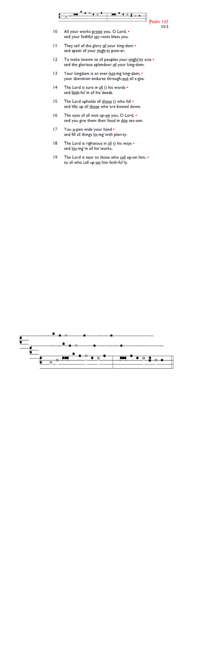
Weekly Events
Monday-Friday 8.30am -8.50am: Morning Prayers.
Wednesdays @ Holy Trinity, Craft Group 1-3pm on,
11th & 25th Feb. Thursday, Eucharist 10-11am, Bible Studies 11am – 12noon 12.00pm – 1.00pm Spanish.

This week

All are invited to Holy Trinity’s Pancake Party on Tue 17th Feb at 4pm. If you’d like to attend, please sign up here is.gd/ShroveTuesday26 or on the sign-up sheet at the back of church so that we know how many pancakes to prepare.

Sunday 22nd February, PCC meeting 12.30-1-30pm.

LENT begins soon; St Augustine’s will be reading The Things Jesus Carried by Stephen Cottrell on Thursday mornings at 11am. If you would like to join the group, please add your name to the sign-up sheet, or use gd/LentGroup26

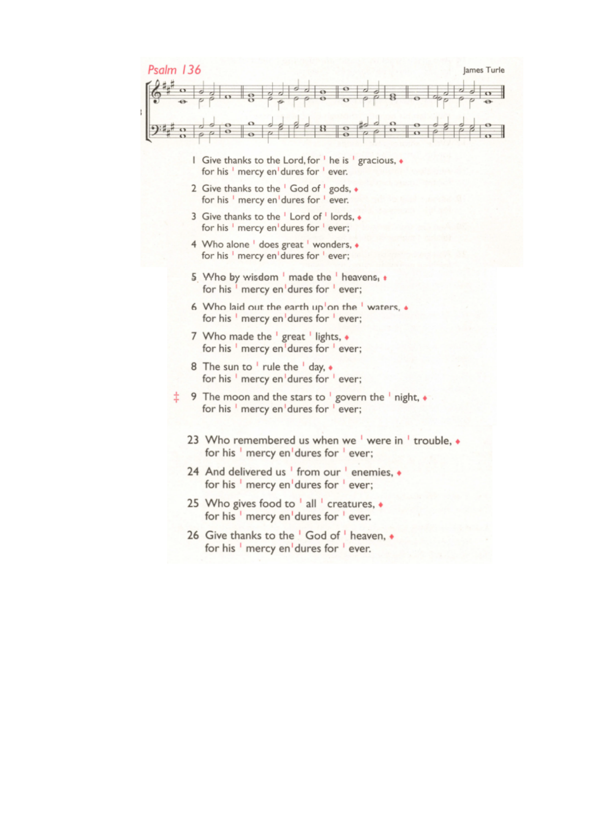
Booking enquiries: For any hall booking enquiries at St. Augustine’s, can you please call or email the office who will then pass on the request for approval to the Vicar and Churchwardens.

Those who have asked for prayers:
Thelma Benjamin, Gene Bovell, Aileen Brewley, Fitzgerald Brewley, Gloria Ellis Clarke, Yvonne Clarke, Oscar Sam Carrol, Kathleen Cummings, Jennifer Donahue, Kenny Farrell, Shirly Lynch, Shanthi Nesaraj, Horatio Obodai, Esther Persaud, Tina Roberts, Olivia Schulz, Orville Simpson, Thelma Simpson, Mark Sinclair, Delce Taylor, Louisa Upjohn, Eula Watson, Velda Welch.

Contacts & Church Office:
Administrator, Church Notices & Bookings:
Zorah Baig 020 8772 4454
churchoffice@uppertooting.net
The Revd Angela Rayner: (Vicar) 07385 181103
vicar@uppertooting.net
The Revd Sarah Whitehouse (Assistant Priest)
sarah@uppertooting.net
Claudette Dey – Pastoral Lay Minister 07979 598889
Jacqueline Obodai– Churchwarden. 07956 337643
jackieo12@live.com
Idene Waithe –Churchwarden. 07883 421147
murmaid47@outlook.com

Steve Payne – Buildings Manager 07885 706637

To make a one-off or regular donation to St Augustine's, please either telephone 0333 002 1271,
scan the QR code or use the following link: bit.ly/GiveToStAugustine



11am Parish Eucharist
8th February 2026 2nd before Lent

Celebrant: The Revd Sarah Whitehouse
Preacher: The Revd Sarah Whitehouse

Readers: Richard Decker, Claudette Dey
Intercessions: Steve Payne
Greeters: Russell Yates, Helen Duxbury

Hymns
Processional 242: Immortal, invisible, God only wise
Psalm 136: 1-9, 23-end
Offertory 9: All creatures of our God and King
Communion 62: Blessed assurance, Jesus is mine
Recessional 302: Let us, with a gladsome mind

