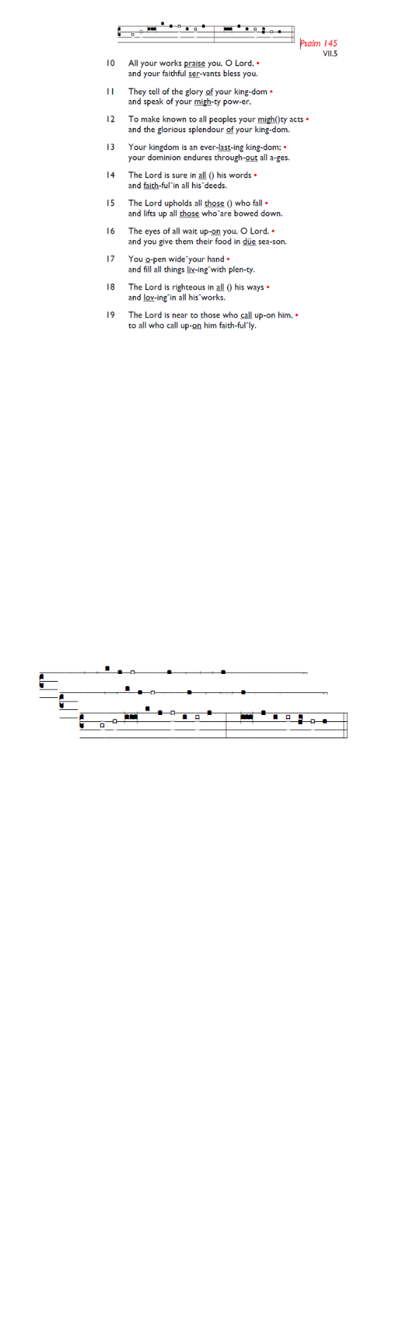
Weekly Events
- Monday-Friday 8.30am -8.50am: Morning Prayers.
- Craft Group @ Holy Trinity, Wednesday 25th March
from 1-3pm, final session.
- Thursday, Eucharist 10-11am, Bible Studies
11am – 12noon.
- There will be no Spanish class on 19th & 26th March.
Next session, Thursday 2nd April.

Fridays in Lent – 6pm: Stations of the Cross, a simple, prayerful devotion walking with Christ in his Passion.

Coming up
Monday, March 23rd, Tooting Methodist Church (39 Longmead Rd) at 2.30pm, Annual Daffodil Rally. All welcome to join in.

Thursday, March 26th 6.30pm. HMP Wandsworth 175th Anniversary Service at Southwark Cathedral. If you would like to attend, please email the church office to request the code for booking, registration is essential.

Sun 29th Mar, 3pm: On Palm Sunday, a Prelude to Holy Week & Easter Concert is at All Saints Church, Tooting, SW17 8DQ
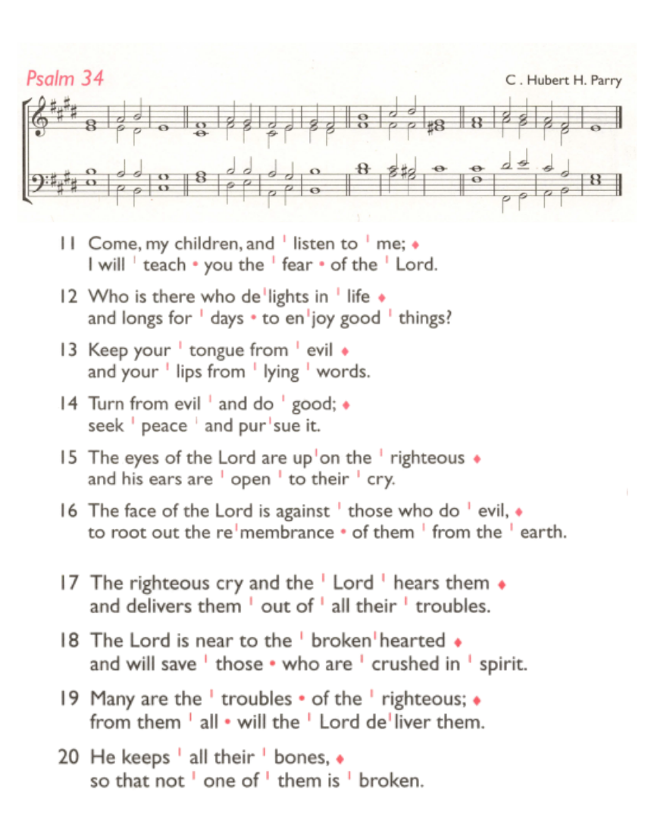
Palm Sunday. 29th March.
To join the longer Palm Sunday procession, servers etc should be prepared to leave St Augustine's at 10.30am to walk down to the corner of Lambeth Cemetery and Broadwater Road. For everybody else processing, please meet directly at 10.45am on the same corner. For those who do not wish to walk so far, please meet outside St Augustine's front gates at 11am where we will process around to the car park entrance and then into the church.

Confessions: The Vicar is available at our sister church,
Holy Trinity Church, 74 Trinity Road, to hear formal confessions in the Chapel. Sat, 21st, 28th March All between 6.30pm-7pm

Save the date
Sat 9th May - St Augustine's Away Day 10am- 3pm (coffee from 9.30am; includes lunch). Venue tbc.

Those who have asked for prayers:
Thelma Benjamin, Gene Bovell, Aileen Brewley, Fitzgerald Brewley, Gloria Ellis Clarke, Yvonne Clarke, Oscar Sam Carrol, Kathleen Cummings, Jennifer Donahue, Kenny Farrell, Shirly Lynch, Shanthi Nesaraj, Horatio Obodai, Esther Persaud, Tina Roberts, Olivia Schulz, Orville Simpson, Thelma Simpson, Mark Sinclair, Delce Taylor, Louisa Upjohn, Idene Waithe, Eula Watson, Velda Welch.

Contacts & Church Office:
Administrator, Church Notices & Bookings:
Zorah Baig 020 8772 4454
churchoffice@uppertooting.net
The Revd Angela Rayner: (Vicar) 07385 181103
vicar@uppertooting.net
The Revd Sarah Whitehouse (Assistant Priest)
sarah@uppertooting.net
Claudette Dey – Pastoral Lay Minister 07979 598889
Jacqueline Obodai– Churchwarden. 07956 337643
jackieo12@live.com
Idene Waithe –Churchwarden. 07883 421147
murmaid47@outlook.com
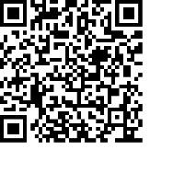
Steve Payne – Buildings Manager 07885 706637

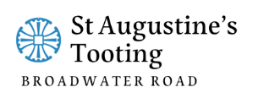

11am Parish Eucharist
15th March 2026 Mothering Sunday

Celebrant: The Revd Dorothy Pennicooke
Preacher: The Revd Dorothy Pennicooke

Readers: Helen Duxbury, Doris Pappoe
Intercessions: Tyrone Payne
Greeters: Ethel Addo, Shirley Sandiford

Hymns
Processional 175: God of mercy, God of grace
Psalm 34: 11-20
Offertory 120: Father, hear the prayer we offer
Communion 313: Lord of all hopefulness
Recessional 467: Tell out, my soul

