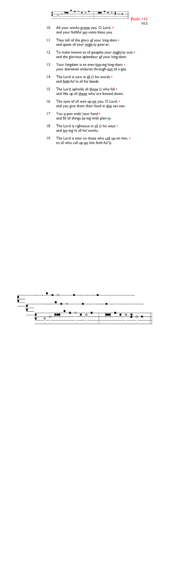
Weekly Events
- Monday-Friday 8.30am -8.50am: Morning Prayers.
- Craft Group @ Holy Trinity, Wednesday 25th March from
1-3pm. Final session.
- Thursday, Eucharist 10-11am, Bible Studies
11am – 12noon. (no Spanish class on 26th March).
Next class April 2nd.

Fridays in Lent – 6pm: Stations of the Cross, a simple, prayerful devotion walking with Christ in his Passion.

Monday, March 23rd, Tooting Methodist Church (39 Longmead Rd) at 2.30pm, Annual Daffodil Rally. All welcome to join in.

Thursday, March 26th 6.30pm. HMP Wandsworth 175th Anniversary Service at Southwark Cathedral. If you would like to attend, please email the church office to request the code for booking, registration is essential.

Palm Sunday. 29th March.
To join the longer Palm Sunday procession, servers etc should be prepared to leave St Augustine's at 10.30am to walk down to the corner of Lambeth Cemetery and Broadwater Road. For everybody else processing, please meet directly at 10.45am on the same corner. For those who do not wish to walk so far, please meet outside St Augustine's front gates at 11am where we will process around to the car park entrance and then into the church.

Also on Sun 29th March, 3pm: On Palm Sunday, a Prelude to Holy Week & Easter Concert is at All Saints Church, Tooting, SW17 8DQ

Sunday 12th April @ Holy Trinity Church, Memorial Service for Bernice Broggio from 6.30pm – 7.30pm, followed by refreshments. All welcome.

Save the date
Sat 9th May - St Augustine's Away Day 10am- 3pm (coffee from 9.30am; includes lunch). Venue tbc.

Clocks go forward next Sunday 29th March. Don’t Forget!


Those who have asked for prayers:
Thelma Benjamin, Gene Bovell, Aileen Brewley, Fitzgerald Brewley, Gloria Ellis Clarke, Yvonne Clarke, Oscar Sam Carrol, Kathleen Cummings, Jennifer Donahue, Kenny Farrell, Paul Harris, Shirly Lynch, Shanthi Nesaraj, Horatio Obodai, Esther Persaud, Tina Roberts, Olivia Schulz, Orville Simpson, Thelma Simpson, Mark Sinclair, Delce Taylor, Louisa Upjohn, Idene Waithe, Eula Watson, Velda Welch.

Contacts & Church Office:
Administrator, Church Notices & Bookings:
Zorah Baig 020 8772 4454
churchoffice@uppertooting.net
The Revd Angela Rayner: (Vicar) 07385 181103
vicar@uppertooting.net
The Revd Sarah Whitehouse (Assistant Priest)
sarah@uppertooting.net
Claudette Dey – Pastoral Lay Minister 07979 598889
Jacqueline Obodai– Churchwarden. 07956 337643
jackieo12@live.com
Idene Waithe –Churchwarden. 07883 421147
murmaid47@outlook.com

Steve Payne – Buildings Manager 07885 706637


11am Parish Eucharist
22nd March 2026 Lent 5

Celebrant: The Revd Angela Rayner
Preacher: Ethan Glacklin-McColgan

Readers: Ethel Addo, Jeremy Clarke
Intercessions: Steve Payne
Greeters: Helen Duxbury, Ethel Addo

Hymns
Processional 303: Lift high the Cross verses 1,3,5,7,9 & 11
Psalm 130
Offertory 10: All for Jesus
Communion 159: Glory be to Jesus
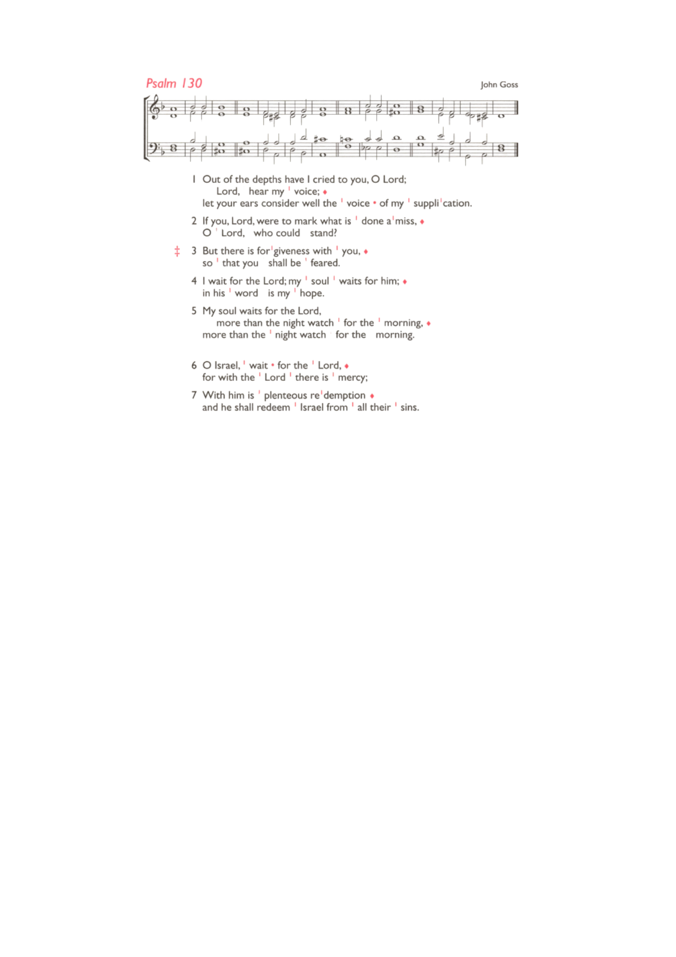
Recessional 255: It is a thing most wonderful

Holy Week Services. 29th March – 5th April
Holy Monday - Wednesday, March 30th – 1st April 6.30pm Eucharist followed by simple shared lunch @ 7pm.
Maundy Thursday, 2nd April, 8pm onwards Eucharist and Watch of Prayer.
Good Friday, 3rd April 12.30pm. Procession of Hope, starting at Chapel Square. 2pm Service of the Cross.
Easter Vigil, Saturday 4th April 8pm – Fire Eucharist & Fizz.
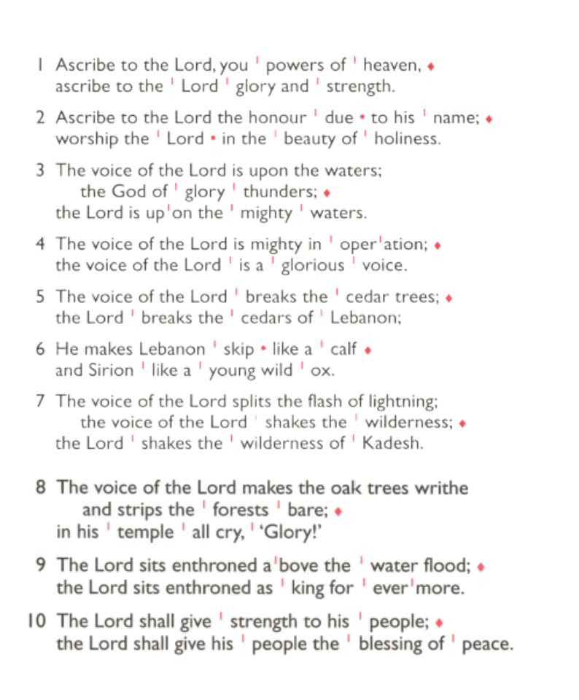
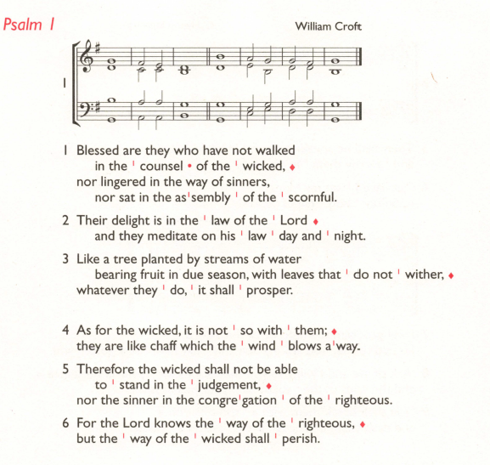
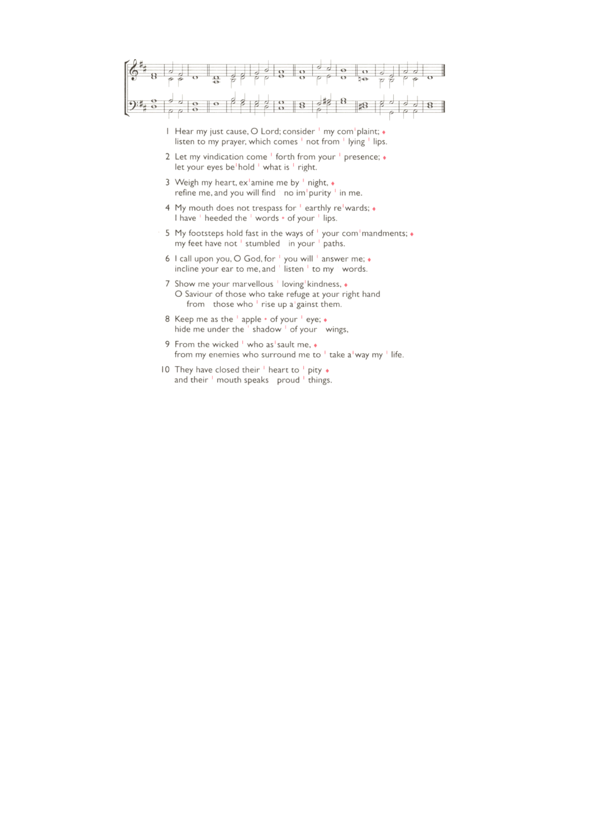
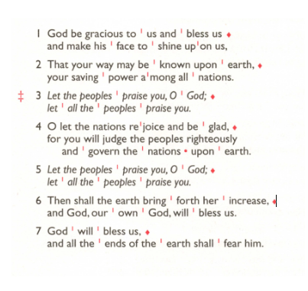
Easter Day, Sunday 5th April, 11am Easter Service followed by Easter Egg Hunt.

