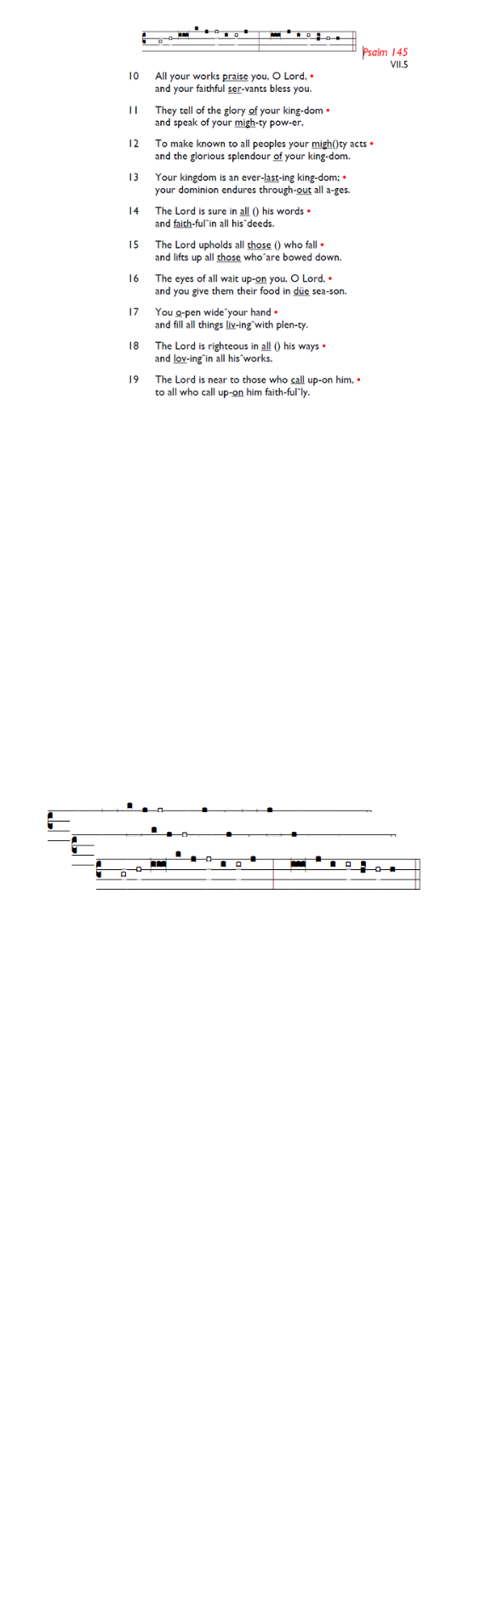
Weekly Events
- Monday-Friday 8.30am -8.50am: Morning Prayers.
- Thursday, Eucharist 10-11am, Bible Studies
11am – 12noon. Spanish Class, 12noon -1.15pm.

Today: Palm Sunday Eucharist & short procession.
To join the procession, meet on corner of Lambeth Cemetery and Broadwater Road at 10.45am.

ALSO TODAY, 3pm, a Prelude to Holy Week & Easter Concert is at All Saints Church, Tooting, SW17 8DQ

Coming up
Sunday 12th April @ Holy Trinity Church, Memorial Service for Bernice Broggio from 6.30pm – 7.30pm, followed by refreshments. All welcome.

Wednesday 15th April, PCC meeting, 7-8pm.

Sunday 19th April: Stories of Identity & Inclusions. St George’s Day Celebration. All Saints Church, Kingston,
4-7pm. Market Place, Kingston upon Thames, KT1 1JP.

Save the date
Saturday 9th May - St Augustine's Away Day 10am- 3pm (coffee from 9.30am; includes lunch). Venue tbc.

Bishop Christopher, the Bishop of Southwark, will be retiring this summer. The Diocese want to hear everybody’s views about what you most value in a new Bishop. Fill out the survey here; it closes this week: is.gd/HaveYourSay2026

INEQE Safeguarding Group is currently conducting an independent safeguarding audit in Southwark Diocese. They have asked more people to share their views here: is.gd/INEQE2026 (closing 8/4/26).

Those who have asked for prayers:
Thelma Benjamin, Gene Bovell, Aileen Brewley, Fitzgerald Brewley, Gloria Ellis Clarke, Yvonne Clarke, Oscar Sam Carrol, Kathleen Cummings, Jennifer Donahue, Kenny Farrell, Shirly Lynch, Shanthi Nesaraj, Horatio Obodai, Esther Persaud, Tina Roberts, Olivia Schulz, Orville Simpson, Thelma Simpson, Mark Sinclair, Delce Taylor, Louisa Upjohn, Idene Waithe, Eula Watson, Velda Welch.

Contacts & Church Office:
Administrator, Church Notices & Bookings:
Zorah Baig 020 8772 4454
churchoffice@uppertooting.net
The Revd Angela Rayner: (Vicar) 07385 181103
vicar@uppertooting.net
The Revd Sarah Whitehouse (Assistant Priest)
sarah@uppertooting.net
Claudette Dey – Pastoral Lay Minister 07979 598889
Jacqueline Obodai– Churchwarden. 07956 337643
jackieo12@live.com
Idene Waithe –Churchwarden. 07883 421147
murmaid47@outlook.com

Steve Payne – Buildings Manager 07885 706637


11am Parish Eucharist
29th March 2026 Palm Sunday

Celebrant: The Revd Angela Rayner
Preacher: The Revd Angela Rayner

Reader: Sam Carrol
Intercessions: Jacqueline Obodai
Greeters: Ann Whelan Wilkes, Helen Duxbury

Hymns
Procession: Service Booklet: All Glory, Laud and Honour
Offertory 32: And now, O Father, mindful of the love
Communion 383: O love, how deep, how broad, how high
Recessional 536: We sing the praise of him who died

Holy Week
29th March – 5th April

Holy Monday & Wednesday, March 30th – 1st April
6.30pm Eucharist followed by simple shared lunch.

Maundy Thursday, 2nd April, 8pm onwards Eucharist and Watch of Prayer.

Good Friday, 3rd April 12.30pm. Procession of Hope, starting at Chapel Square. 2pm Service of the Cross.

Good Friday, Churches Together, 10.30am Worship & Witness, open air service behind Sainsburys in Balham.

Easter Vigil, Saturday 4th April 8pm – Fire Eucharist & Fizz.

Easter Day, Sunday 5th April, 11am Easter Service followed by Easter Egg Hunt.



