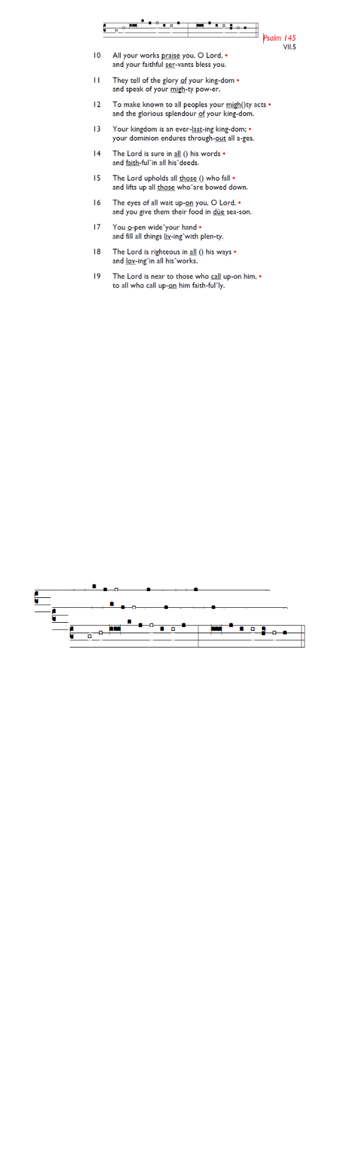
Weekly Events
Monday-Friday 8.30am -8.50am: Morning Prayers.
Thursday, Eucharist 10-11am, Bible Studies.
11am – 12noon. Spanish class Wednesday, 11th March
2-3pm (no Spanish class on 26th March). Craft Group @ Holy Trinity, Wednesday 11th & 25th March from 1-3pm.

TODAY 11.30am (ish): Holy Week Pre-Meeting. If you’d be interested in taking part or assisting in Holy Week with serving, reading, cooking, welcoming, or any other way, please be ready to meet after the Sunday service.

Fridays in Lent – 6pm: Stations of the Cross, a simple, prayerful devotion walking with Christ in his Passion.

Coming up
March 26th 6.30pm. HMP Wandsworth 175th Anniversary Service at Southwark Cathedral. If you would like to attend, please email the church office to request the code for booking, registration is essential.

Sun 29th Mar, 3pm: On Palm Sunday, a Prelude to Holy Week & Easter Concert is at All Saints Church, Tooting, SW17 8DQ
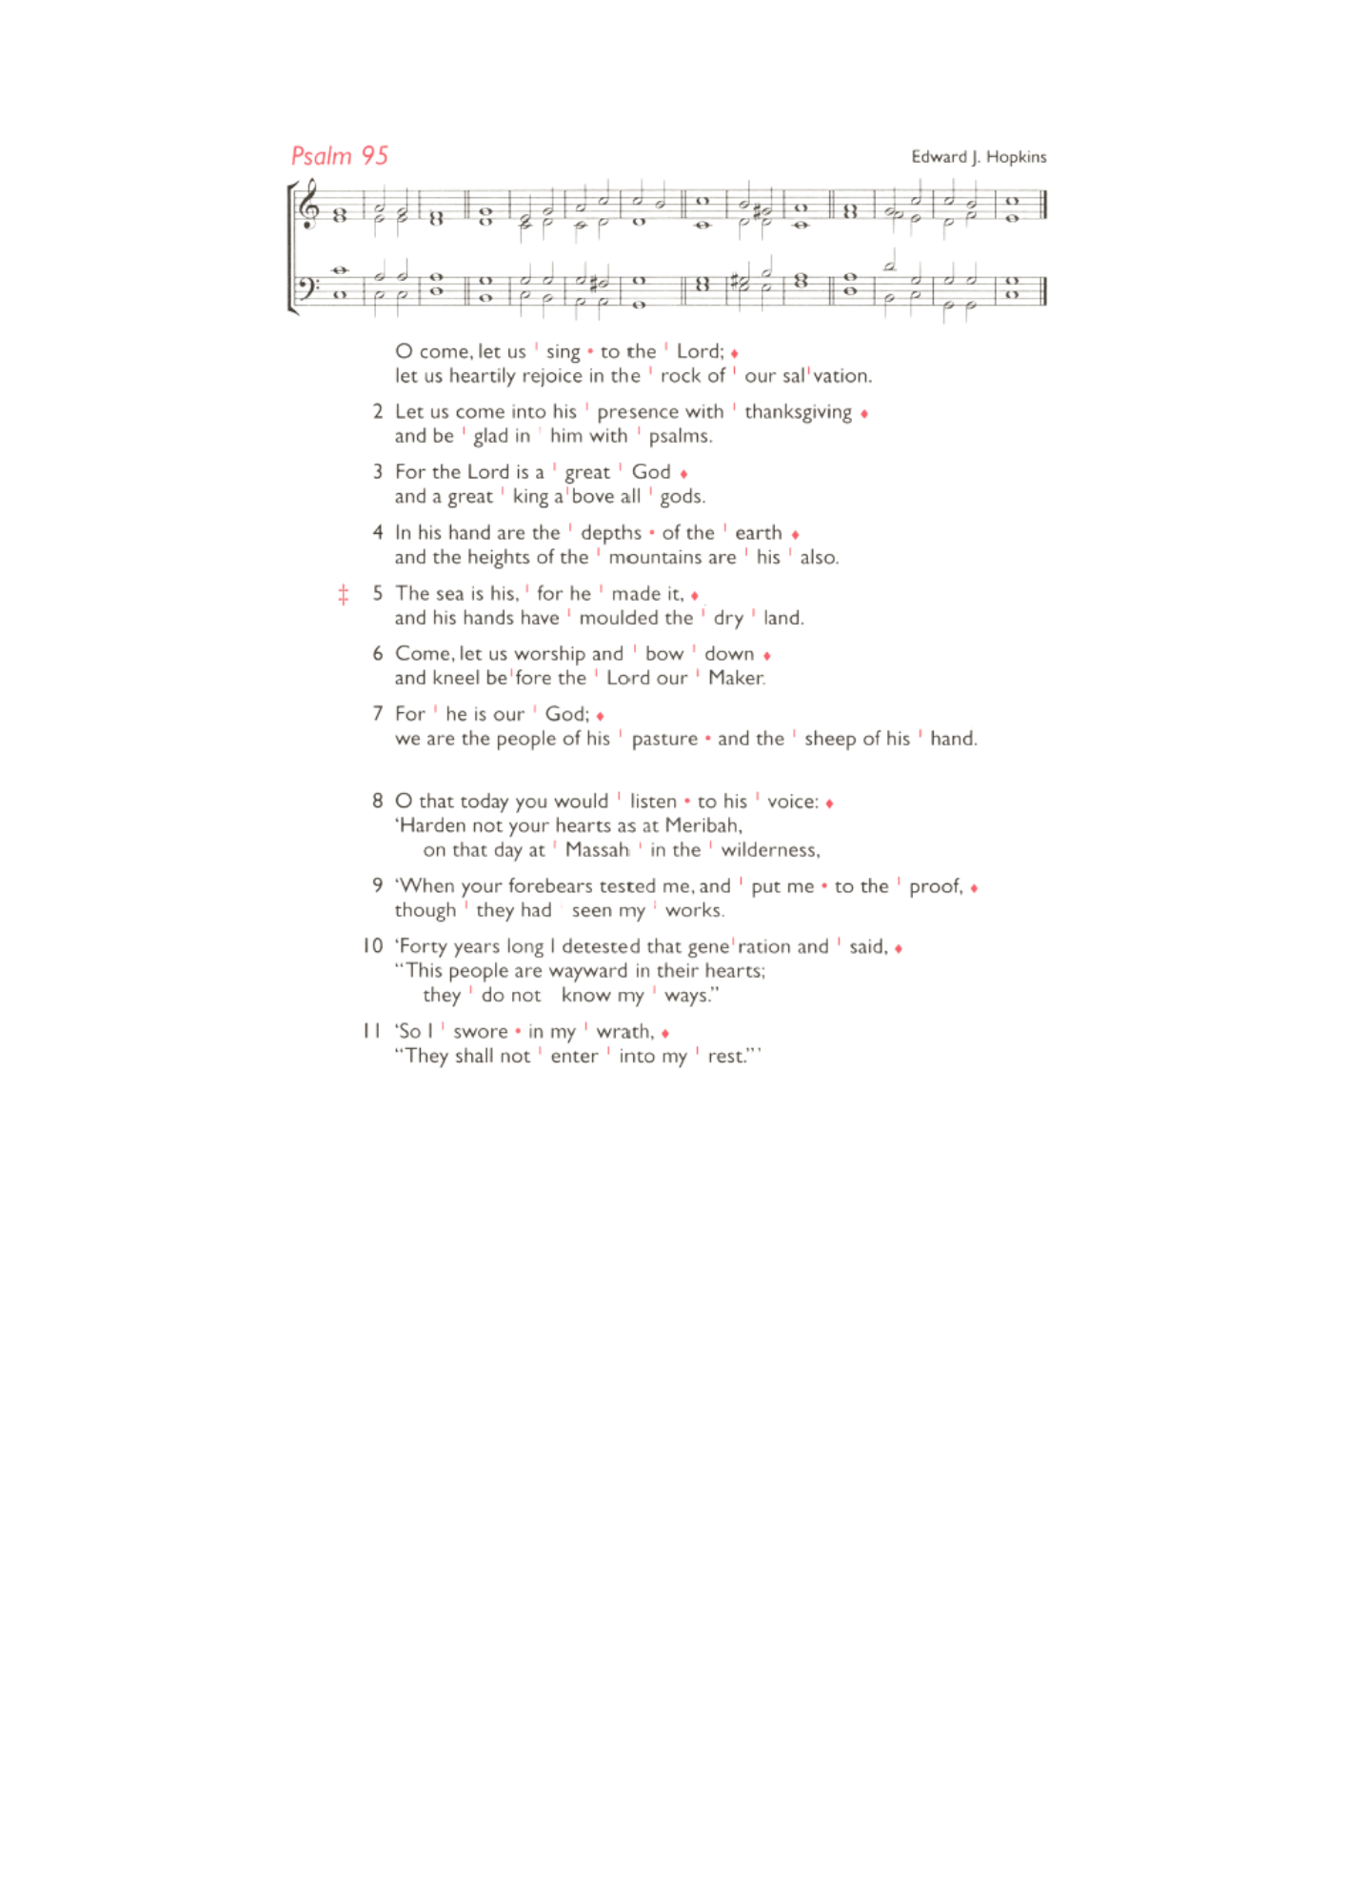
Confessions: The Vicar is available at our sister church,
Holy Trinity Church, 74 Trinity Road, to hear formal confessions in the Chapel. Sat 14th, 21st, 28th March All between 6.30pm-7pm

INEQE Safeguarding Group is conducting independent safeguarding audits across all Church of England dioceses. Southwark’s review takes place in June 2026. Parishioners are invited to complete an anonymous and confidential survey to share their views. Watch a video message from Bp Christopher about it: is.gd/SouthwarkAudit26
All survey responses go directly to INEQE’s audit team, not to the Diocese. The survey closes at 11.30pm on Wed 8 April 2026. Take part in the survey: is.gd/INEQE2026

Those who have asked for prayers:
Thelma Benjamin, Gene Bovell, Aileen Brewley, Fitzgerald Brewley, Gloria Ellis Clarke, Yvonne Clarke, Oscar Sam Carrol, Kathleen Cummings, Jennifer Donahue, Kenny Farrell, Shirly Lynch, Shanthi Nesaraj, Horatio Obodai, Esther Persaud, Tina Roberts, Olivia Schulz, Orville Simpson, Thelma Simpson, Mark Sinclair, Delce Taylor, Louisa Upjohn, Idene Waithe, Eula Watson, Velda Welch.

Contacts & Church Office:
Administrator, Church Notices & Bookings:
Zorah Baig 020 8772 4454
churchoffice@uppertooting.net
The Revd Angela Rayner: (Vicar) 07385 181103
vicar@uppertooting.net
The Revd Sarah Whitehouse (Assistant Priest)
sarah@uppertooting.net
Claudette Dey – Pastoral Lay Minister 07979 598889
Jacqueline Obodai– Churchwarden. 07956 337643
jackieo12@live.com
Idene Waithe –Churchwarden. 07883 421147
murmaid47@outlook.com
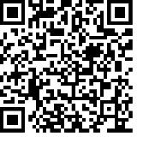
Steve Payne – Buildings Manager 07885 706637
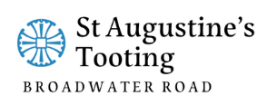

11am Parish Eucharist
8th March 2026 Lent 3

Celebrant: The Revd Angela Rayner
Preacher: The Revd Angela Rayner

Readers: Soma, Rachel Phillips
Intercessions: Sam Carrol
Greeters: Helen Duxbury, Jeremy Clarke

Hymns
Processional 15: All my hope on God is founded
Psalm 95
Offertory 343: My God, how wonderful thou art
Communion 437: Rock of ages
Recessional 425: Praise the Lord, ye heavens adore him

