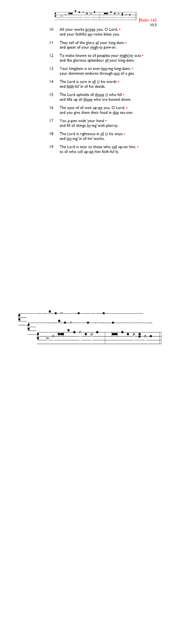
Weekly Events
- Monday-Friday 8.30am -8.50am: Morning Prayers.
- Thursday, Eucharist 10-11am, Bible Studies
11am – 12noon. Spanish Class, 12noon -1.15pm.

TODAY
Sunday 12th April @ Holy Trinity Church, Memorial Service for Bernice Broggio from 6.30pm – 7.30pm, followed by refreshments. All welcome.

Wednesday 15th April, PCC meeting, 7-8pm.

Save the date: Saturday 9th May - St Augustine's Away Day 10am- 3pm (coffee from 9.30am; includes lunch). Venue tbc.

Sunday 19th April: Stories of Identity & Inclusions. St George’s Day Celebration. All Saints Church, Kingston,
4-7pm. Market Place, Kingston upon Thames, KT1 1JP.

Saturday 9th May - St Augustine's Away Day 10am- 3pm (coffee from 9.30am; includes lunch). Venue tbc.

Ascension Day, Thursday 14th May 7-8pm.

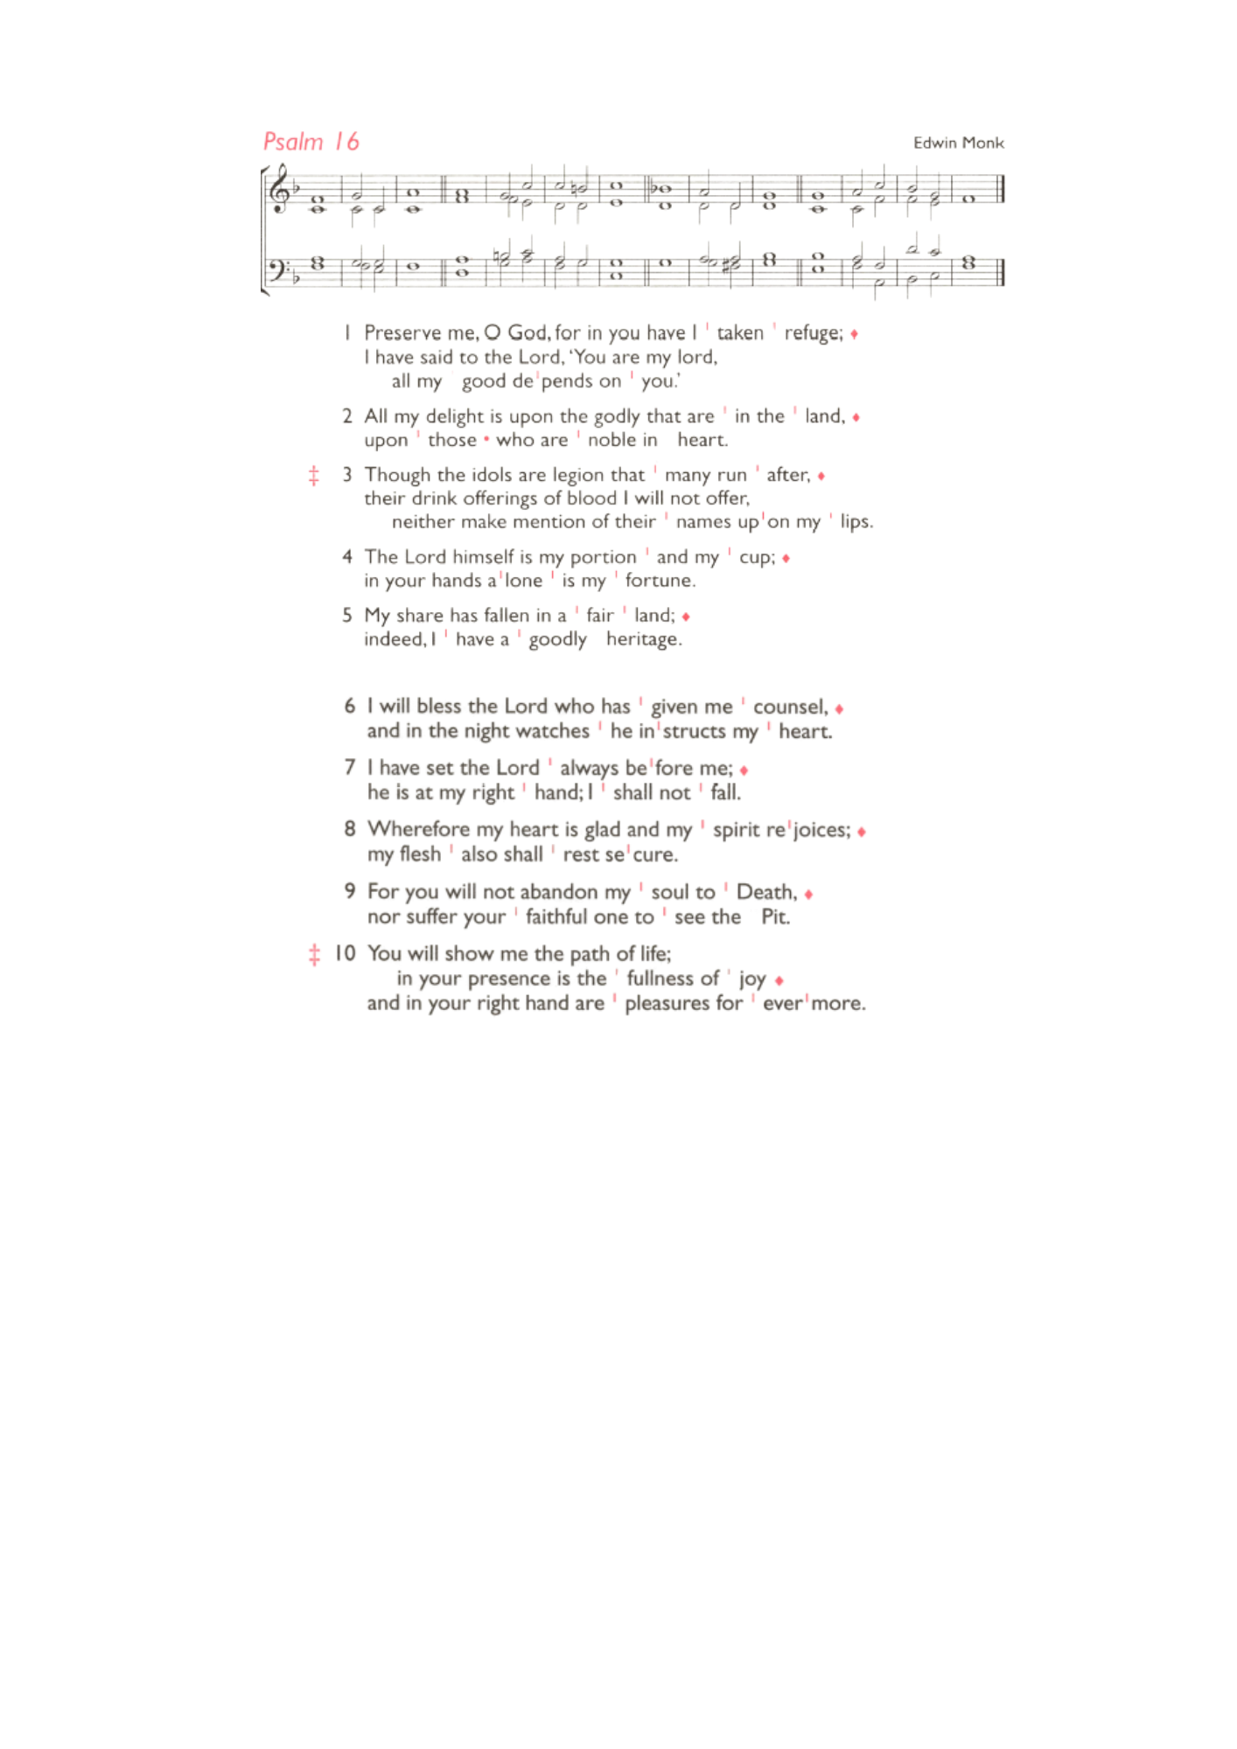
St Augustine's maintains an Electoral Roll; a list of those who have committed to regularly attending the church. If you have been worshipping here for 6 months or more, please do join. Those on the roll can stand for PCC election and vote at the Annual Meeting (24th May). To join, complete the form at is.gd/SAJoinRoll, or ask a welcomer for a paper copy

Sunday 24th May, APCM 12.45pm – 1.45pm.

Thank you to everybody who contributed in any way to our keeping of Holy Week and Easter. From those who prepared our worship and led us in prayer, to those who arranged flowers, music, cooking, cleaning, hospitality, and all the quiet acts of service behind the scenes. Your care and generosity made it possible for us to observe the Passion and to celebrate the joy of the Resurrection.

Those who have asked for prayers:
Thelma Benjamin, Gene Bovell, Aileen Brewley, Fitzgerald Brewley, Gloria Ellis Clarke, Yvonne Clarke, Oscar Sam Carrol, Kathleen Cummings, Jennifer Donahue, Kenny Farrell, Shirly Lynch, Shanthi Nesaraj, Horatio Obodai, Esther Persaud, Tina Roberts, Olivia Schulz, Orville Simpson, Thelma Simpson, Mark Sinclair, Delce Taylor, Louisa Upjohn, Idene Waithe, Eula Watson, Velda Welch.

Contacts & Church Office:
Administrator, Church Notices & Bookings:
Zorah Baig 020 8772 4454
churchoffice@uppertooting.net
The Revd Angela Rayner: (Vicar) 07385 181103
vicar@uppertooting.net
The Revd Sarah Whitehouse (Assistant Priest)
sarah@uppertooting.net
Claudette Dey – Pastoral Lay Minister 07979 598889
Jacqueline Obodai– Churchwarden. 07956 337643
jackieo12@live.com
Idene Waithe –Churchwarden. 07883 421147
murmaid47@outlook.com
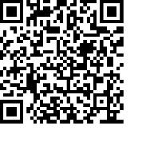
Steve Payne – Buildings Manager 07885 706637



11am Parish Eucharist
12th April 2026 Easter 2

Celebrant: The Revd Sarah Whitehouse
Preacher: The Revd Sarah Whitehouse

Reader: Jacqueline Obodai, Steve Payne
Intercessions: Ethel Addo
Greeters: Helen Duxbury, Steve Payne

Hymns
Introit 351: Now is eternal life
Psalm 16
Offertory 45: At the Lamb’s high feast, we sing
Communion 63: Blest are the pure in heart
Recessional 188: Guide me, O thou great Redeemer

