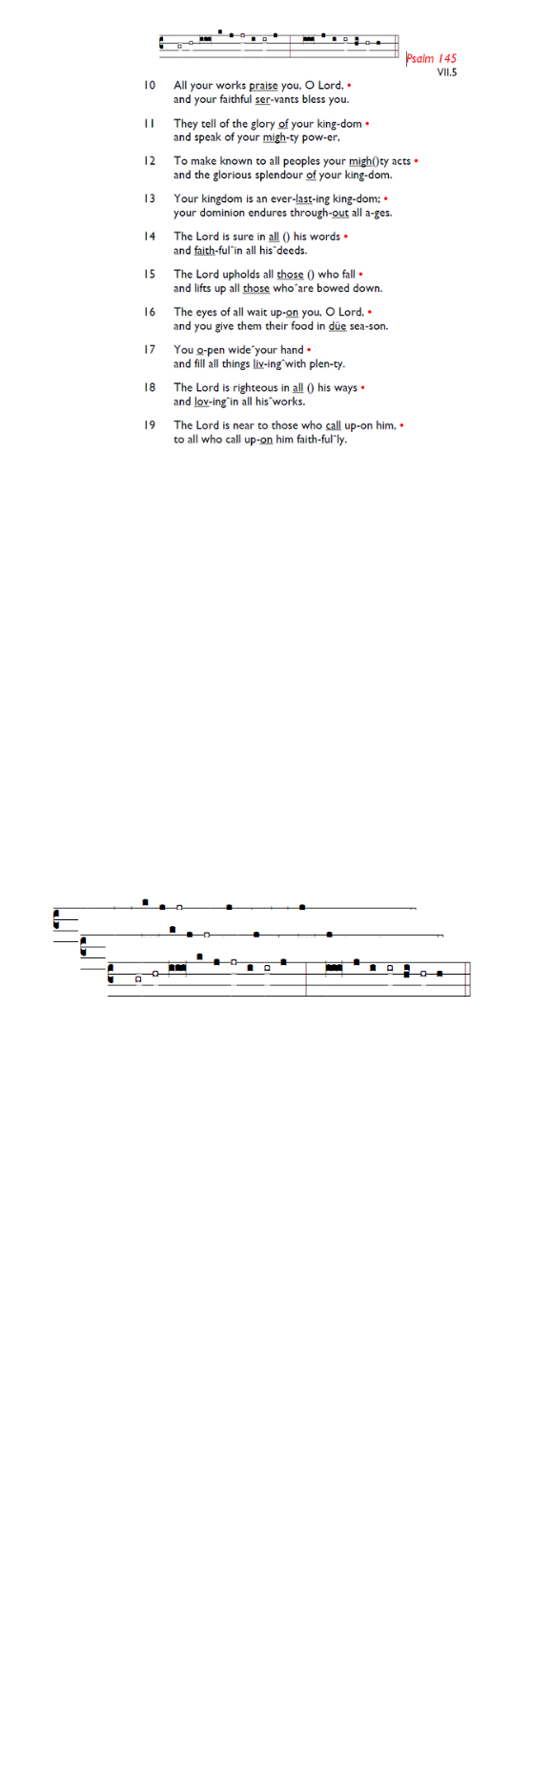
Weekly Events
- Monday-Friday 8.30am -8.50am: Morning Prayers.
- Thursday, Eucharist 10-11am, Bible Studies
11am – 12noon. Spanish Class, 12noon -1.15pm.

TODAY: Sunday 19th April: Stories of Identity & Inclusions. St George’s Day Celebration. All Saints Church, Kingston,
4-7pm. Market Place, Kingston upon Thames, KT1 1JP.

Saturday 25th April, 2.30-4.30pm ‘Spring Open Day’ @ Fishponds fields, Tooting SW17 7NW, entrance 91 Hebdon Rd. Various children’s activities and refreshments.

Save the date: Saturday 9th May - St Augustine's Away Day 10am- 3pm (coffee from 9.30am; includes lunch). Venue tbc.

Ascension Day, Thursday 14th May 7-8pm.

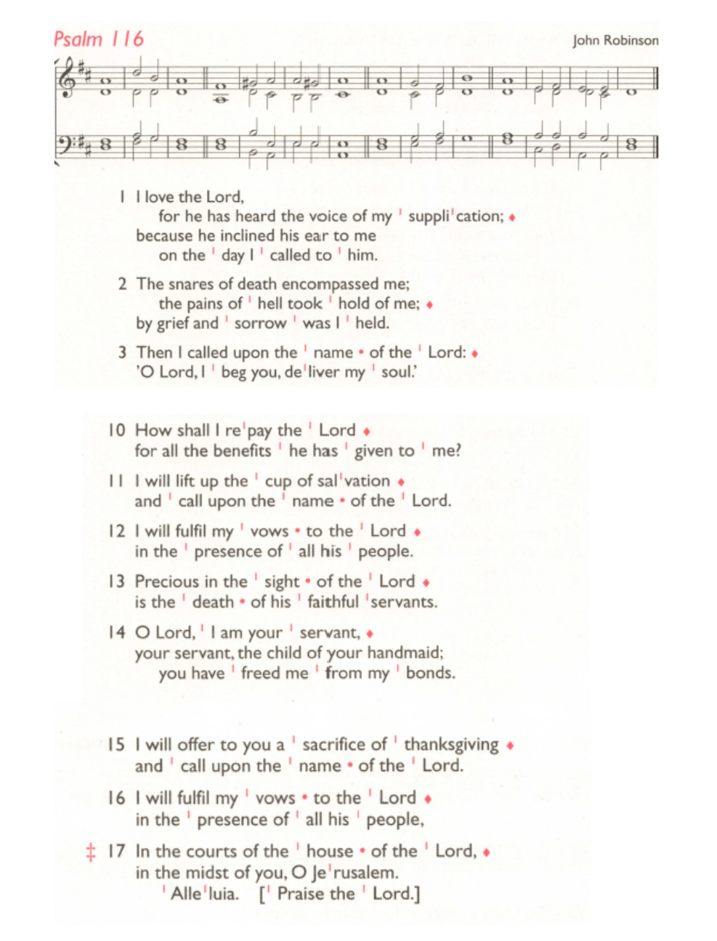
St Augustine's maintains an Electoral Roll; a list of those who have committed to regularly attending the church. If you have been worshipping here for 6 months or more, please do join. Those on the roll can stand for PCC election and vote at the Annual Meeting (24th May). To join, complete the form at is.gd/SAJoinRoll, or ask a welcomer for a paper copy.

Sunday 24th May, APCM 12.45pm – 1.45pm.

Those who have asked for prayers:
Thelma Benjamin, Gene Bovell, Aileen Brewley, Fitzgerald Brewley, Gloria Ellis Clarke, Yvonne Clarke, Oscar Sam Carrol, Kathleen Cummings, Jennifer Donahue, Kenny Farrell, Shirly Lynch, Shanthi Nesaraj, Horatio Obodai, Esther Persaud, Tina Roberts, Olivia Schulz, Orville Simpson, Thelma Simpson, Mark Sinclair, Delce Taylor, Louisa Upjohn, Idene Waithe, Eula Watson, Velda Welch.

Contacts & Church Office:
Administrator, Church Notices & Bookings:
Zorah Baig 020 8772 4454
churchoffice@uppertooting.net
The Revd Angela Rayner: (Vicar) 07385 181103
vicar@uppertooting.net
The Revd Sarah Whitehouse (Assistant Priest)
sarah@uppertooting.net
Claudette Dey – Pastoral Lay Minister 07979 598889
Jacqueline Obodai– Churchwarden. 07956 337643
jackieo12@live.com
Idene Waithe –Churchwarden. 07883 421147
murmaid47@outlook.com

Steve Payne – Buildings Manager 07885 706637



11am Parish Eucharist
19th April 2026 Easter 3

Celebrant: The Revd Obi Chike
Preacher: The Revd Obi Chike

Readers: Tyrone Payne, Helen Duxbury
Intercessions: Sam Carrol
Greeters: Ann Whelan Wilkes, Rachel Phillips

Hymns
Introit 509: This joyful Eastertide
Psalm 116: 1-3,19 end
Offertory 432: Rejoice, the Lord is King
Communion 299: Let us break bread together
Recessional 532: We have a gospel to proclaim

