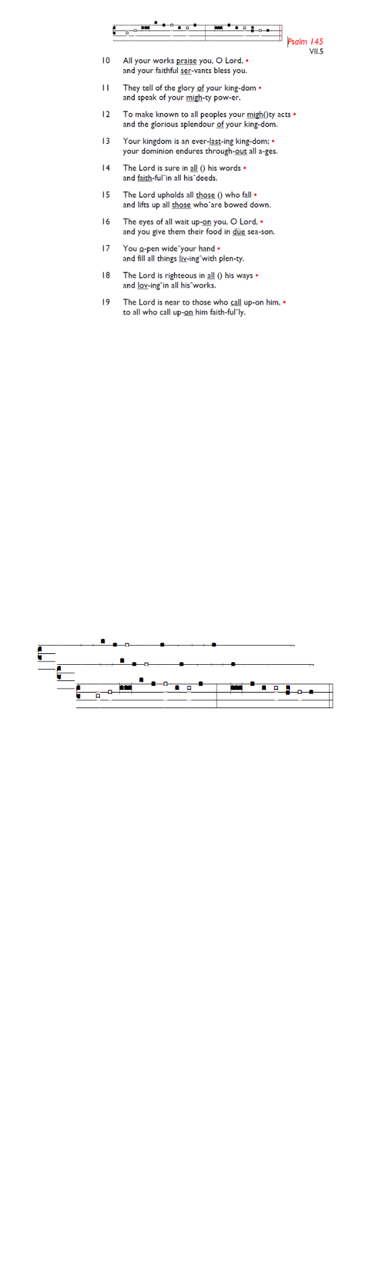
Weekly Events
- Monday-Friday 8.30am -8.50am: Morning Prayers.
- Thursday, Eucharist 10-11am, Bible Studies
11am – 12noon. Spanish Class, 12noon -1.15pm.

Tuesday 28th April, 6.30pm-8pm: Lecture at St Paul's Cathedral: William Tyndale and the making of the English Reformation. Booking required here: is.gd/Tyndale2026

Save the date: Saturday 9th May - St Augustine's Away Day 10am- 3pm (coffee from 9.30am; includes lunch). Venue tbc.

Christian Aid Week: Sunday 10th May – Saturday 16th May.

Ascension Day, Thursday 14th May 7-8pm followed by refreshments.

Look out for Formation Tuesdays, launching soon across our two churches, and beginning with the Bible Course at St
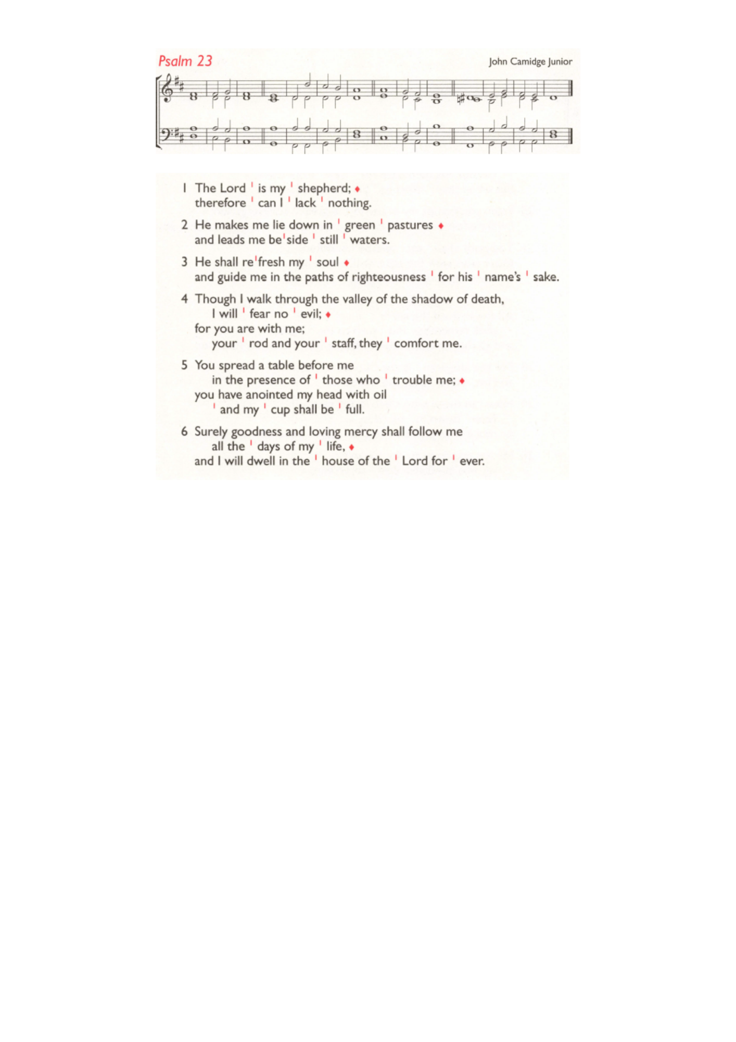
Augustine's (SW17 0EF) for 8 weeks from Tuesday May 26th at 7pm for a journey through the whole story of Scripture, helping you see how everything fits together from Genesis to Revelation with food and fellowship! Sign up here is.gd/Bible2026

St Augustine's maintains an Electoral Roll; a list of those who have committed to regularly attending the church. If you have been worshipping here for 6 months or more, please do join. Those on the roll can stand for PCC election and vote at the Annual Meeting (24th May). To join, complete the form at is.gd/SAJoinRoll, or ask a welcomer for a paper copy.

Sunday 24th May, APCM 12.45pm – 1.45pm.

Those who have asked for prayers:
Thelma Benjamin, Gene Bovell, Aileen Brewley, Fitzgerald Brewley, Gloria Ellis Clarke, Yvonne Clarke, Oscar Sam Carrol, Kathleen Cummings, Jennifer Donahue, Kenny Farrell, Shirly Lynch, Shanthi Nesaraj, Horatio Obodai, Esther Persaud, Tina Roberts, Olivia Schulz, Orville Simpson, Thelma Simpson, Mark Sinclair, Delce Taylor, Louisa Upjohn, Idene Waithe, Eula Watson, Velda Welch.

Contacts & Church Office:
Administrator, Church Notices & Bookings:
Zorah Baig 020 8772 4454
churchoffice@uppertooting.net
The Revd Angela Rayner: (Vicar) 07385 181103
vicar@uppertooting.net
The Revd Sarah Whitehouse (Assistant Priest)
sarah@uppertooting.net
Claudette Dey – Pastoral Lay Minister 07979 598889
Jacqueline Obodai– Churchwarden. 07956 337643
jackieo12@live.com
Idene Waithe –Churchwarden. 07883 421147
murmaid47@outlook.com

Steve Payne – Buildings Manager 07885 706637
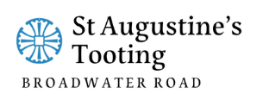

11am Parish Eucharist
26th April 2026 Easter 4

Celebrant: The Revd Dorothy Pennicooke
Preacher: The Revd Dorothy Pennicooke

Readers: Jay Bonney, Claudette Dey
Intercessions: Jacqueline Obodai
Greeters: Helen Duxbury, Paula Stevenson

Hymns
Introit 186: Great is thy Faithfulness
Psalm 23
Offertory 237: I will sing the wondrous story
Communion 434: Restore, O Lord, the honour of your name
Recessional 46: At the name of Jesus. Vs 1,3,5 & 7)

