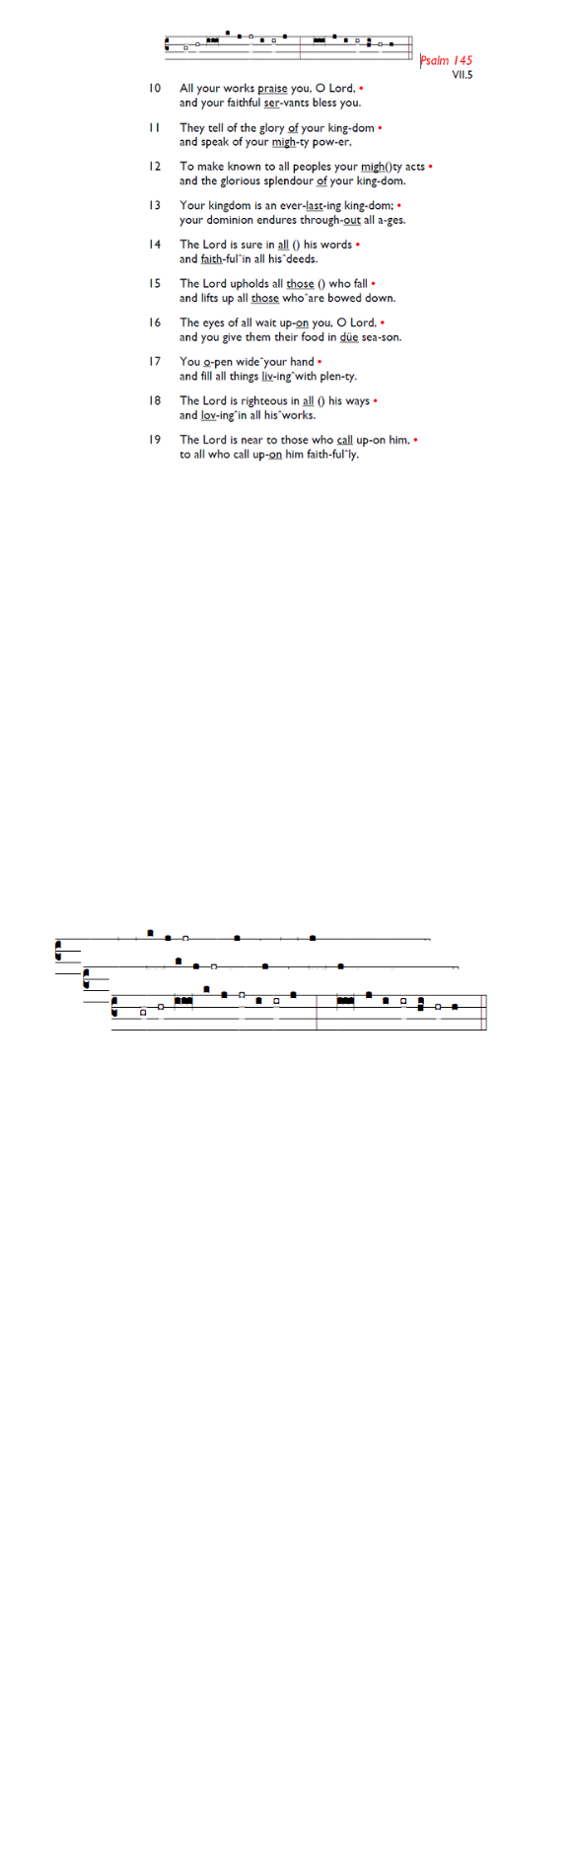
Weekly Events
- Monday-Friday 8.30am -8.50am: Morning Prayers.
- Thursday, Eucharist 10-11am, Bible Studies
11am – 12noon. Spanish Class, 12noon -1.15pm.
All Spanish Classes are cancelled for April and will
resume in May.

Coming up
Sunday 12th April @ Holy Trinity Church, Memorial Service for Bernice Broggio from 6.30pm – 7.30pm, followed by refreshments. All welcome.

Wednesday 15th April, PCC meeting, 7-8pm.

Save the date
Sunday 19th April: Stories of Identity & Inclusions. St George’s Day Celebration. All Saints Church, Kingston,
4-7pm. Market Place, Kingston upon Thames, KT1 1JP.

Saturday 9th May - St Augustine's Away Day 10am- 3pm (coffee from 9.30am; includes lunch). Venue tbc.

Ascension Day, Thursday 14th May.

Sunday 24th May, APCM 12.45pm – 1.45pm.

Those who have asked for prayers:

Thelma Benjamin, Gene Bovell, Aileen Brewley, Fitzgerald Brewley, Gloria Ellis Clarke, Yvonne Clarke, Oscar Sam Carrol, Kathleen Cummings, Jennifer Donahue, Kenny Farrell, Shirly Lynch, Shanthi Nesaraj, Horatio Obodai, Esther Persaud, Tina Roberts, Olivia Schulz, Orville Simpson, Thelma Simpson, Mark Sinclair, Delce Taylor, Louisa Upjohn, Idene Waithe, Eula Watson, Velda Welch.

Contacts & Church Office:
Administrator, Church Notices & Bookings:
Zorah Baig 020 8772 4454
churchoffice@uppertooting.net
The Revd Angela Rayner: (Vicar) 07385 181103
vicar@uppertooting.net
The Revd Sarah Whitehouse (Assistant Priest)
sarah@uppertooting.net
Claudette Dey – Pastoral Lay Minister 07979 598889
Jacqueline Obodai– Churchwarden. 07956 337643
jackieo12@live.com
Idene Waithe –Churchwarden. 07883 421147
murmaid47@outlook.com

Steve Payne – Buildings Manager 07885 706637



11am Parish Eucharist
5th April 2026 Easter Sunday

Celebrant: The Revd Angela Rayner
Preacher: The Revd Angela Rayner

Reader: Russell Yates, Bernicee Baird-Dundas
Intercessions: Doris Pappoe
Greeters: Jeremy Clark, Helen Duxbury

Hymns
Processional 267: Jesus Christ is risen today
Gradual 272: Jesus lives, thy terrors now
Offertory 532: We have a gospel to proclaim
Communion: Surrexit Christus
Recessional 503: Thine be the glory

