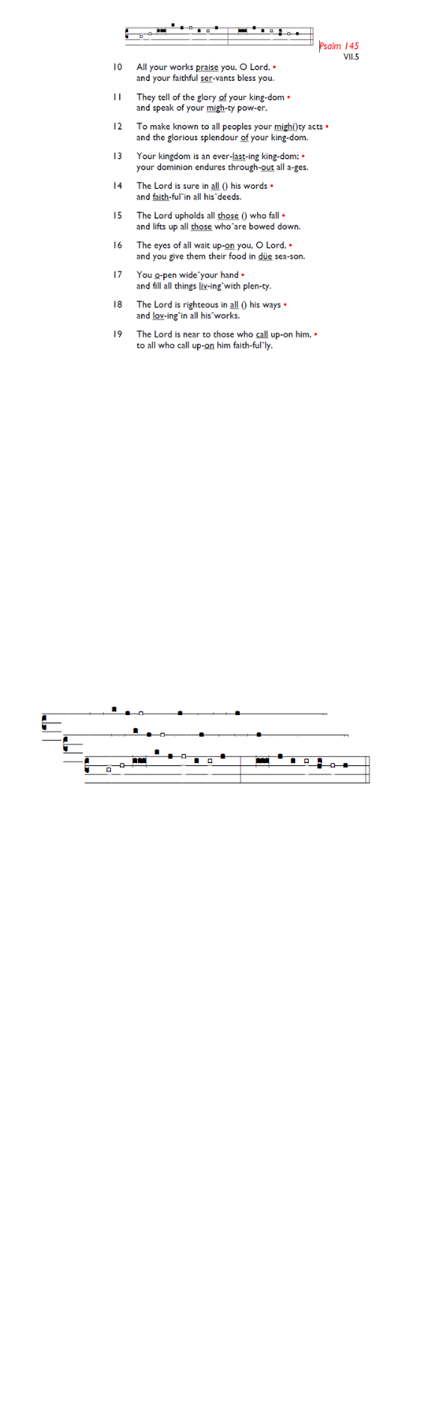
Weekly Events
- Monday-Friday 8.30am -8.50am: Morning Prayers.
- Thursday, Eucharist 10-11am, Bible Studies
11am – 12noon. Spanish Class, 12noon -1.15pm.

This Week
Morning Ascension Day @ Holy Trinity Church 14th May 6.50am-8am: Early morning Ascension Day service with fizz, bubbles, croissants, and all things that rise,
including Jesus in a cloud of glory!

Evening Ascension Day @ St Augustine’s, Thursday 14th May 7-8pm followed by bubbly, refreshments & fireworks.

Coming Soon
Look out for Formation Tuesdays, launching soon across our two churches, and beginning with the Bible Course at St
Augustine's (SW17 0EF) for 8 weeks from Tuesday May 26th at 7pm for a journey through the whole story of Scripture, helping you see how everything fits together from Genesis to Revelation with food and fellowship! Sign up here is.gd/Bible2026

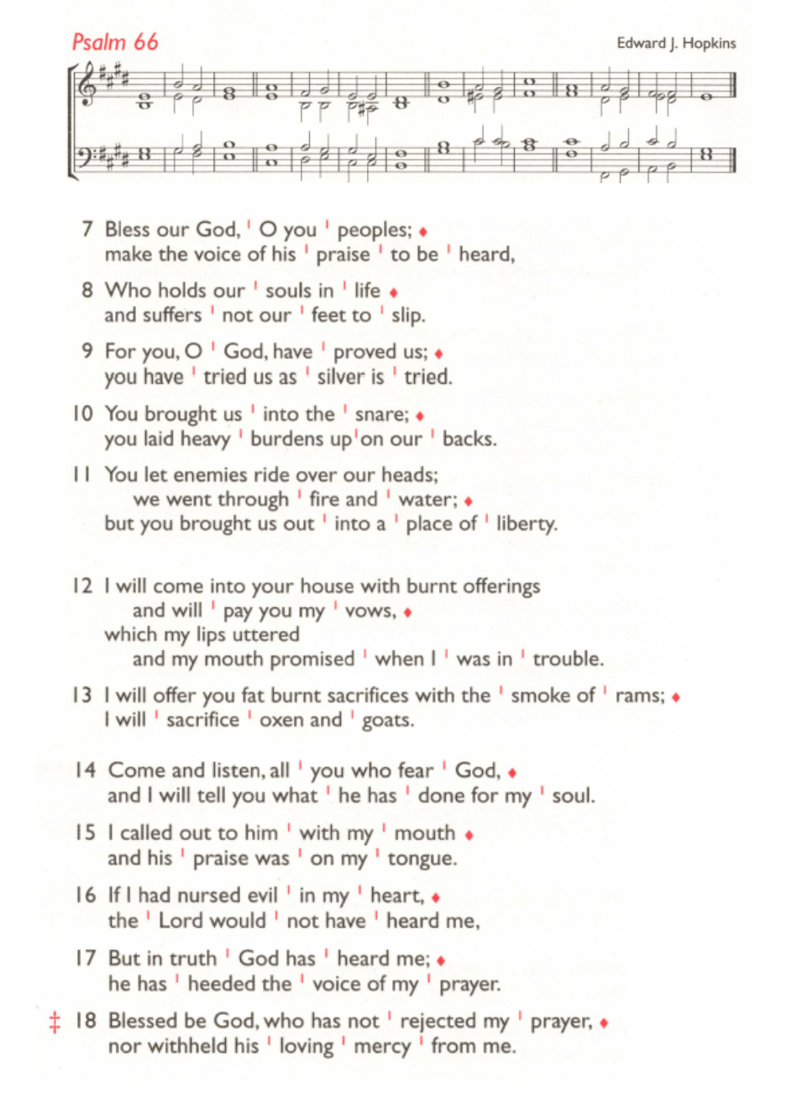
St Augustine's maintains an Electoral Roll; a list of those who have committed to regularly attending the church. If you have been worshipping here for 6 months or more, please do join. Those on the roll can stand for PCC election and vote at the Annual Meeting (24th May). To join, complete the form at is.gd/SAJoinRoll, or ask a welcomer for a paper copy.

Sunday 24th May, 11am Pentecost Service, followed by APCM 12.45pm – 1.45pm.

Thursdays Eucharist services. There will be no Eucharist Service on Thursday 14th & 21st May. As Angela will be away on 21st May, the Bible Study session will be lay led.
There will be no Eucharist service on June 4th also.

Those who have asked for prayers:
Thelma Benjamin, Gene Bovell, Aileen Brewley, Fitzgerald Brewley, Gloria Ellis Clarke, Yvonne Clarke, Oscar Sam Carrol, Kathleen Cummings, Jennifer Donahue, Kenny Farrell, Shirly Lynch, Shanthi Nesaraj, Horatio Obodai, Esther Persaud, Tina Roberts, Olivia Schulz, Orville Simpson, Thelma Simpson, Mark Sinclair, Delce Taylor, Louisa Upjohn, Idene Waithe, Eula Watson, Velda Welch.

Contacts & Church Office:
Administrator, Church Notices & Bookings:
Zorah Baig 020 8772 4454
churchoffice@uppertooting.net
The Revd Angela Rayner: (Vicar) 07385 181103
vicar@uppertooting.net
The Revd Sarah Whitehouse (Assistant Priest)
sarah@uppertooting.net
Claudette Dey – Pastoral Lay Minister 07979 598889
Jacqueline Obodai– Churchwarden. 07956 337643
jackieo12@live.com
Idene Waithe –Churchwarden. 07883 421147
murmaid47@outlook.com
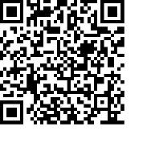
Steve Payne – Buildings Manager 07885 706637



11am Parish Eucharist
10th May 2026 Easter 6

Celebrant: The Revd Sarah Whitehouse
Preacher: The Revd Sarah Whitehouse

Readers: Richard Decker, Doris Pappoe
Intercessions: Steve Payne
Greeters: Ethel Addo, Paula Stevenson

Hymns
Introit 282: Jesu, where’er thy people meet
Psalm 66:7-end
Offertory 321: Love divine, all loves excelling
Communion 319: Lord, we come to ask your healing
Recessional 352: Now let us from this table rise

