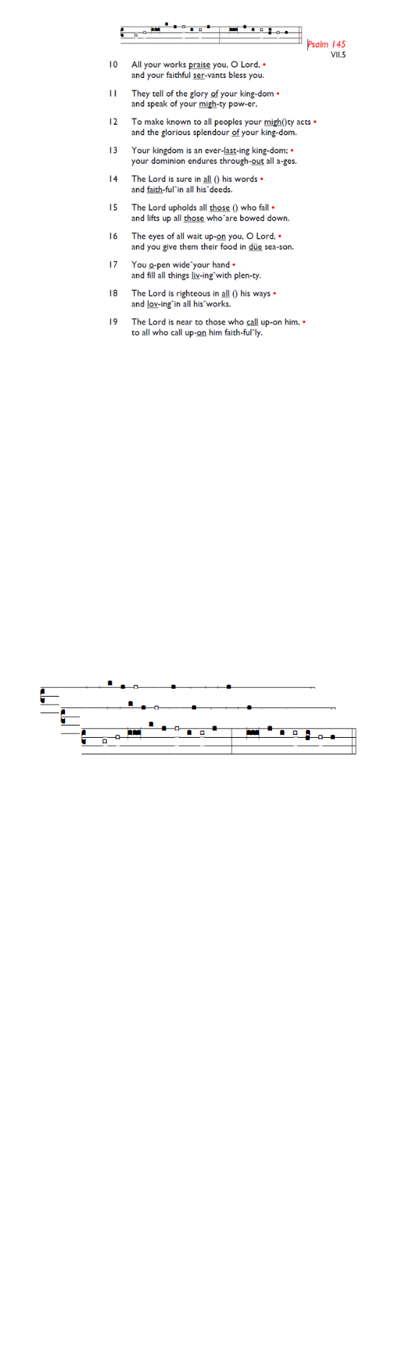
Weekly Events
- Monday-Friday 8.30am -8.50am: Morning Prayers.
- Thursday, Eucharist 10-11am, Bible Studies
11am – 12noon. Spanish Class, 12noon -1.15pm.
28th May, then 11th & 25th June
Coming Soon
Look out for Formation Tuesdays, launching soon across our two churches, and beginning with the Bible Course at St
Augustine's (SW17 0EF) for 8 weeks from Tuesday May 26th at 7pm for a journey through the whole story of Scripture, helping you see how everything fits together from Genesis to Revelation with food and fellowship! Sign up here is.gd/Bible2026

St Augustine's maintains an Electoral Roll; a list of those who have committed to regularly attending the church. If you have been worshipping here for 6 months or more, please do join. Those on the roll can stand for PCC election and vote at the Annual Meeting (24th May). To join, complete the form at is.gd/SAJoinRoll, or ask a welcomer for a paper copy.
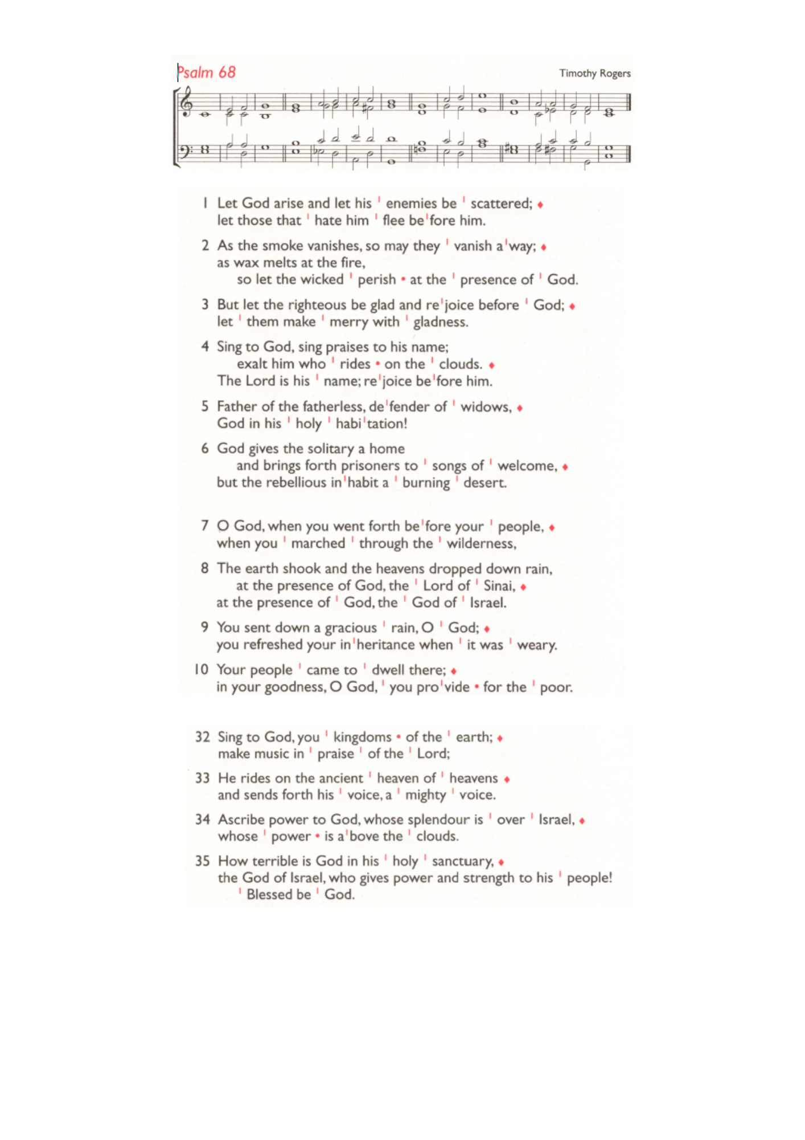


Next Sunday 24th May, 11am Pentecost Service, followed by APCM 12.45pm – 1.45pm.

Thursday’s Eucharist Services. There will be no Eucharist Service on Thursday 21st May as Angela will be away, the Bible Study session will be lay led.
There will be no Eucharist service on June 4th.

PCC Meeting – Monday 15th June 7.30pm.

Southwark Diocese – Sign up monthly newsletter/events. If anyone is interested to receive this online, please refer to the links below.
https://mailchi.mp/southwark/discipleship-news
https://southwark.anglican.org/missionministry/ministry/discipleship-ministry/
Those who have asked for prayers:
Thelma Benjamin, Gene Bovell, Aileen Brewley, Fitzgerald Brewley, Gloria Ellis Clarke, Yvonne Clarke, Oscar Sam Carrol, Kathleen Cummings, Jennifer Donahue, Kenny Farrell, Shirly Lynch, Shanthi Nesaraj, Horatio Obodai, Esther Persaud, Tina Roberts, Olivia Schulz, Orville Simpson, Thelma Simpson, Mark Sinclair, Delce Taylor, Louisa Upjohn, Idene Waithe, Eula Watson, Velda Welch.

Contacts & Church Office:
Administrator, Church Notices & Bookings:
Zorah Baig 020 8772 4454
churchoffice@uppertooting.net
The Revd Angela Rayner: (Vicar) 07385 181103
vicar@uppertooting.net
The Revd Sarah Whitehouse (Assistant Priest)
sarah@uppertooting.net
Claudette Dey – Pastoral Lay Minister 07979 598889
Jacqueline Obodai– Churchwarden. 07956 337643
jackieo12@live.com
Idene Waithe –Churchwarden. 07883 421147
murmaid47@outlook.com
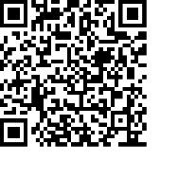
Steve Payne – Buildings Manager 07885 706637

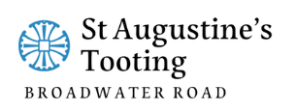

11am Parish Eucharist
17th May 2026 Easter 7

Celebrant: The Revd Angela Rayner
Preacher: The Revd Angela Rayner

Readers: Soma, Neil Yates O’Brien
Intercessions: Doris Pappoe
Greeters: Helen Duxbury, Russell Yates

Hymns
Introit 94: Come, let us join our cheerful songs
Psalm 68: 1-10
Offertory 192: Hail, thou once despised Jesus
Communion 391: O thou, who at thy Eucharist
Recessional 13: All hail the power of Jesus’ name

