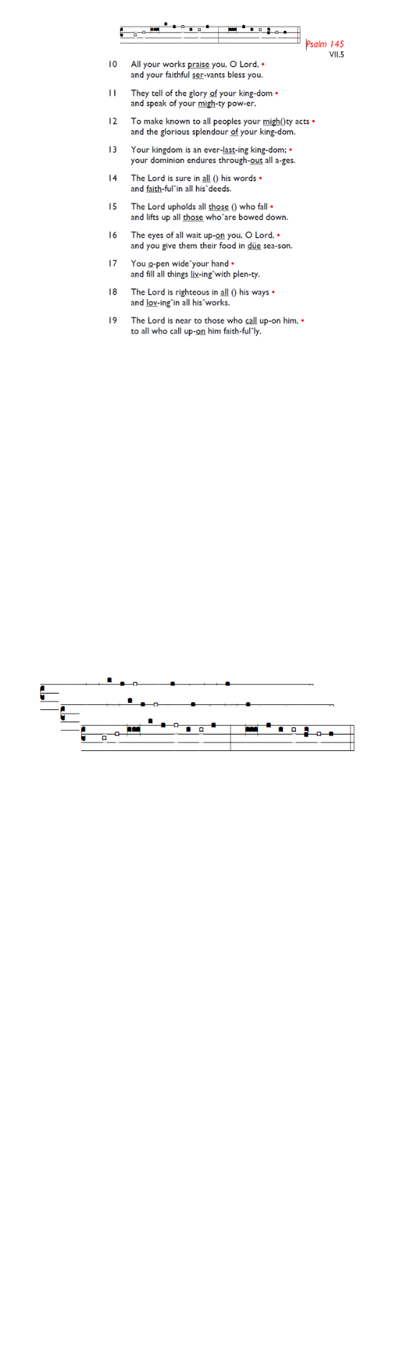
Weekly Events
- Monday-Friday 8.30am -8.50am: Morning Prayers.
- Thursday, Eucharist 10-11am, Bible Studies
11am – 12noon. Spanish Class, 12noon -1.15pm.
28th May, then 11th & 25th June



TODAY 11am Pentecost Service, followed by APCM 12.45pm – 1.45pm.

Starting this week
Formation Tuesdays, launching this week across our two churches, and beginning with the Bible Course at St
Augustine's (SW17 0EF) for 8 weeks from Tuesday May 26th at 7pm for a journey through the whole story of Scripture, helping you see how everything fits together from Genesis to Revelation with food and fellowship! Sign up here is.gd/Bible2026

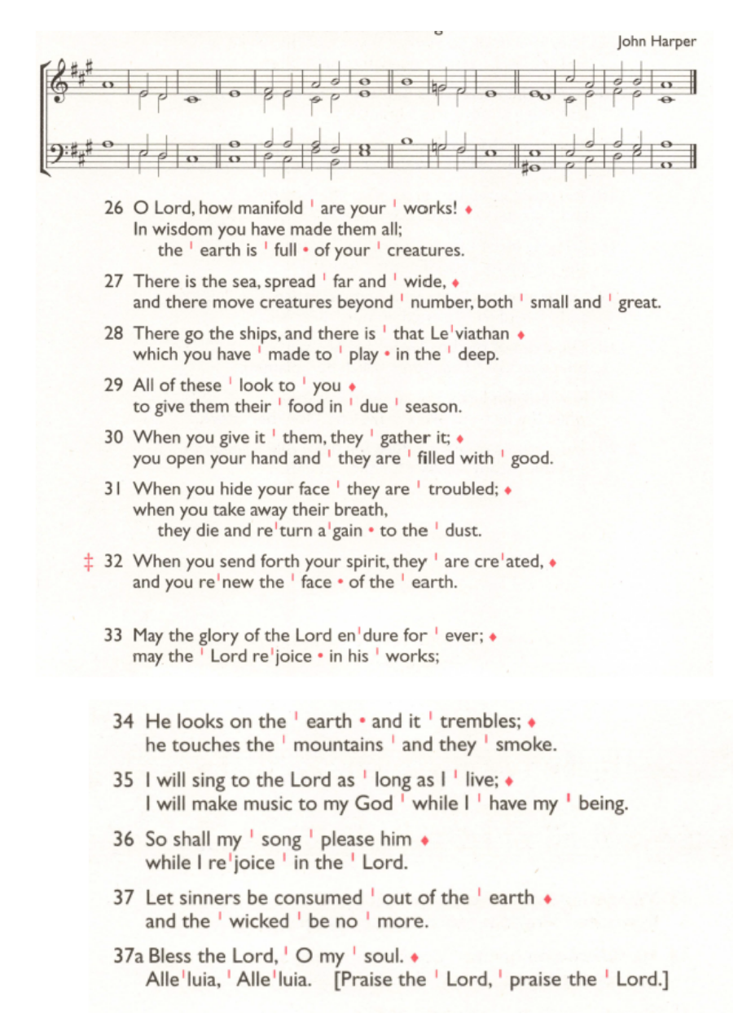
St Augustine's maintains an Electoral Roll; a list of those who have committed to regularly attending the church. If you have been worshipping here for 6 months or more, please do join. Those on the roll can stand for PCC election and vote at the Annual Meeting (24th May). To join, complete the form at is.gd/SAJoinRoll, or ask a welcomer for a paper copy.

Thursday’s Eucharist Services. There will be no Eucharist service on June 4th

Sunday 7th June from 6-8pm – WIFFA Service.

PCC Meeting – Monday 15th June 7.30pm.

Southwark Diocese – Sign up monthly newsletter/events. If anyone is interested to receive this online, please refer to the links below.
https://mailchi.mp/southwark/discipleship-news
https://southwark.anglican.org/missionministry/ministry/discipleship-ministry/
Those who have asked for prayers:
Thelma Benjamin, Gene Bovell, Aileen Brewley, Fitzgerald Brewley, Gloria Ellis Clarke, Yvonne Clarke, Oscar Sam Carrol, Kathleen Cummings, Jennifer Donahue, Shirly Lynch, Indra Nalliah, Shanthi Nesaraj, Horatio Obodai, Esther Persaud, Tina Roberts, Orville Simpson, Thelma Simpson, Mark Sinclair, Delce Taylor, Louisa Upjohn, Idene Waithe, Eula Watson, Velda Welch.

Contacts & Church Office:
Administrator, Church Notices & Bookings:
Zorah Baig 020 8772 4454
churchoffice@uppertooting.net
The Revd Angela Rayner: (Vicar) 07385 181103
vicar@uppertooting.net
The Revd Sarah Whitehouse (Assistant Priest)
sarah@uppertooting.net
Claudette Dey – Pastoral Lay Minister 07979 598889
Jacqueline Obodai– Churchwarden. 07956 337643
jackieo12@live.com
Idene Waithe –Churchwarden. 07883 421147
murmaid47@outlook.com
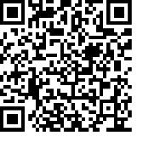
Steve Payne – Buildings Manager 07885 706637

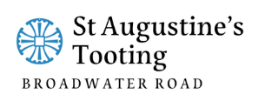

11am Parish Eucharist
24th May 2026 Pentecost

Celebrant: The Revd Angela Rayner
Preacher: The Revd Angela Rayner

Readers: Russell Yates, Helen Duxbury
Intercessions: Ethel Addo
Greeters: Ann Whelan Wilkes, Helen Duxbury

Hymns
Introit 90: Come down, O Love divine
Psalm 104, 26-end
Offertory 392: O thou who camest from above
Communion 455: Spirit of the living God (4x)
Recessional 532: We have a gospel to proclaim

