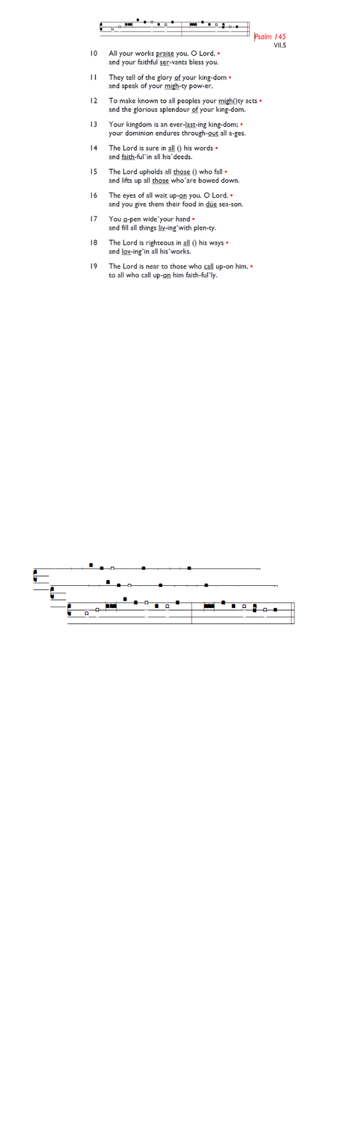
Weekly Events
- Monday-Friday 8.30am -8.50am: Morning Prayers.
- Thursday, Eucharist 10-11am, Bible Studies (cancelled due to the evening Corpus Christi Service see below for further details)
11am – 12noon. Spanish Class, 12noon -1.15pm.
11th & 25th June

This week
Formation Tuesdays, Bible Course at St Augustine's
(SW17 0EF) has started, a journey through the whole story of Scripture, helping you see how everything fits together from Genesis to Revelation with food and fellowship! Sign up here, it’s not too late to join .gd/Bible2026.

Thursday’s Morning Eucharist Service – 4th June. There will be no Bible Studies & Eucharist service (this week) due to the evening Corpus Christi Service.

Thursday 4th June: Corpus Christi Eucharist Service 7.15pm followed by refreshments.

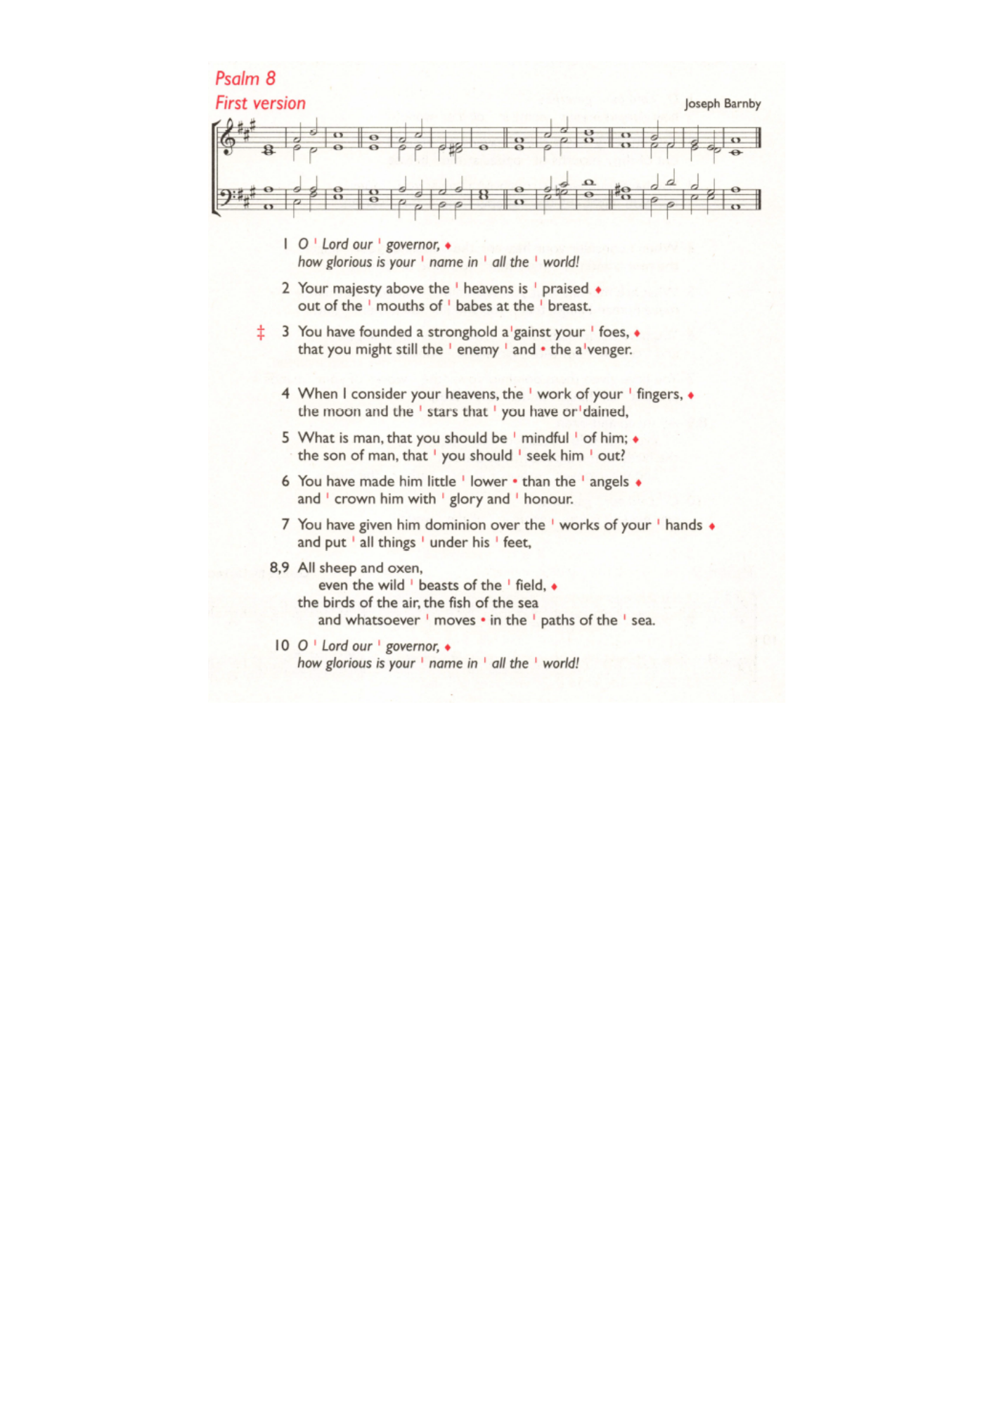
Rose petals needed for Corpus Christi Service! It would be wonderful if people could bring rose and flower petals to the church a day or two before (there will be a trug in the front porch where they can be left). Assistance with setting up the flower petal carpet at 1pm on 4th June would be appreciated. Please let the vicar or one of the Churchwardens know if you can either bring petals or help with the set up.

Sunday 7th June from 6-8pm – WIFFA Service.

Coming Soon
PCC Meeting – Monday 15th June 7.30pm.

Those who have asked for prayers:
Thelma Benjamin, Gene Bovell, Aileen Brewley, Fitzgerald Brewley, Gloria Ellis Clarke, Yvonne Clarke, Oscar Sam Carrol, Kathleen Cummings, Jennifer Donahue, Shirly Lynch, Indra Nalliah, Shanthi Nesaraj, Horatio Obodai, Esther Persaud, Tina Roberts, Orville Simpson, Thelma Simpson, Mark Sinclair, Delce Taylor, Louisa Upjohn, Idene Waithe, Eula Watson, Velda Welch.

Contacts & Church Office:
Administrator, Church Notices & Bookings:
Zorah Baig 020 8772 4454
churchoffice@uppertooting.net
The Revd Angela Rayner: (Vicar) 07385 181103
vicar@uppertooting.net
The Revd Sarah Whitehouse (Assistant Priest)
sarah@uppertooting.net
Claudette Dey – Pastoral Lay Minister 07979 598889
Jacqueline Obodai– Churchwarden. 07956 337643
jackieo12@live.com
Idene Waithe –Churchwarden. 07883 421147
murmaid47@outlook.com

Steve Payne – Buildings Manager 07885 706637



11am Parish Eucharist
31st May 2026 Trinity Sunday

Celebrant: The Revd Sarah Whitehouse
Preacher: The Revd Sarah Whitehouse

Readers: Rachel Phillips, Ethel Addo
Intercessions: Tyrone Payne
Greeters: Rachel Phillips, Sylvia Furneaux

Hymns
Introit 212: Holy, holy, holy! Lord God Almighty!
Psalm 8
Offertory 343: My God, how wonderful thou art
Communion 126: Father, we love you
Recessional 164: Go forth and tell

