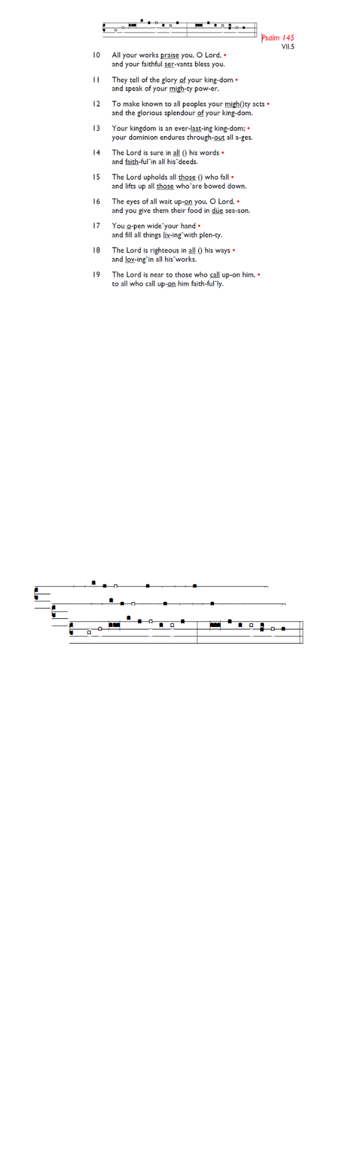
Weekly Events
- Monday-Friday 8.30am -8.50am: Morning Prayers.
- Thursday, Eucharist 10-11am, Bible Studies
11am – 12noon. Spanish Class, 12pm -1.15pm.
25th June, then 9th & 16th July.

This week
Tue 16th Jun, 7pm: Bible Course at St Augustine's (SW17 0EF), session 4 of 8 (meeting weekly). Looking at the books of Exodus, Leviticus, Numbers & Deuteronomy. It isn't too late to join and attend a light supper followed by film and
conversation.

PCC Meeting – Monday 15th June 7.30pm.

Coming soon
Sunday 28th June, St Augustine’s is celebrating the feast of
St Peter & St Paul in style. After the Eucharist at about 12.15pm, we will head outside to celebrate with Pizza & Pinot (including non-alcoholic drinks). Sign up online here so that we know how many pizzas/how much topping we need: bit.ly/BookEventHT or in church using the sign-up sheet at the back.
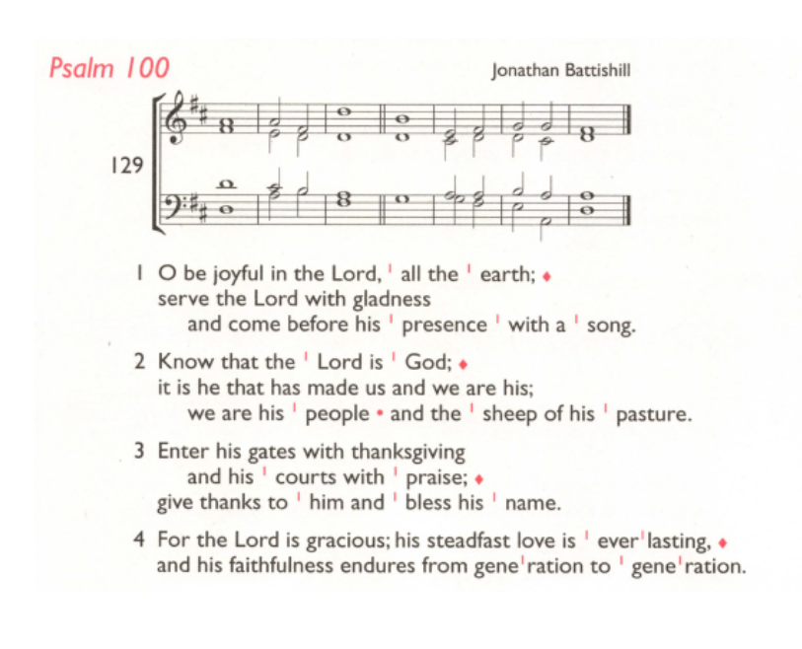
Sunday 28th June, 6pm @ Holy Trinity Church, Choral Evensong followed by refreshments.

The Archbishops’ Prime Minister’s Appointments Secretaries will host an Online Public Meeting on
Thu 18th Jun, 6pm-7pm for anyone in the diocese to share their views on the qualities needed for the next Bishop of Southwark. All welcome. No booking needed. Join here: tinyurl.com/Appointment26

Those who have asked for prayers:
Thelma Benjamin, Gene Bovell, Aileen Brewley, Fitzgerald Brewley, Gloria Ellis Clarke, Yvonne Clarke, Oscar Sam Carrol, Kathleen Cummings, Jennifer Donahue, Shirly Lynch, Indra Nalliah, Shanthi Nesaraj, Horatio Obodai, Esther Persaud, Tina Roberts, Orville Simpson, Thelma Simpson, Mark Sinclair, Delce Taylor, Louisa Upjohn, Idene Waithe, Eula Watson, Velda Welch.

Faithful departed: Claudette Husbands

Contacts & Church Office:
Administrator, Church Notices & Bookings:
Zorah Baig 020 8772 4454
churchoffice@uppertooting.net
The Revd Angela Rayner: (Vicar) 07385 181103
vicar@uppertooting.net
The Revd Sarah Whitehouse (Assistant Priest)
sarah@uppertooting.net
Claudette Dey – Pastoral Lay Minister 07979 598889
Jacqueline Obodai– Churchwarden. 07956 337643
jackieo12@live.com
Idene Waithe –Churchwarden. 07883 421147
murmaid47@outlook.com
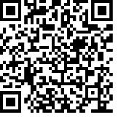
Steve Payne – Buildings Manager 07885 706637

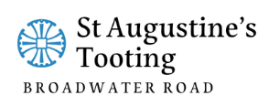

11am Parish Eucharist
14th June 2026 Trinity 2

Celebrant: The Revd Sarah Whitehouse
Preacher: Ethan Glacklin-McColgan

Readers: Jaqueline Obodai, Soma
Intercessions: Steve Payne
Greeters: Ethel Addo, Shirley Sandiford

Hymns
Introit 56: Be thou my vision, O Lord of my heart
Psalm 100:
Offertory 380: O Lord my God, when I, in awesome wonder
Communion 68: Bread of the world in mercy broken
Recessional 282: Jesus, where’er thy people meet

