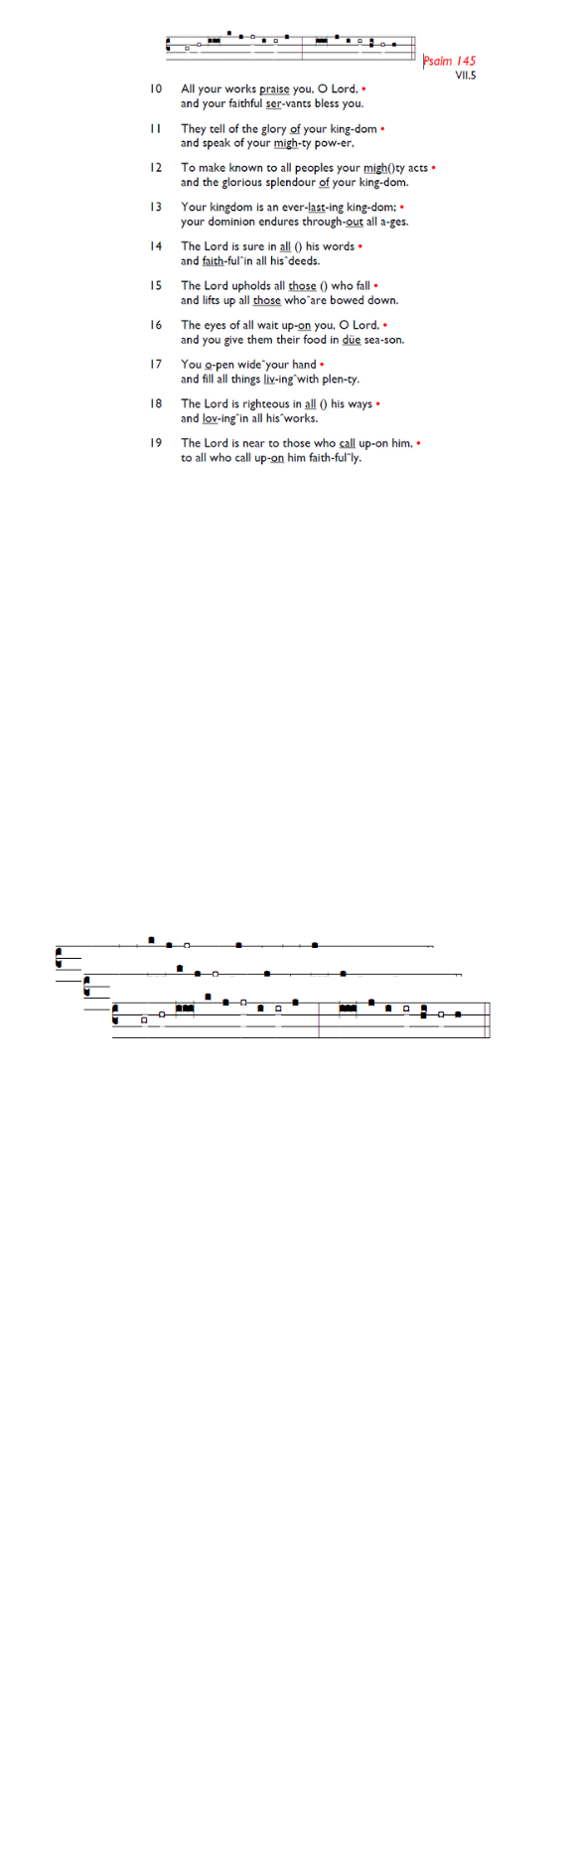
Weekly Events
- Monday-Friday 8.30am -8.50am: Morning Prayers.
- Thursday, Eucharist 10-11am, Bible Studies
11am – 12noon. Spanish Class, 12pm -1.15pm.
25th June, then 9th & 16th July.

This week
Tue 23rd Jun, 7pm: Bible Course at St Augustine's (SW17 0EF), session 5 of 8 (meeting weekly). Looking at the books of Exodus, Leviticus, Numbers & Deuteronomy. It isn't too late to join and attend a light supper followed by film and
conversation.

Next Sunday St Paul & St Peter
Sunday 28th after morning service, Peter, Paul, Pizza & Pinot, 12.15-2pm.

Evening 6pm: Choral Evensong at Holy Trinity on the feast of St Peter & St Paul to be followed by drinks and a selection of delicious puddings. Please sign up so we know how many puddings are needed: bit.ly/BookEventHT

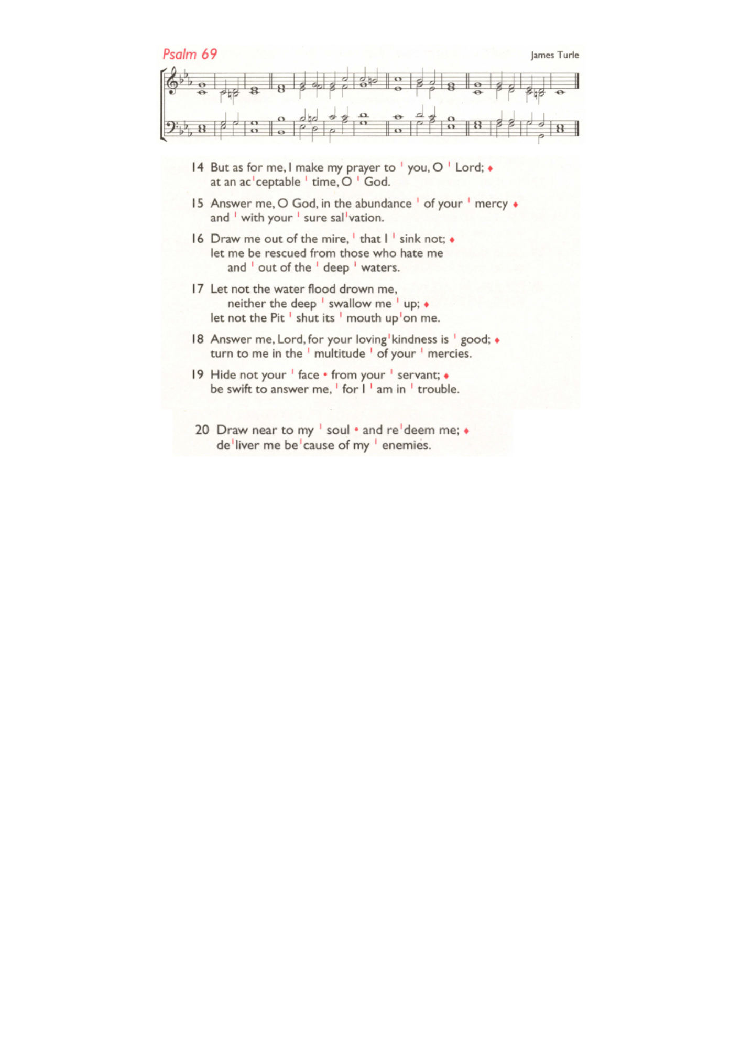
Thursday July 16th @ 1.30pm – Paddock School Visit.

Farewell to Bishop Christopher
Would you like to leave a farewell message for Bishop
Christopher? As he prepares to retire, reflections on his
ministry are being collected from parishes. Please share any
memories, stories, and words of thanks using this form:
tinyurl.com/Farewellbpc

Those who have asked for prayers:
Thelma Benjamin, Gene Bovell, Aileen Brewley, Fitzgerald Brewley, Gloria Ellis Clarke, Yvonne Clarke, Oscar Sam Carrol, Kathleen Cummings, Jennifer Donahue, Shirly Lynch, Indra Nalliah, Shanthi Nesaraj, Horatio Obodai, Esther Persaud, Tina Roberts, Orville Simpson, Thelma Simpson, Mark Sinclair, Delce Taylor, Louisa Upjohn, Idene Waithe, Eula Watson, Velda Welch.

Faithful departed: Claudette Husbands

Contacts & Church Office:
Administrator, Church Notices & Bookings:
Zorah Baig 020 8772 4454
churchoffice@uppertooting.net
The Revd Angela Rayner: (Vicar) 07385 181103
vicar@uppertooting.net
The Revd Sarah Whitehouse (Assistant Priest)
sarah@uppertooting.net
Claudette Dey – Pastoral Lay Minister 07979 598889
Jacqueline Obodai– Churchwarden. 07956 337643
jackieo12@live.com
Idene Waithe –Churchwarden. 07883 421147
murmaid47@outlook.com

Steve Payne – Buildings Manager 07885 706637



11am Parish Eucharist
21st June 2026 Trinity 3

Celebrant: The Revd Angela Rayner
Preacher: The Revd Angela Rayner

Readers: Claudette Dey, Neil O’Brien
Intercessions: Doris Pappoe
Greeters: Helen Duxbury, Paula Stevenson

Hymns
Introit 158: Glorious things of thee are spoken
Psalm 69: 14-20
Offertory 464: Take my life, and let it be
Communion 54: Be still, my soul
Recessional 504: Thine for ever! God of love

