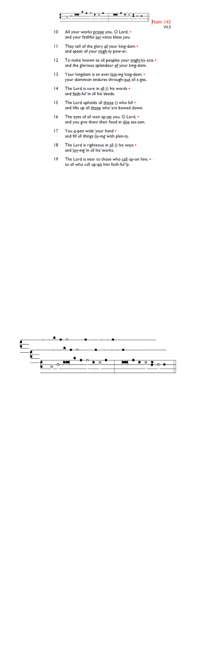
Weekly Events
- Monday-Friday 8.30am -8.50am: Morning Prayers.
- Thursday, Eucharist 10-11am, Bible Studies
11am – 12noon. Spanish Class, 12pm -1.15pm.
9th & 16th July. (on July 9th the class will start at 1pm)

Today we are delighted to welcome our new curate, The Rev'd Jacqueline Gray to St Augustine's for Pizza and Pinot after our service. Jacqueline was made Deacon yesterday at Southwark Cathedral and will serve as Deacon at her first Mass at St Augustine's on 12th July 2026. Congratulations, Jacqueline!

Today
Sunday 28th after morning service, Peter, Paul, Pizza & Pinot, 12.15-2pm. Evening 6pm: Choral Evensong at Holy Trinity on the feast of St Peter & St Paul to be followed by drinks and a selection of delicious puddings.

This week
Tue 30 Jun, 7pm: Bible Course at St Augustine's (SW17 0EF), (meeting weekly). Looking at the books of Exodus, Leviticus, Numbers & Deuteronomy. It isn't too late to join and attend a light supper followed by film and
conversation.

The morning Eucharist & Bible Studies on the 9^{th of} July will be cancelled due to the funeral service to be held at St Augustine’s.

The funeral of Lawrence Sinckler will take place at St Augustine’s on Thursday 9 July at 11.30am.

The funeral of Claudette Husbands will take place at St Jude with St Aidan’s Church at 11.30am, followed by the burial at 2pm at Streatham Cemetery on Rowan Road SW16.

Hold the dates for your diary
Recitals will be held at St Augustine on 11th July, 1st August and 29th August, all on Saturdays between 2pm-3pm. Please pick up a leaflet at church for further details.

Those who have asked for prayers:
Thelma Benjamin, Gene Bovell, Aileen Brewley, Fitzgerald Brewley, Gloria Ellis Clarke, Yvonne Clarke, Oscar Sam Carrol, Kathleen Cummings, Jennifer Donahue, Shirly Lynch, Indra Nalliah, Horatio Obodai, Esther Persaud, Tina Roberts, Orville Simpson, Thelma Simpson, Mark Sinclair, Delce Taylor, Louisa Upjohn, Idene Waithe, Eula Watson, Velda Welch.

Faithful departed: Claudette Husbands, Lawrence Sinckler.

Contacts & Church Office:
Administrator, Church Notices & Bookings:
Zorah Baig 020 8772 4454
churchoffice@uppertooting.net
The Revd Angela Rayner: (Vicar) 07385 181103
vicar@uppertooting.net
The Revd Sarah Whitehouse (Assistant Priest)
sarah@uppertooting.net
Claudette Dey – Pastoral Lay Minister 07979 598889
Jacqueline Obodai– Churchwarden. 07956 337643
jackieo12@live.com
Idene Waithe –Churchwarden. 07883 421147
murmaid47@outlook.com
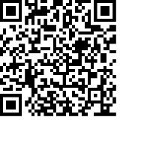
Steve Payne – Buildings Manager 07885 706637



11am Parish Eucharist
28th June 2026 St Peter & St Paul

Celebrant: The Revd Dorothy Penniecooke
Preacher: The Revd Dorothy Penniecooke

Readers: Steve Payne, Jeremy Clarke
Intercessions: Sam Carrol
Greeters: Paula Stevenson, Steve Payne

Hymns
Introit 277: Jesus shall reign
Psalm 125
Offertory 473: The Church’s once foundation
Communion 128: Fight the good fight
Recessional 134: For all the saints
