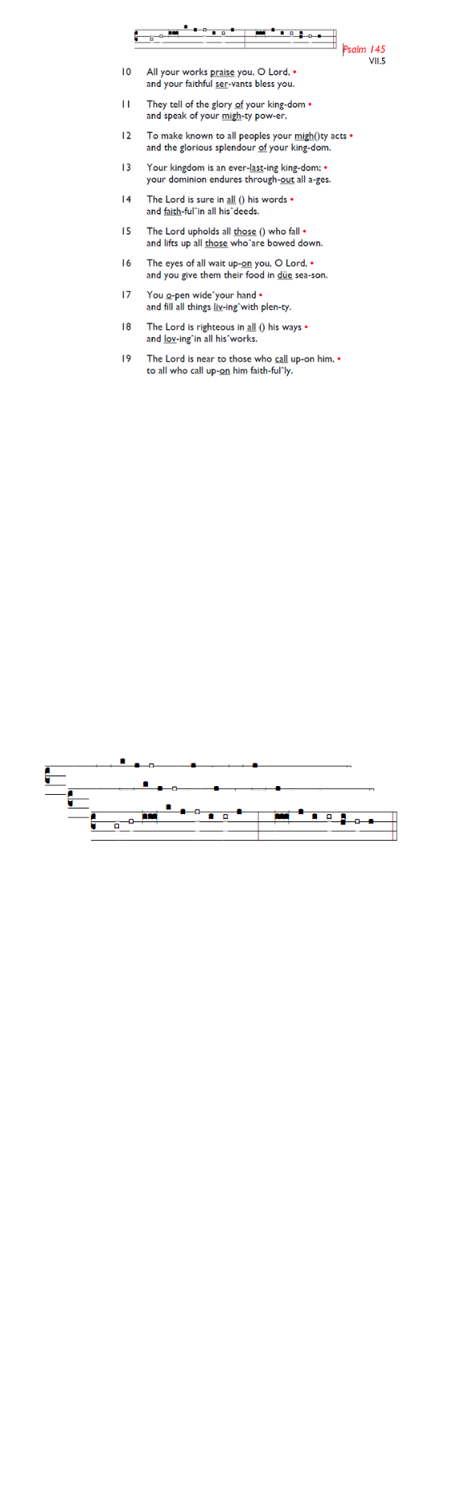
Weekly Events
- Monday-Friday 8.30am -8.50am: Morning Prayers.
- Thursday, Eucharist 10-11am, Bible Studies
11am – 12noon. Spanish Class, 12pm -1.15pm.
11th & 25th June.

TODAY: from 6-8pm – WIFFA Service.

This week
Tue 9th Jun, 7pm: Bible Course at St Augustine's (SW17 0EF), session 3 of 8 (meeting weekly). Looking at the books of Exodus, Leviticus, Numbers & Deuteronomy. It isn't too late to join and attend a light supper followed by film and
conversation.

Coming Soon
PCC Meeting – Monday 15th June 7.30pm.

Sunday 28th June @ Holy Trinity Church, 6pm Choral Evensong on the feast of St Peter and St Paul, followed by drinks and a selection of puddings. All welcome.

Would you like to leave a farewell message for Bishop
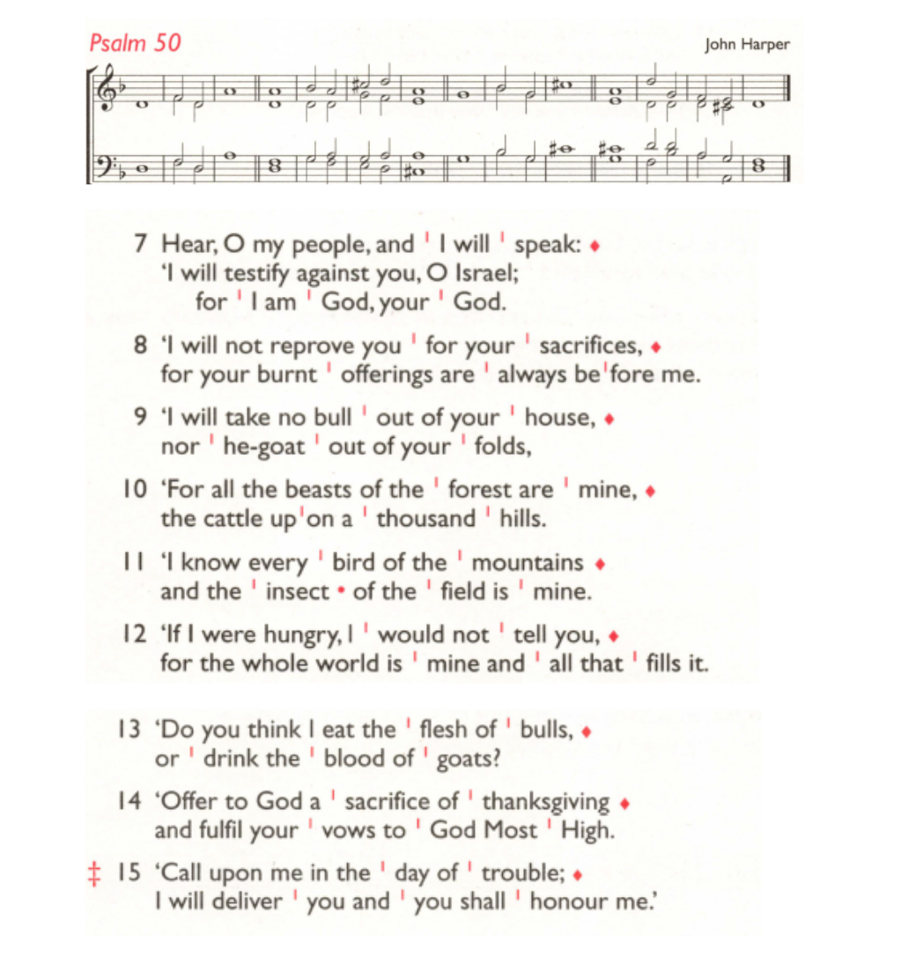
Christopher? As he prepares to retire, reflections on his
ministry are being collected from parishes. Please share any
memories, stories, and words of thanks using this form:
tinyurl.com/Farewellbpc

Those who have asked for prayers:
Thelma Benjamin, Gene Bovell, Aileen Brewley, Fitzgerald Brewley, Gloria Ellis Clarke, Yvonne Clarke, Oscar Sam Carrol, Kathleen Cummings, Jennifer Donahue, Shirly Lynch, Indra Nalliah, Shanthi Nesaraj, Horatio Obodai, Esther Persaud, Tina Roberts, Orville Simpson, Thelma Simpson, Mark Sinclair, Delce Taylor, Louisa Upjohn, Idene Waithe, Eula Watson, Velda Welch.

Contacts & Church Office:
Administrator, Church Notices & Bookings:
Zorah Baig 020 8772 4454
churchoffice@uppertooting.net
The Revd Angela Rayner: (Vicar) 07385 181103
vicar@uppertooting.net
The Revd Sarah Whitehouse (Assistant Priest)
sarah@uppertooting.net
Claudette Dey – Pastoral Lay Minister 07979 598889
Jacqueline Obodai– Churchwarden. 07956 337643
jackieo12@live.com
Idene Waithe –Churchwarden. 07883 421147
murmaid47@outlook.com

Steve Payne – Buildings Manager 07885 706637



11am Parish Eucharist
7th June 2026 Trinity 1

Celebrant: The Revd Angela Rayner
Preacher: The Revd Angela Rayner

Readers: Sam Carrol, Jeremy Clarke
Intercessions: Jacqueline Obodai
Greeters: Jeremy Clarke, Sandra Jones

Hymns
Introit 85: City of God, how broad and far
Psalm 50: 7-15
Offertory 30: And can it be that I should gain
Communion 66: Bread is blessed and broken (x2)
Recessional 442: Seek ye first the kingdom of God

