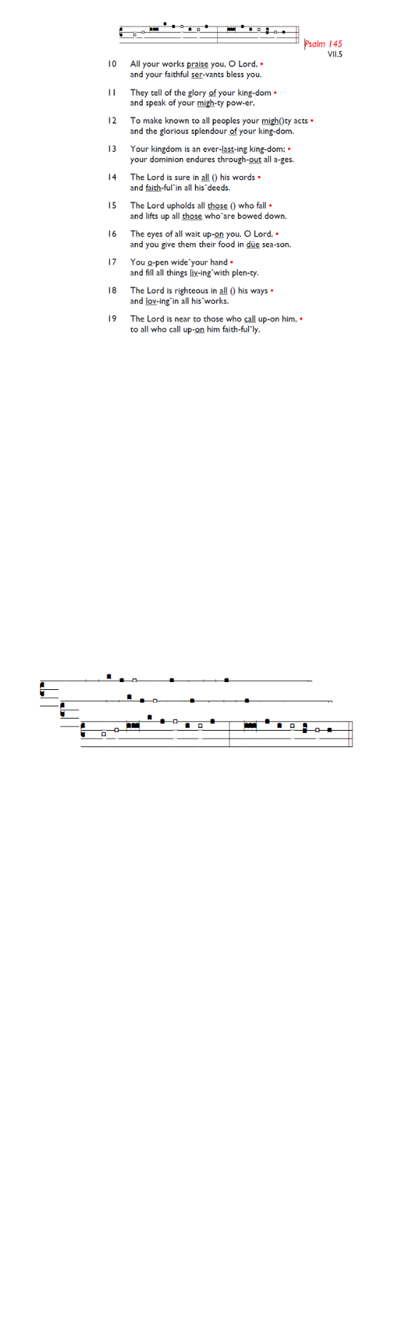
Weekly Events
- Monday-Friday 8.30am -8.50am: Morning Prayers.
- Thursday, Eucharist 10-11am, Bible Studies
11am – 12noon. Spanish Class, 12pm -1.15pm.
16th July, then 13th & 20th August.
This week
Tue 14th July, 7pm: Bible Course at St Augustine's (SW17 0EF), (meeting weekly). Looking at the books of Exodus, Leviticus, Numbers & Deuteronomy.

Hold the dates for your diary
Recitals will be held at St Augustine on 1st August and 29th August, all on Saturdays between 2pm-3pm. Please pick up a leaflet at church for further details.

Coming soon
Sunday 2nd August, Emancipation service followed by lunch and refreshments.

Holy Trinity is planning to run an 8-week Prayer Course on Tuesday evenings from 28th July - 15th September as part of our Benefice-wide Formation Tuesday initiative. Food from 7pm, and video to start at 7.30pm. All welcome. Please sign up if you can for catering purposes: bit.ly/BookEventHT
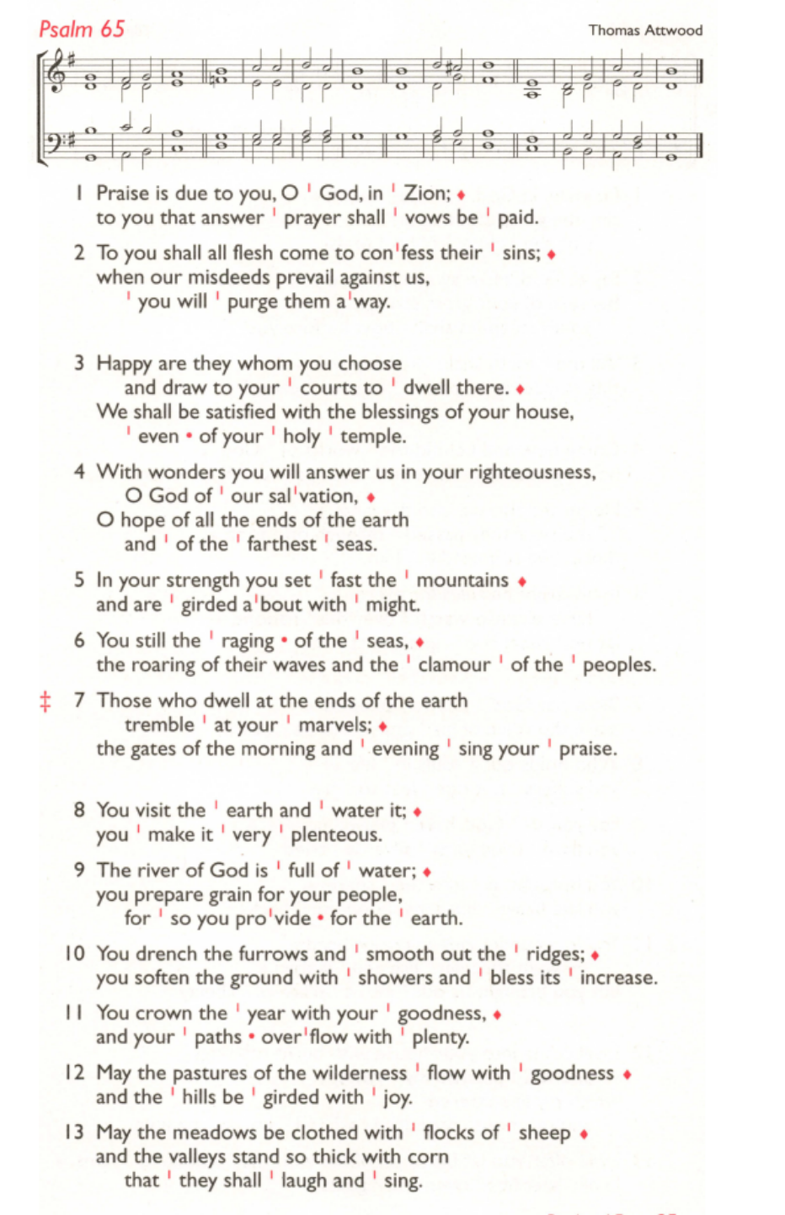
Those who have asked for prayers:
Thelma Benjamin, Gene Bovell, Aileen Brewley, Fitzgerald Brewley, Gloria Ellis Clarke, Yvonne Clarke, Oscar Sam Carrol, Kathleen Cummings, Jennifer Donahue, Shirly Lynch, Indra Nalliah, Horatio Obodai, Esther Persaud, Tina Roberts, Orville Simpson, Thelma Simpson, Mark Sinclair, Delce Taylor, Louisa Upjohn, Idene Waithe, Eula Watson, Leo Watson, Velda Welch.

Faithful departed: Headley Martin

Contacts & Church Office:
Administrator, Church Notices & Bookings:
Zorah Baig 020 8772 4454
churchoffice@uppertooting.net
The Revd Angela Rayner: (Vicar) 07385 181103
vicar@uppertooting.net
The Revd Sarah Whitehouse (Assistant Priest)
sarah@uppertooting.net
Claudette Dey – Pastoral Lay Minister 07979 598889
Jacqueline Obodai– Churchwarden. 07956 337643
jackieo12@live.com
Idene Waithe –Churchwarden. 07883 421147
murmaid47@outlook.com

Steve Payne – Buildings Manager 07885 706637



11am Parish Eucharist
12th July 2026 Trinity 6

Celebrant: The Revd Angela Rayner
Preacher: The Revd Angela Rayner

Readers: Richard Decker, Sue Bruno
Intercessions: Tyrone Payne
Greeters: Shirley Sandiford, Rachel Phillips

Hymns
Introit 124: Father of heaven, whose love profound
Psalm 65
Offertory 304: Lift up your hearts
Communion 318: Lord, thy word abideth
Recessional 571: You shall go out with joy

