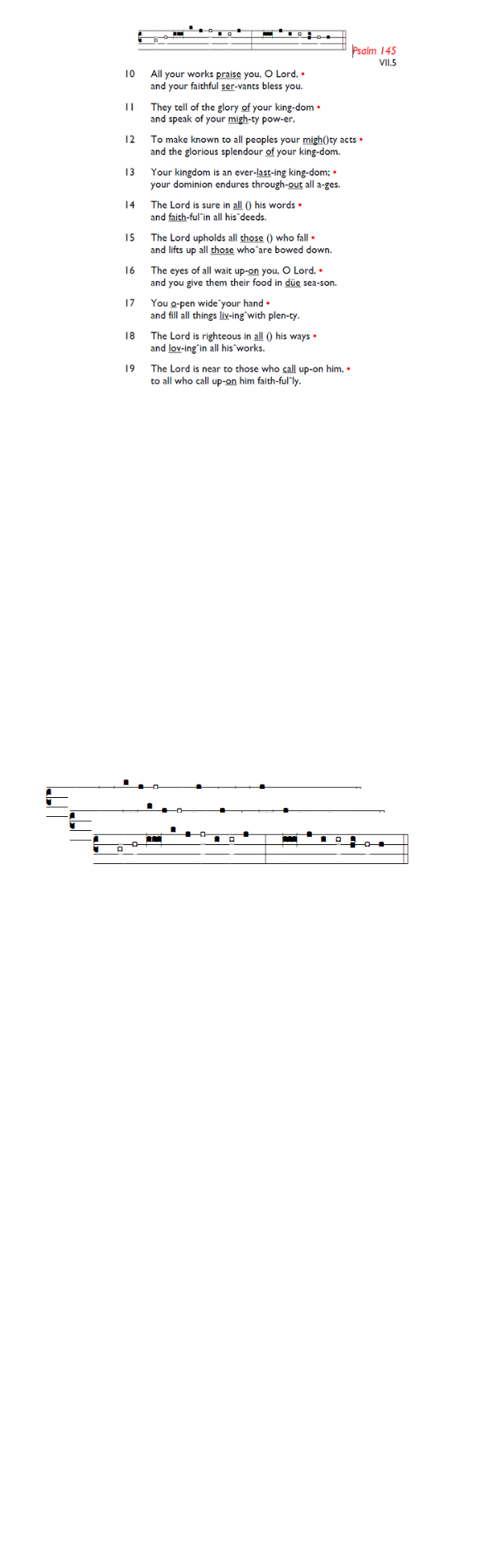
Weekly Events
- Monday-Friday 8.30am -8.50am: Morning Prayers.
- Thursday, Eucharist 10-11am, Bible Studies
11am – 12noon. Spanish Class, 12pm -1.15pm.
13th & 20th August.
Today we warmly welcome the Revd Gordon Waller to lead our Service.

Next Recitals coming up
Recitals will be held at St Augustine on 1st August and 29th August, both on Saturdays between 2pm-3pm. Please pick up a leaflet at church for further details.

Bishop Christopher’s Valedictory Service takes place this Saturday, 18th July, at Southwark Cathedral at 12pm. (The Rev'd Jacqueline Gray will be deaconning for the service!) All are welcome to attend; no tickets are needed. Give thanks for his ministry and pray for him as he retires. Those unable to be present in person can watch the service live on Youtube: http://y2u.be/O2IypJ-B5hM

Holy Trinity is planning to run an 8-week Prayer Course on Tuesday evenings from 28th July - 15th September as part of our Benefice-wide Formation Tuesday initiative. Food from 7pm, and video to start at 7.30pm. All welcome. Please sign up if you can for catering purposes: bit.ly/BookEventHT
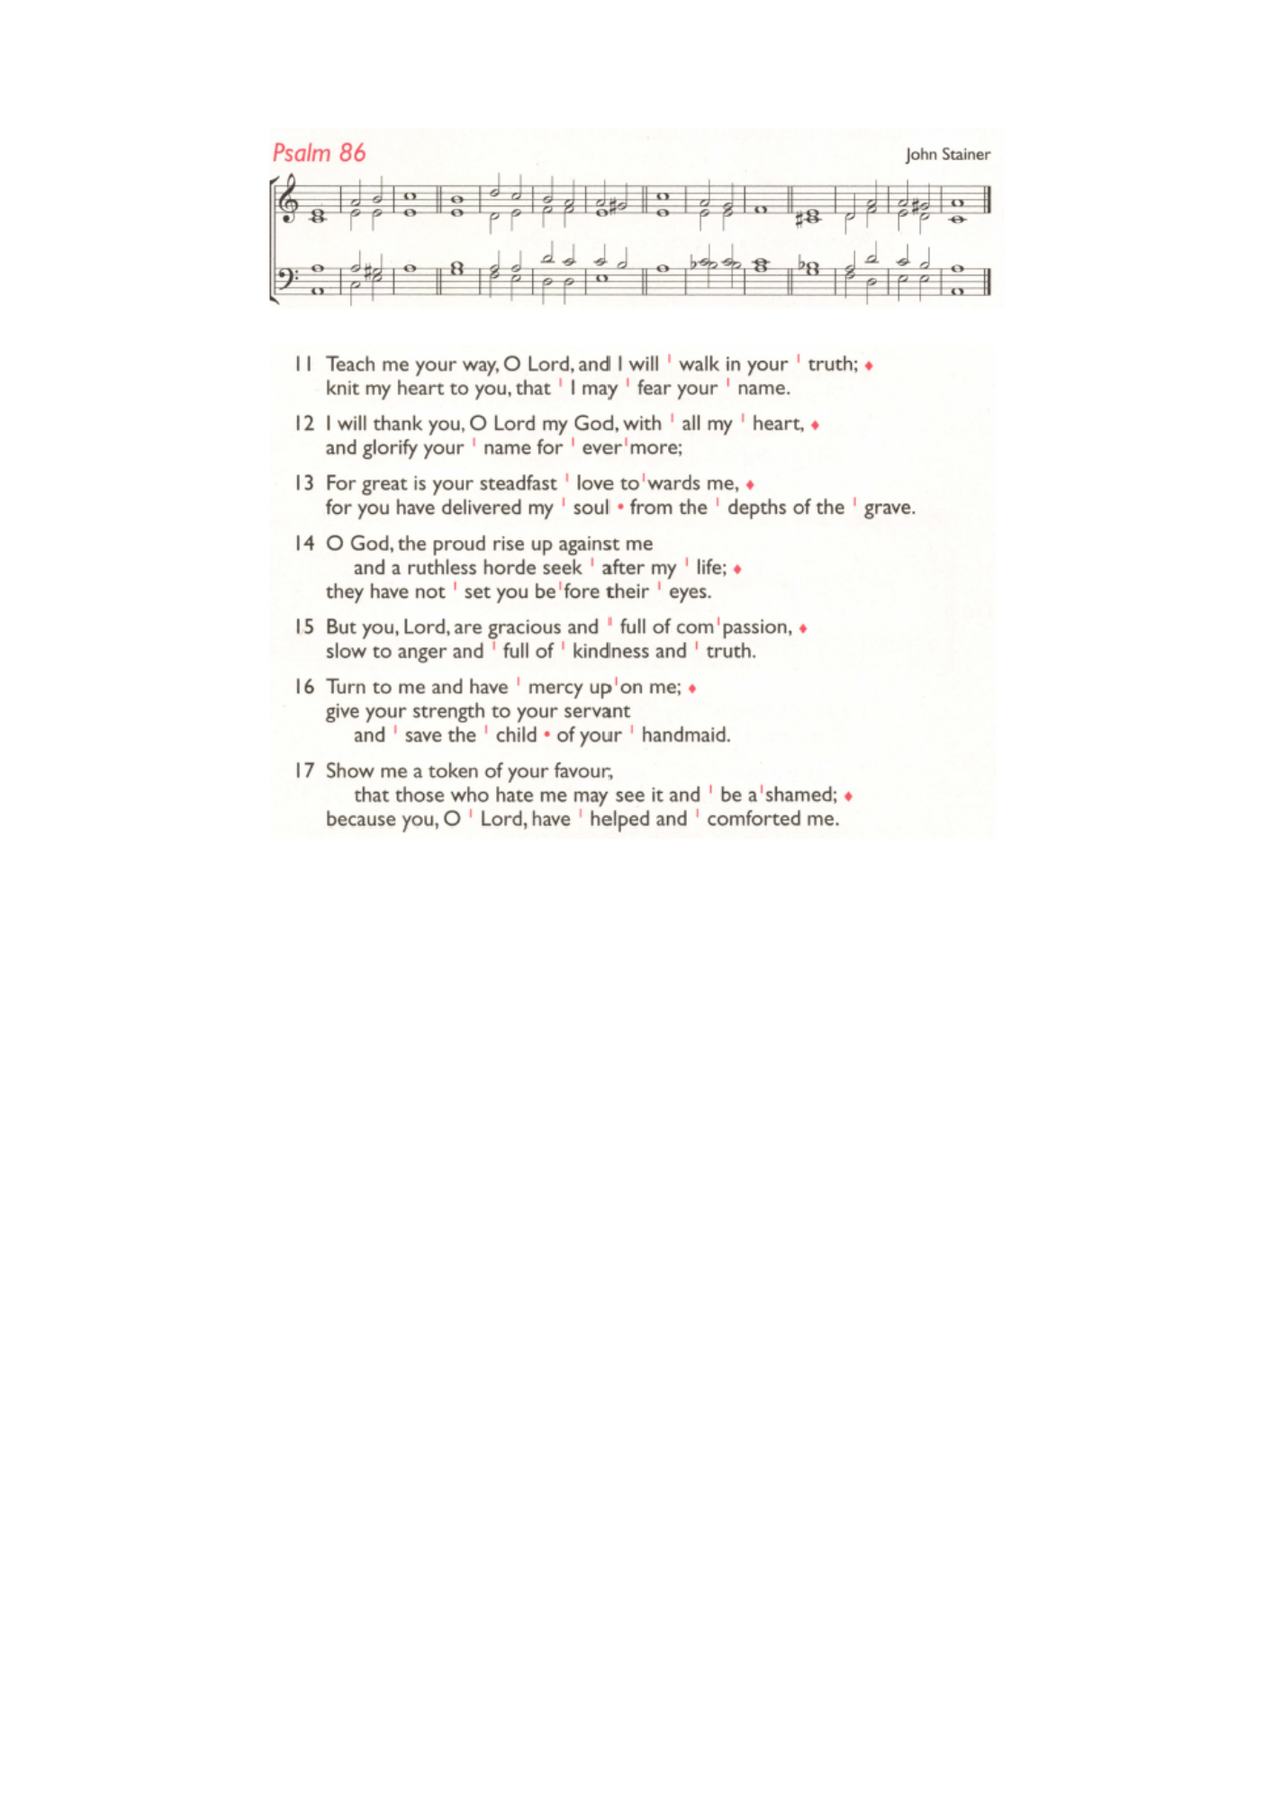
If you were taken ill in a Medical Emergency at church, after calling the emergency services, who else would you like us to call? The information will be stored securely on ChurchSuite against your record. We would be very grateful if you would email/phone the name and telephone number of your emergency contact to churchoffice@uppertooting.net, or
020 8772 4454.

Coming soon
Sunday 2nd August, Emancipation service followed by lunch and refreshments. As part of our Emancipation Sunday Lunch, we will be making a donation to the Stephen Lawrence Day Foundation, a charity that supports young people from underrepresented backgrounds and promotes equality of opportunity. We will be inviting contributions towards this donation.

Those who have asked for prayers:
Thelma Benjamin, Gene Bovell, Aileen Brewley, Fitzgerald Brewley, Gloria Ellis Clarke, Yvonne Clarke, Oscar Sam Carrol, Kathleen Cummings, Jennifer Donahue, Shirly Lynch, Horatio Obodai, Esther Persaud, Tina Roberts, Orville Simpson, Thelma Simpson, Mark Sinclair, Delce Taylor, Louisa Upjohn, Idene Waithe, Eula Watson, Leo Watson, Velda Welch.

Contacts & Church Office:
Administrator, Church Notices & Bookings:
Zorah Baig 020 8772 4454
churchoffice@uppertooting.net
The Revd Angela Rayner: (Vicar) 07385 181103
vicar@uppertooting.net
The Revd Sarah Whitehouse (Assistant Priest)
sarah@uppertooting.net
Claudette Dey – Pastoral Lay Minister 07979 598889
Jacqueline Obodai– Churchwarden. 07956 337643
jackieo12@live.com
Idene Waithe –Churchwarden. 07883 421147
murmaid47@outlook.com

Steve Payne – Buildings Manager 07885 706637
Jacqueline Gray – (Curate) 07557 024845
jacquelineg@uppertooting.net

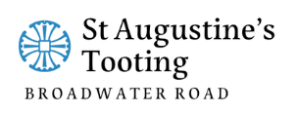

11am Parish Eucharist
19th July 2026 Trinity 7

Celebrant: The Revd Gordon Waller
Preacher: The Revd Gordon Waller

Readers: Neil O’Brien, Jeremy Clarke
Intercessions: Ethel Addo
Greeters: Ethel Addo, Sandra Jones

Hymns
Introit 364: O God of Bethel, by whose hand
Psalm 86: 11-end
Offertory 365: O God of earth and altar
Communion 214: Holy Spirit, come confirm us
Recessional 143: Forth in thy name, O Lord, I go

