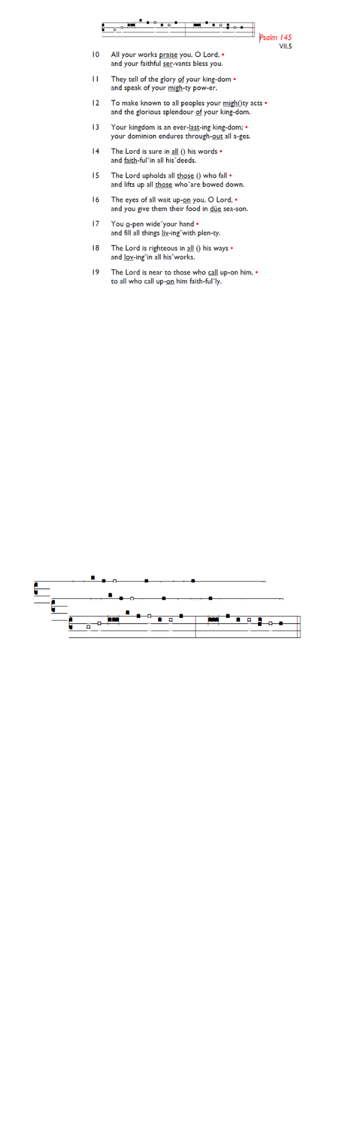
Weekly Events
- Monday-Friday 8.30am -8.50am: Morning Prayers.
- Thursday, Eucharist 10-11am, Bible Studies
11am – 12noon. Spanish Class, 12pm -1.15pm.
9th & 16th July. (on July 9th the class will start at 1pm)
This week
Tue 7th July, 7pm: Bible Course at St Augustine's (SW17 0EF), (meeting weekly). Looking at the books of Exodus, Leviticus, Numbers & Deuteronomy.

The morning Eucharist & Bible Studies on the 9^{th of} July will be cancelled due to the funeral service of Lawrence Sinckler.

“Holly” (Lawrence) Sinckler's funeral will take place on 9th July at 11.30am at St Augustine's Church. Members of the congregation are most welcome to attend.

The funeral of Claudette Husbands will take place on Friday 10th July, at St Jude with St Aidan’s Church, Thornton Rd, Thronton Heath, CR7 6BA at 11am, followed by the burial at 2pm at Streatham Park Cemetery on Rowan Road SW16 5JN.

Hold the dates for your diary
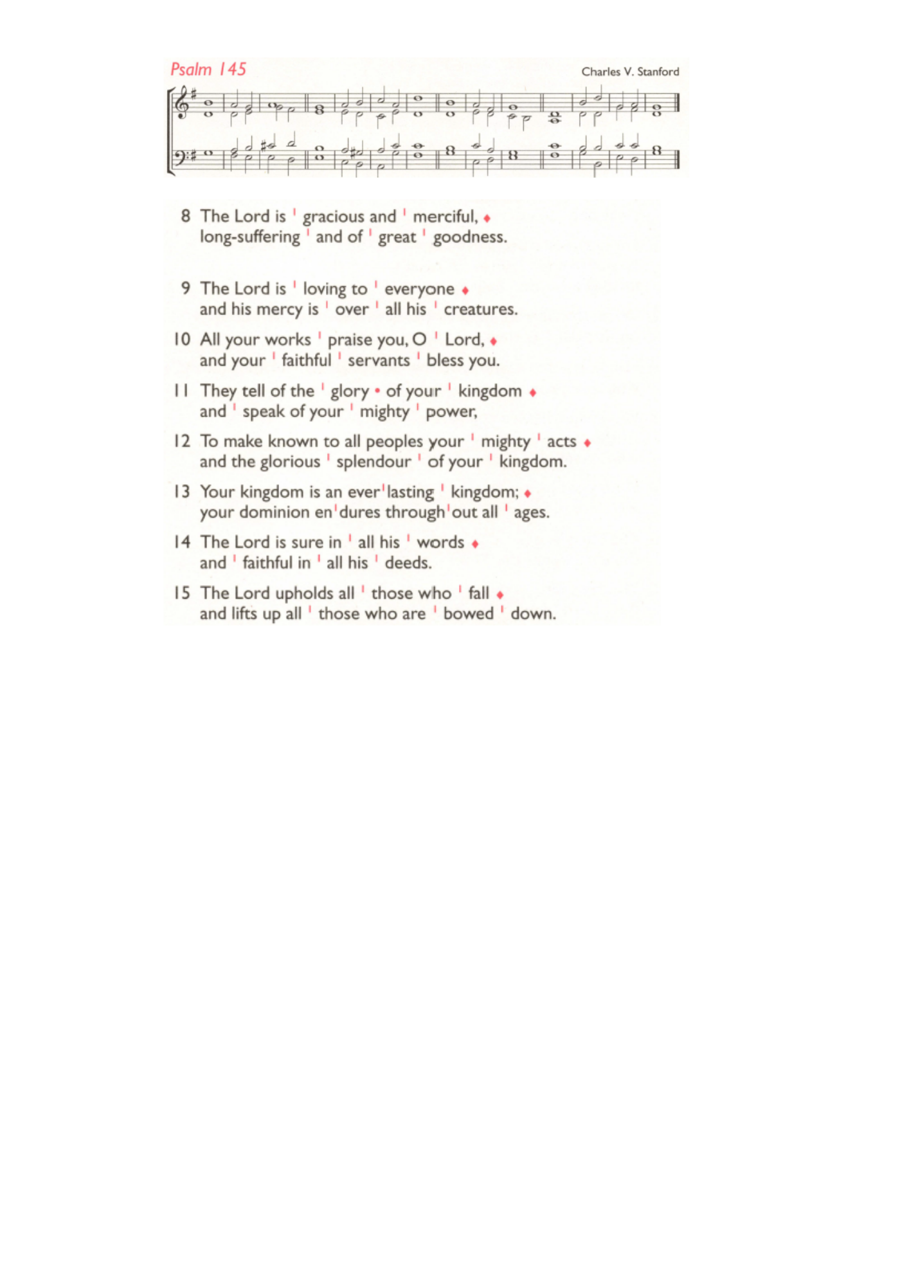
Recitals will be held at St Augustine on 11th July, 1st August and 29th August, all on Saturdays between 2pm-3pm. Please pick up a leaflet at church for further details.

Coming soon
Sunday 2nd August, Emancipation service followed by lunch and refreshments.

Many thanks to all who welcomed our new curate, The Rev'd Jacqueline Gray and friends last week with pizza, pinot, and much rejoicing! Jacqueline will deacon at her first Eucharist at St Augustine's on 12th July.

Holy Trinity is planning to run an 8-week Prayer Course on Tuesday evenings from 28th July - 15th September as part of our Benefice-wide Formation Tuesday initiative. Food from 7pm, and video to start at 7.30pm. All welcome. Please sign up if you can for catering purposes: bit.ly/BookEventHT

Those who have asked for prayers:
Thelma Benjamin, Gene Bovell, Aileen Brewley, Fitzgerald Brewley, Gloria Ellis Clarke, Yvonne Clarke, Oscar Sam Carrol, Kathleen Cummings, Jennifer Donahue, Shirly Lynch, Indra Nalliah, Horatio Obodai, Esther Persaud, Tina Roberts, Orville Simpson, Thelma Simpson, Mark Sinclair, Delce Taylor, Louisa Upjohn, Idene Waithe, Eula Watson, Leo Watson, Velda Welch.

Faithful departed: Claudette Husbands, Lawrence Sinckler, Indirani Nalliah.

Contacts & Church Office:
Administrator, Church Notices & Bookings:
Zorah Baig 020 8772 4454
churchoffice@uppertooting.net
The Revd Angela Rayner: (Vicar) 07385 181103
vicar@uppertooting.net
The Revd Sarah Whitehouse (Assistant Priest)
sarah@uppertooting.net
Claudette Dey – Pastoral Lay Minister 07979 598889
Jacqueline Obodai– Churchwarden. 07956 337643
jackieo12@live.com
Idene Waithe –Churchwarden. 07883 421147
murmaid47@outlook.com
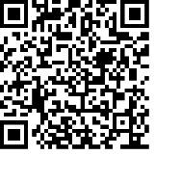
Steve Payne – Buildings Manager 07885 706637
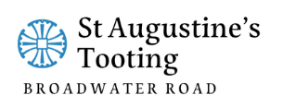

11am Parish Eucharist
5th July 2026 Trinity 5

Celebrant: The Revd Dorothy Penniecooke
Preacher: The Revd Dorothy Penniecooke

Readers: Ethel Addo, Steve Payne
Intercessions: Jacqueline Obodai
Greeters: Helen Duxbury, Paula Stevenson

Hymns
Introit 220: How sweet the name of Jesus sounds
Psalm 145: 8-15
Offertory 362: O for a thousand tongues to sing
Communion 264: Jesus, the very thought of thee
Recessional 226: I cannot tell

