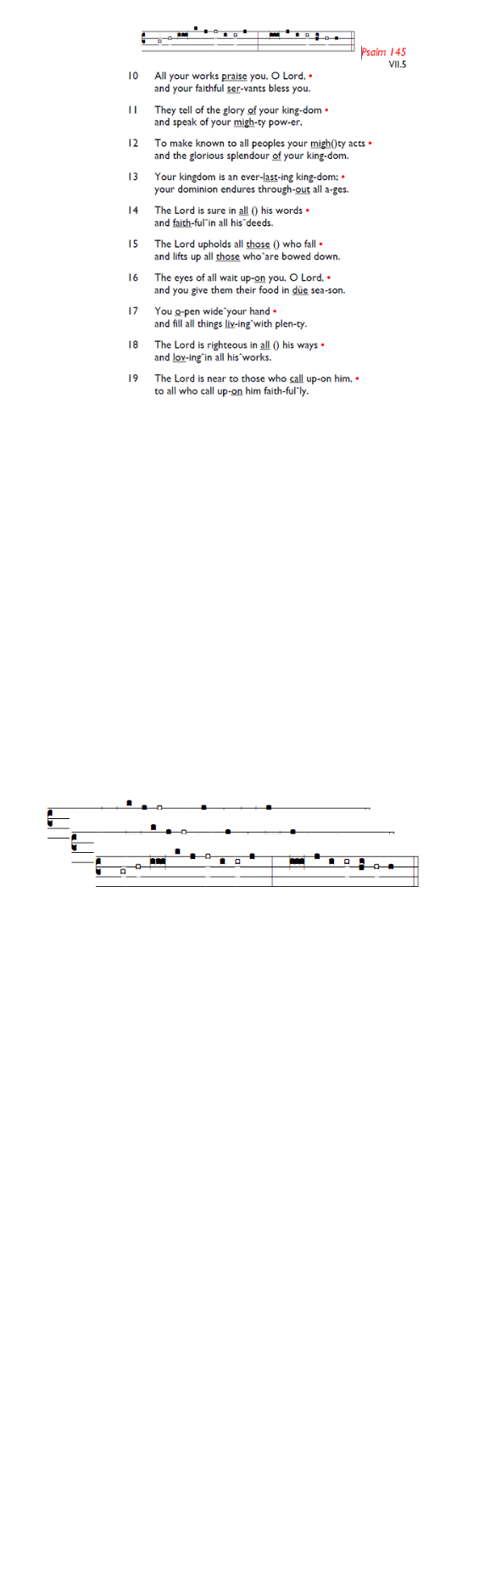
Weekly Events
- Monday-Friday 8.30am -8.50am: Morning Prayers.
- Thursday, Eucharist 10-11am, Bible Studies
11am – 12noon. Spanish Class, 12pm -1.15pm.
September 3rd, 17th & 24th

Today at Holy Trinity Church
You are warmly invited to attend the Family Picnic at Holy Trinity Church starting around 12.30pm. The picnic will be held on the lawn next to Trinity Crescent.

This Week
The 8-week Prayer Course continues at Holy Trinity Church on Tuesday evenings until 15th September as part of our Benefice-wide Formation Tuesday initiative. Food from 7pm, and video to start at 7.30pm. All welcome to join in.

Looking ahead
Harvest Festival will be held on 4th October, 11am followed by refreshments.

Black History Month Talk: 11th October. With special guest speaker, details to follow.

Sat 17th October, all day: Joint Benefice Visit to Salisbury Cathedral. We'll go to visit Fr Russ, our former associate priest and spend some time in Salisbury and at the Cathedral etc. More information regarding timings and transport arrangements nearer the time.

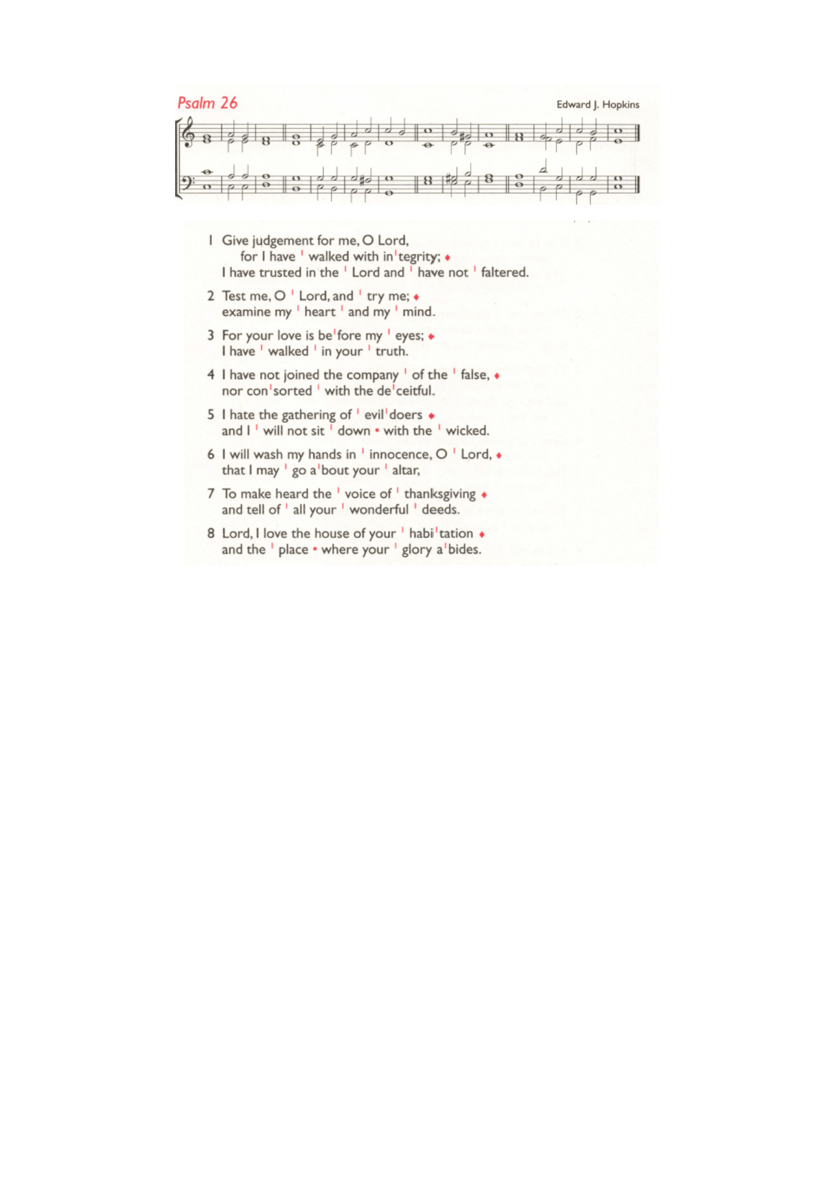
October 6th 13th, 20th, & 27th St Augustine’s will run the 321 course, a short introduction to the Christian faith over 4 weeks on Tuesday evenings in October. Food is at 7pm, with the course beginning at 7.30pm.

Southwark Diocese are offering a free training day on Children & Young People Ministry Foundations for anyone interested in ministry among families. Sat 26 Sep at St Thomas with St Stephen, Telford Park, 9am–4pm. Book here: tinyurl.com/CYPFoundations2026

Those who have asked for prayers:
Thelma Benjamin, Gene Bovell, Aileen Brewley, Fitzgerald Brewley, Gloria Ellis Clarke, Yvonne Clarke, Oscar Sam Carrol, Kathleen Cummings, Jennifer Donahue, Shirly Lynch, Horatio Obodai, Esther Persaud, Tina Roberts, Orville Simpson, Thelma Simpson, Mark Sinclair, Delce Taylor, Louisa Upjohn, Idene Waithe, Eula Watson, Leo Watson, Velda Welch.

Contacts & Church Office:
Administrator, Church Notices & Bookings:
Zorah Baig 020 8772 4454
churchoffice@uppertooting.net
The Revd Angela Rayner: (Vicar) 07385 181103
vicar@uppertooting.net
The Revd Sarah Whitehouse (Assistant Priest)
sarah@uppertooting.net
Claudette Dey – Pastoral Lay Minister 07979 598889
Jacqueline Obodai– Churchwarden. 07956 337643
jackieo12@live.com
Idene Waithe –Churchwarden. 07883 421147
murmaid47@outlook.com

Steve Payne – Buildings Manager 07885 706637
Jacqueline Gray – (Curate) 07557 024845
jacquelineg@uppertooting.net



11am Parish Eucharist with
Blessing of Lectern and Reading Desk

30th August 2026 Trinity 13

Celebrant: The Revd Sarah Whitehouse
Preacher The Revd Sarah Whitehouse

Readers: Sue Bruno, Jaqueline Obodai
Intercessions: Ethel Addo
Greeters: Jeremy Clarke, Ethel Addo

Hymns
Introit 205: He who would be valiant be
Psalm: 26: 1-8
Offertory 533: We love the place O God
Communion 227: I come with joy
Recessional 560: Will you come and follow me

