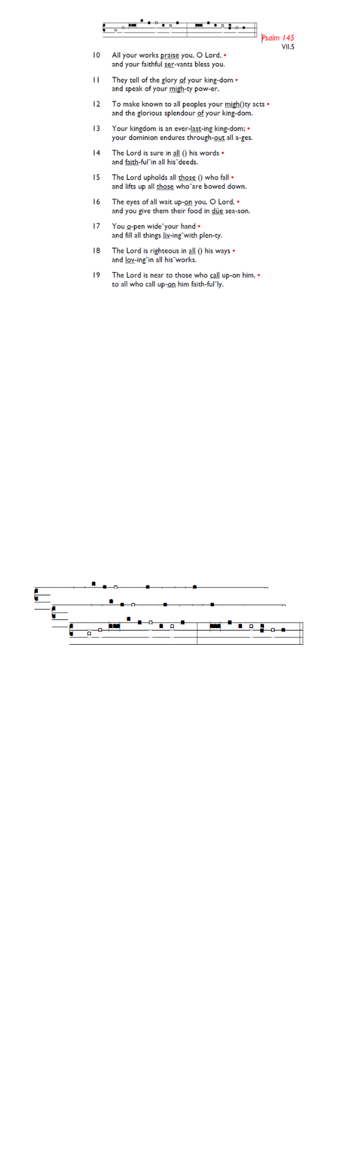
Weekly Events
- Monday-Friday 8.30am -8.50am: Morning Prayers.
- Thursday, Eucharist 10-11am, Bible Studies
11am – 12noon. Spanish Class, 12pm -1.15pm.
13th, 20th & 27th August.

This Week
The 8-week Prayer Course continues at Holy Trinity Church on Tuesday evenings until 15th September as part of our Benefice-wide Formation Tuesday initiative. Food from 7pm, and video to start at 7.30pm. All welcome. Please sign up if you can for catering purposes: bit.ly/BookEventHT

PCC Monday 12th August 7-8pm.

Save the date
Sunday 30th August 12 noon, Family Picnic at Holy Trinity Church.
Anyone who would like to attend are warmly welcomed.

If you were taken ill in a Medical Emergency at church, after calling the emergency services, who else would you like us to call? The information will be stored securely on ChurchSuite against your record. We would be very grateful if you would email/phone the name and telephone number of your emergency contact to churchoffice@uppertooting.net, or 020 8772 4454.

Southwark Diocese are offering a free training day on Children & Young People Ministry Foundations for anyone interested in ministry among families. Sat 26 Sep at St Thomas with St Stephen, Telford Park, 9am–4pm. Book here: tinyurl.com/CYPFoundations2026

Those who have asked for prayers:
Thelma Benjamin, Gene Bovell, Aileen Brewley, Fitzgerald Brewley, Gloria Ellis Clarke, Yvonne Clarke, Oscar Sam Carrol, Kathleen Cummings, Jennifer Donahue, Shirly Lynch, Horatio Obodai, Esther Persaud, Tina Roberts, Orville Simpson, Thelma Simpson, Mark Sinclair, Delce Taylor, Louisa Upjohn, Idene Waithe, Eula Watson, Leo Watson, Velda Welch.

Faithful departed: Jean Bobell

Contacts & Church Office:
Administrator, Church Notices & Bookings:
Zorah Baig 020 8772 4454
churchoffice@uppertooting.net
The Revd Angela Rayner: (Vicar) 07385 181103
vicar@uppertooting.net
The Revd Sarah Whitehouse (Assistant Priest)
sarah@uppertooting.net
Claudette Dey – Pastoral Lay Minister 07979 598889
Jacqueline Obodai– Churchwarden. 07956 337643
jackieo12@live.com
Idene Waithe –Churchwarden. 07883 421147
murmaid47@outlook.com
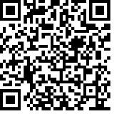
Steve Payne – Buildings Manager 07885 706637
Jacqueline Gray – (Curate) 07557 024845
jacquelineg@uppertooting.net

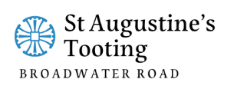

11am Parish Eucharist
9th August 2026 Trinity 10

Celebrant: The Revd Sarah Whitehouse
Preacher The Revd Sarah Whitehouse

Readers: Jacqueline Obodai, Helen Duxbury
Intercessions: Doris Pappoe
Greeters: Russell Yates, Helen Duxbury

Hymns
Introit 266: Jesus calls us: o’er the tumult
Psalm 85: 8-13
Offertory 523: To the name of our salvation
Communion 106: Dear Lord and Father of mankind
Recessional 114: Eternal Father, strong to save

