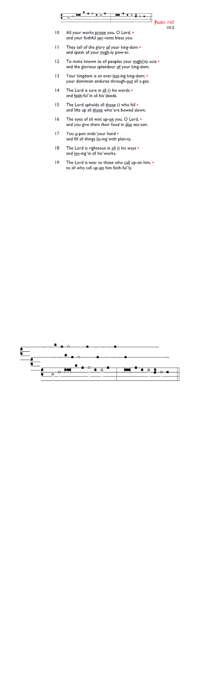
Weekly Events
- Monday-Friday 8.30am -8.50am: Morning Prayers.
- Thursday, Eucharist 10-11am, Bible Studies
11am – 12noon. Spanish Class, 12.30pm -1.30pm.
October 8th-15th

Looking ahead
Harvest Festival will be held on 4th October, 11am followed by refreshments.

Black History Month Talk: 11th October. With special guest
speaker, details to follow.

Sat 17th October, all day: Joint Benefice Visit to Salisbury
Cathedral. We'll go to visit Fr Russ, our former associate priest
and spend some time in Salisbury and at the Cathedral etc.
More information regarding timings and transport arrangements
nearer the time.

October 6th 13th, 20th, & 27th St Augustine’s will run the 321 course,
a short introduction to the Christian faith over 4 weeks on Tuesday evenings in October. Food is at 7pm, with the course beginning at 7.30pm.

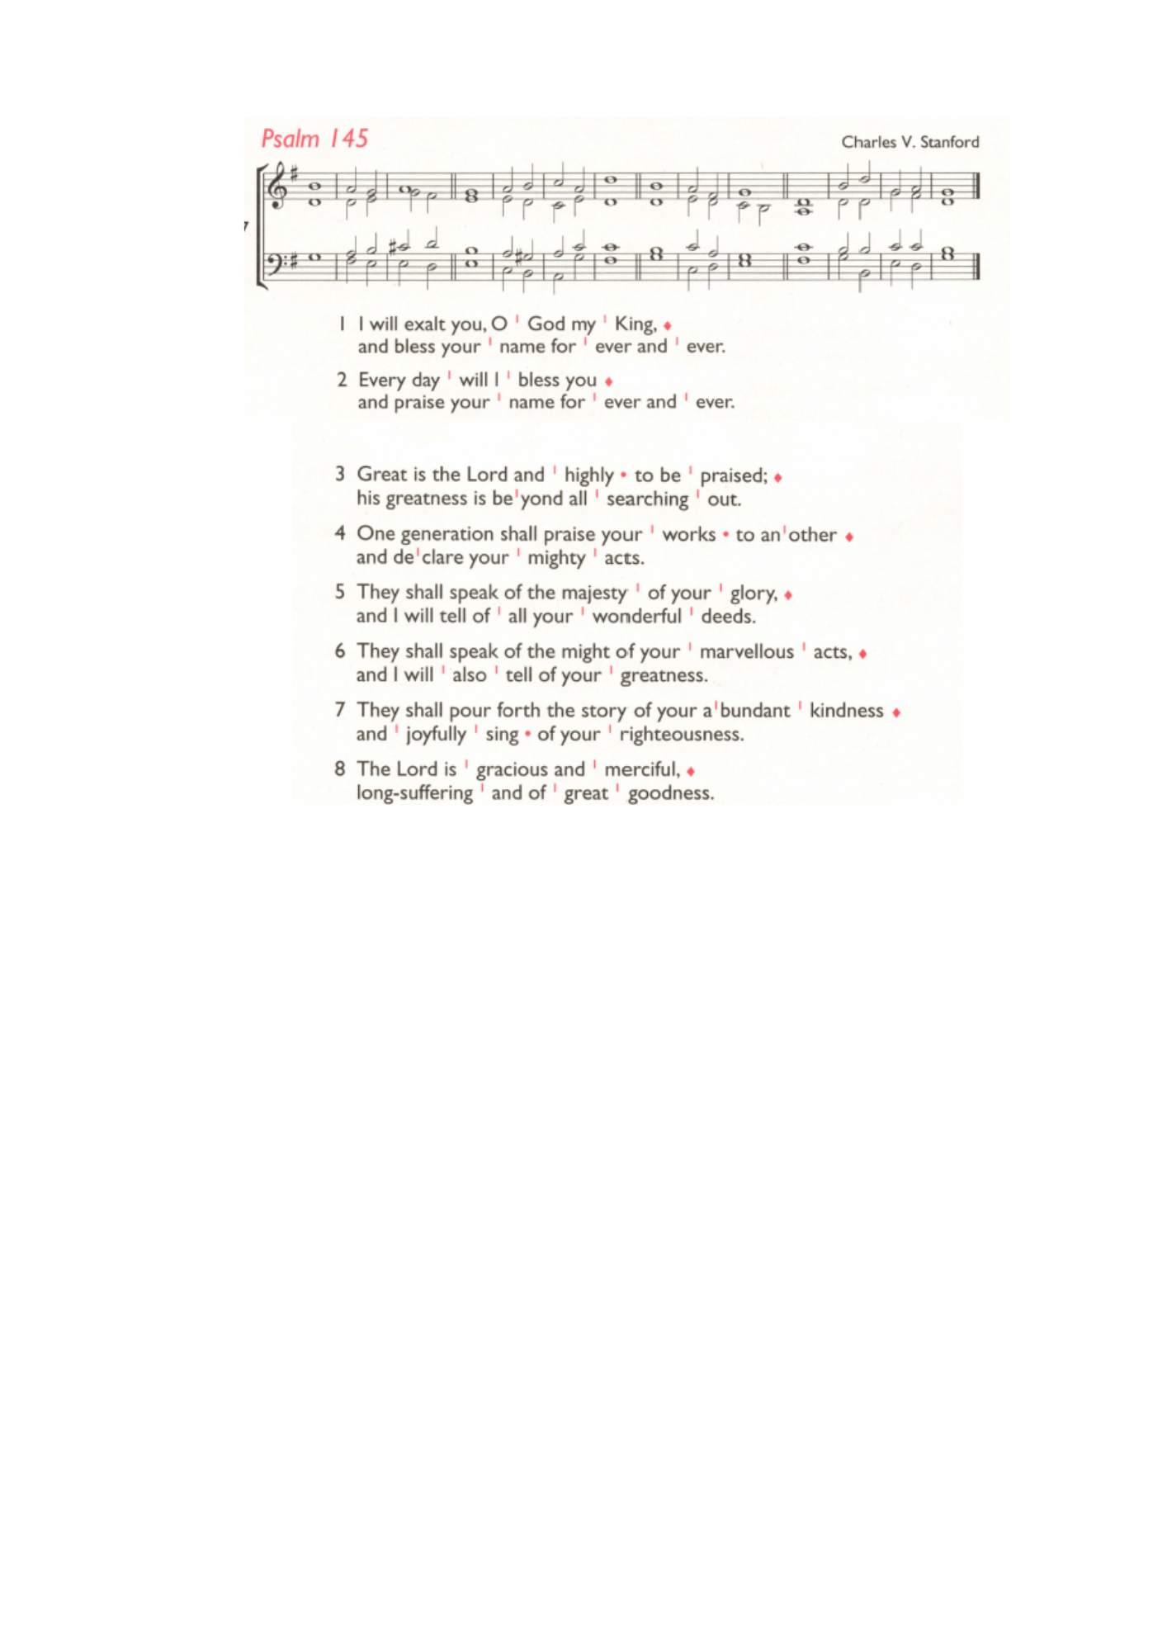
Sat 3rd Oct, 11am Annual Service of Thanksgiving for Black
History Month at Southwark Cathedral. Meet at Tooting
Bec tube at 10am to travel together or go straight to the
Cathedral. Service 11am - 12.30pm. Optional workshops 1pm - 2pm.Bring a packed lunch!
Booking is required: bit.ly/SouthwarkBHM2026

Sunday 25th October PCC Meeting 12.30pm.

Southwark Diocese are offering a free training day on Children & Young People Ministry Foundations for anyone interested in
ministry among families. Sat 26 Sep at St Thomas with St Stephen, Telford Park, 9am–4pm.
Book here: tinyurl.com/CYPFoundations2026

Those who have asked for prayers:
Thelma Benjamin, Aileen Brewley, Fitzgerald Brewley, Gloria Ellis Clarke, Yvonne Clarke, Oscar Sam Carrol, Kathleen Cummings,
Jennifer Donahue, Shirly Lynch, Horatio Obodai, Esther Persaud,
Tina Roberts, Orville Simpson, Thelma Simpson, Mark Sinclair,
Delce Taylor, Louisa Upjohn, Idene Waithe, Eula Watson,
Velda Welch.

Contacts & Church Office:
Administrator, Church Notices & Bookings:
Zorah Baig 020 8772 4454
churchoffice@uppertooting.net
The Revd Angela Rayner: (Vicar) 07385 181103
vicar@uppertooting.net
The Revd Sarah Whitehouse (Assistant Priest)
sarah@uppertooting.net
Claudette Dey – Pastoral Lay Minister 07979 598889
Jacqueline Obodai– Churchwarden. 07956 337643
jackieo12@live.com
Idene Waithe –Churchwarden. 07883 421147
murmaid47@outlook.com
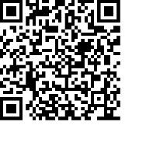
Steve Payne – Buildings Manager 07885 706637
Jacqueline Gray – (Curate) 07557 024845
jacquelineg@uppertooting.net

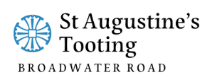

11am Parish Eucharist

20th September 2026 Trinity 16

Celebrant & Preacher: The Revd Dorothy Penniecooke

Readers: Russell Yates, Soma
Intercessions: Sam Carrol
Greeters: Helen Duxbury, Ethel Addo

Hymns
Introit 466: Teach me, my God and King
Psalm 145: 1-8
Offertory 310: Lord, for the years
Communion 108: Deck thyself, my soul
Recessional 456: Stand up and bless the Lord

